H. Landis “Lanny” Floyd II
PE, CSP, CESCP, CUSP, CMRP, CRL, Life Fellow IEEE
Electrical Safety, Accident & Injury Expert
Consultant, Author, Speaker, Professor
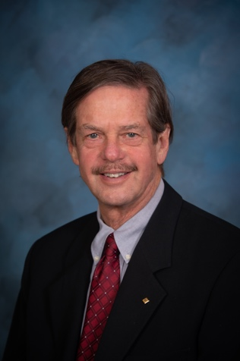 | Owner & Principal Consultant  Electrical Safety Group, Inc.  35 Gina Court  Elkton, MD 21921 USA  Tel: 302-547-4298 FAX: 443-378-5788  Email: H.Landis.Floyd@gmail.com  Consulting Website  LinkedIn Profile | Adjunct Professor  MEng Advanced Safety and Engineering Management  The University of Alabama at Birmingham  Email: lfloyd@uab.edu  UAB Website

Areas of Expertise

- Occupational Electrical Injuries | - Industry Standards, including NEC, NFPA70E, NESC | - Safety Management Systems
- Electric Shock & Arc Flash | - Industry Standards, including NEC, NFPA70E, NESC | - Workforce Development
- OSHA Electrical Regulations | - Electrical Safe Work Practices | - Design, Maintenance, Reliability,
- Human Performance | - Operational Excellence | Operations & Construction

To download my full CV Click here

Brief Biography
I received my BSEE from VA Tech in 1973. My 45+ year career with DuPont focused on electrical safety in the construction, operation and maintenance of DuPont facilities worldwide. My responsibilities included improving management systems, competency renewal, work practices, and the application of technologies critical to electrical safety performance in all DuPont operations globally. From 1990 to 2014, I led the design, implementation, and continuous improvement of the electrical safety management system for DuPont global operations, achieving breakthrough performance in risk reduction. In 2013, I joined the faculty of the graduate school of Advanced Safety and Engineering Management (ASEM) at The University of Alabama at Birmingham (UAB). At UAB, I have taught Introduction to Systems Safety & Prevention through Design, Engineering Ethics & Acceptable Risk, and Electrical Systems Safety which I developed and currently teach. I have published more than 90 peer reviewed papers and articles on occupational electrical safety. I have received awards from leading institutions recognizing my work to advance the practice of electrical safety. I am an IEEE Life Fellow, a professional member of American Society of Safety Professionals, a Certified Safety Professional, a Certified Electrical Safety Compliance Professional, a Certified Utility Safety Professional, a Certified Maintenance & Reliability Professional, a Certified Reliability Leader and a registered professional engineer in Delaware, Michigan, Pennsylvania, and Texas. I established Electrical Safety Group, Inc. in 2001 to provide expert witness and consulting services in electrical safety matters. I have been retained as an expert witness in over 50 cases, 60% by plaintiffs and 40% by defendants.

