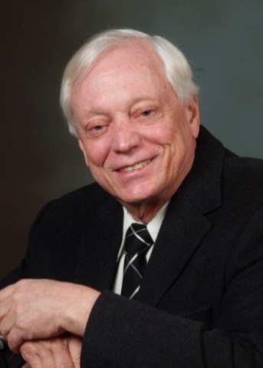

JAY R. CAROW, AIA, pRINCIPAL

expert witness curriculum vitae

Jay Carow has been a licensed architect and a design principal in architectural and planning firms since 1969. He has also taught architecture at universities in the States and overseas for 14 years the last six as a full Professor of Architecture.
Jay Carow has provided expert witness services for 33 years drawing on his teaching of building design, professional experience in code analysis and safety design for his firm’s buildings, and his abilities to provide credibility and a relaxed presentation clearly and convincingly. He is supported by his firm’s technical staff in his research and preparation of exhibits.

EXPERT WITNESS AREAS OF EXPERTISE
Case Types: 80% for Plaintiffs; 20% for the Defendents
- Slip, Trip and Fall Accidents
- Design Defects
- Construction Defects
- Architectural Errors, Omissions and Malpractice
- Building Material Defects
- Architectural Errors and Omissions
- Non-Compliance With Applicable Codes and Standards
- Construction Site Accidents
- ADA Requirements
- Errors in Treatment ofion of Historical Buildings
- Errors in Public Building Design and Construction

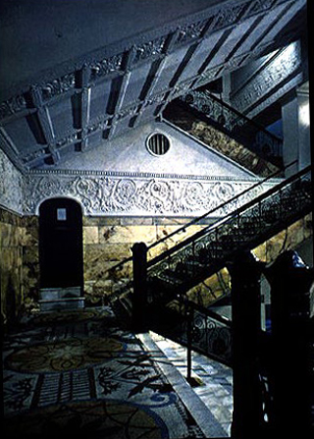
jaY R. CAROW, AIA, pRINCIPAL

expert witness curriculum vitae
Mr. Carow’s first case as an expert witness in 1985 involved the improper design of handrail and the need for safety. Since that time he has provided services on four or five cases a year which are mostly slips and falls with about 80% for plaintiffs. Notable other cases involved injuries from non-code compliance: five people who died in a locked stairwell from smoke inhalation, a workman who backed up onto a glass skylight and fell two floors to his death; two different patrons who accidentally stepped and fell into the same restaurant stairwell a month apart.

Roosevelt University retained Jay’s firm to survey their national historic Auditorium Building annually for safety issues and needed corrections. In inspecting the fire-code required wall and doors on closers between the main stairs and the spacious lounge he reported that this should be corrected for historic reasons. He designed the wall removal with Chicago safety approval: Sullivan and Adler’s light and openness was restored.

education
Massachusetts Institute of Technology, M. Architecture
Illinois Institute of Technology, B. Architecture

professional experience
Carow Architects +, Sole Proprietor, 33 years
Danforth Rockwell Carow, Partner, 9 years
C. F. Murphy Associates, Architects / Engineers, Chicago, Intern, 2 years; Senior Design Associate, 2 years
Other firms: Design Partner or Principal, 4 years

academic experience
Illinois Institute of Technology, College of Architecture, Professor of Architecture, 5 years
University of Science Malaysia, Penang; School of Housing, Building and Planning; Founding Dean and Professor of Architecture, 3 years
University of Baghdad, Department of Architecture, Fulbright Visiting Professor, 1 year
U. S. Peace Corps, Malaysia, Technical College, Dept. of Architecture, Kuala Lumpur, Lecturer, 2 years

honors and awards`
Numerous Architectural publications
AIA Chicago, Nominated for AIA Fellowship

AIA Chicago, Honor Award, with C. F. Murphy Associates
registrations
Licensed Architect: Connecticut, Illinois, Indiana, New Jersey, Massachusetts, Wisconsin
National Council of Arch. Registration Boards, Certification

affiliations
American Institute of Architects
Town of Southbury (CT), Zoning Commission, Board Member
Town of Southbury (CT), Historic Building Com-mission, Board Member and Vice President
Evanston (IL) Public Library Board of Trustees, Past V. P. and Building Committee Chair
Evanston Library Friends, Past President

design competitions
Racine Public Library, Racine, WI, First place and commission
Concordia Theological Seminary, New Library and Centrum on a campus designed by Eero Saarinen, Fort Wayne, IN, First place and commission
Evanston Public Library, Evanston, IL, Honorable Mention
Xe-Lan Competition, Beijing, China, 3rd Place

