Martin E. Gordon, M.D., F.A.C.P., F.A.C.G., F.A.S.G.E., F.A.A.A.S.
CEO, Medical Films, LLC
One McKnight Place, Suite 437
Saint Louis, Missouri 63124

Cellphone 203-507-5551 martin.gordon@yale.edu FAX 203-991-6656

Recognized as the Initiating Pioneer/Creator :

“Gastroscopy-From the Magenkratzer to the Laser”
A traveling Exhibit to most USA Medical Schools, viewed for > 5 years:

The Global Disease Guide* ,
an Int’l Physicians Desk Reference( See below)

“ The Learning Center”
for 2 decades, epicenter of all DDW Annual meetings**

The APP “Plants4Cures“ ( Planting Solutions- Puzzling Problems )
_{Ancillary Activities :}
While Clinical Professor of Medicine, Yale University, Dr. Gordon received the American College of Physician’s Laureate Award for patient care. The Yale New Haven Medical Residents also honored him by the Benedict Harris Teaching Award for contributing most to their First Year of Resident training.

Recipient: Dean’s Peter Parker Medal
“for lifetime contributions to Medicine and Yale University”

Fellowship American Society Advancement Science:
".for contributions to clinical gastroenterology, travel medicine, and biomedical film production "

While Clinical Professor of Medicine, interactions in “Morning Report” with students, House Officers & faculty at Yale Medical Center

Initiated & integrated Yale Medical Students as Tour Guides/Mentors with high school students with the Connecticut State as the "Yale BIO-BUS” program to further stimulate youth interest in the bio-medical sciences.

Instigated the Digital Imaging Center within the Cushing/Whitney Med. Library, featuring Award-winning Int’l Science Films for personal checkout use.
_{Creator Author/Producer:}
“Clinical Aspects of Parasitology “ (Int’l Award- winning Film Series):

The Intruders-Cestodes
The Infiltrators-The Nematodes
The Insinuators-Toxoplasma Gondii
(Image)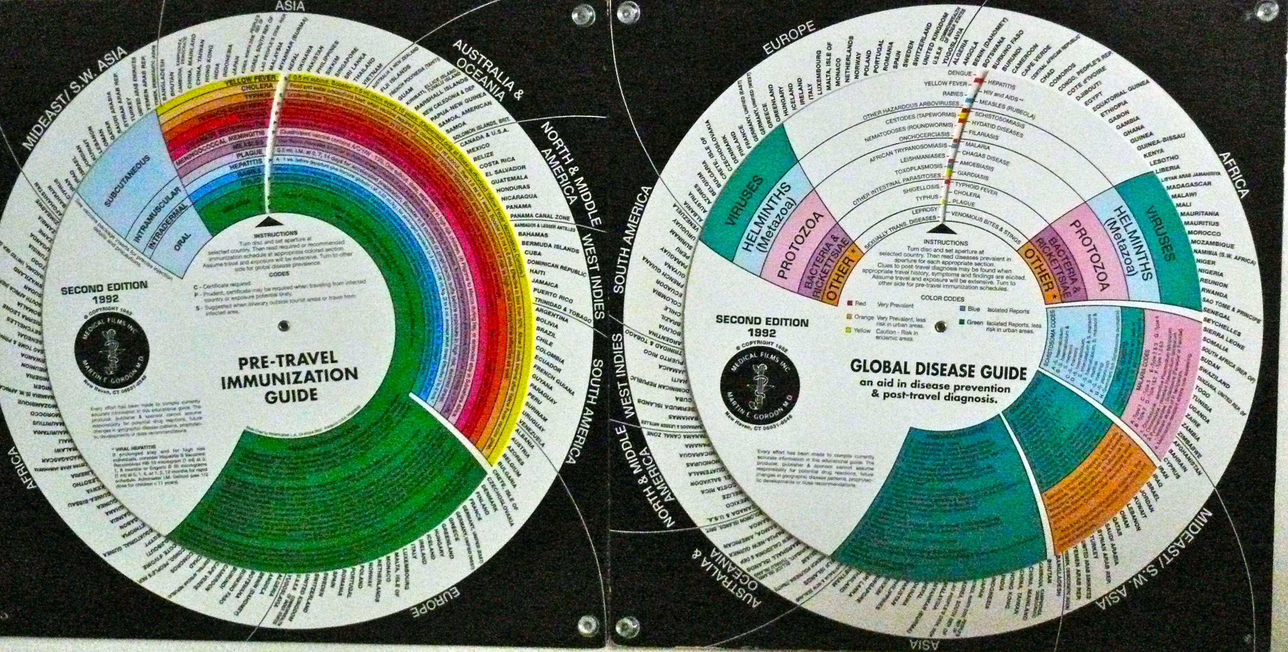

The Global Disease Guide
A Physicians Desk Reference
( Distributed Internationally until exhausted, now out of print )-

-2-

Microscopy--Tools of the Biomedical Sciences”
Produced to honor Yale University Tricentennial Celebration
Film streamed internationally with CD-ROM formats. Available on the International Web, Yale University with Virtual Exhibit of microscopes gathered
Finalist Award in the Basic and Clinical Category of the Time, Inc. International Health and Medical Media Competition

Instigated the Digital Imaging Center within the Cushing/Whitney Med. Library, featuring Award-winning Int’l Science Films,

Organized and chaired: The International Disaster Medicine and Emergency Management Congress, Newwns Int’l Fellowship Committee (>15 years)
Yale Honoris Causa in recognition for “Outstanding Service and Abiding Support of the Downs Student Travel Fellows, April 16, 2007
.
Mounted various scientific programs with contributory Exhibits; sponsored films, posters and educational devices for national and international meetings.
(Web site)

The New England Journal of Medicine published his Book Reviews on the texts
Travel Medicine and Malpractice Myths (April 20, 2006)

Creator of the CD-ROM Probing the Dx”, received the AMWA Will Solimine Award for “Excellence in Med. Communication”, June 14, 2006

(Video Image)

Author, Producer/Director, DVD “Embracing Plants and Cures-From Seedlings to Remedies”,
requested and then deeded to the NIH/NLM for their Archival Shelves in perpetuity. The film is also present within Medical facilities internationally:

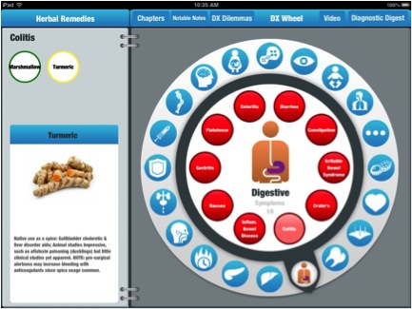

“ PLANTS4CURES”
Newly Launched Medical APP

Presently Senior Advisor, St. Louis Science Center, developing an interactive DVD and traveling Exhibit for future public display

