ARBITRATION NO: DL 21381

IN THE MATTER OF AN ARBITRATION
UNDER DIFC-LCIA ARBITRATION RULES

BETWEEN:

ATELIER 21 LLC
Claimant
and

TAV TEPE AKFEN INVESTMENT CONSTRUCTION AND OPERATIONS
Respondent

EXPERT REPORT
DAMAC Towers by Paramount

31 October 2024

Report to the Tribunal by Christo Papachristou



Prepared by: Christo Papachristou
Schema Management Group Limited
October 2024

Table of Contents

Preface…………………. 5
Documents reviewed 6
Expert’s Declaration 7

General Data.. 8
1. General Data 9
1.1. Objective 9
1.2. The Parties 10
1.3. References 10
1.4. Context 11
1.5. Background 12
1.6. Disputes and Causes 14

SECTION 1: Assessment of Claimant’s entitlement to Extension of Time for Completion 18
1. Preface. 19
1.1. EoT Submissions and Awards 20
1.2. Independent Delay Analysis 21
1.2.1 Process 21
1.2.2 Correlation 21
1.2.2.1 Explicit Correlation 21
1.2.2.2 Implicit Correlation 22
1.2.3 Development of the Independent Delay Analysis 23
1.2.4 Method Implemented 25
1.2.5 Programme Selection 26
1.2.6 Programme Validation 29
1.2.7 Milestone Analysis 32
1.2.8 Variations 33
1.2.8.1 Breakdown of Variations Time impact by Period of analysis 35
1. Period 1: From 4 April 2016 to 29 April 2017 35
2. Period 2: From 30 April 2017 to 31 December 2017 35
3. Period 3: From 1 January 2018 to 26 September 2018 36
1.2.8.2 Approved Time impact for Variations 36
1.2.9 Findings of Delay Analysis 37
1.2.10 Basic Results 37
1.2.11 Detailed Analysis for the entire project: Start 04 April 2016 to 26 September 2018 45
1.2.11.1 Step 1: Analysis from 04 April 2016 to 30 April 2017 45
1.2.11.2 Step 2: Analysis from 01 May 2017 to 31 December 2017 48
1.2.11.3 Step 3: Analysis from 01 January 2018 to 26 September 2018 51
1.2.12 Correlation of the analysis findings 54
1.2.13 Correlation of identified from the analysis Events with documents 55
1.2.14 Summary of Correlation (Delay Events and Documents Discovery) 70
1.2.15 Evidence of Concurrency 71
1.2.16 Summary of Findings 72

SECTION 2: Technical Analysis of Analysis of the Critical Period (30 April through 31 December 2017) 73
2. Preface. 74
2.1 References 74
2.2 General Data of the Main Contract Agreement 75
2.2.1 Preamble 75
2.3 Method of delay analysis utilized 76
2.3.1 MIP 3.3 – Observational / Dynamic/ As is Windows Analysis 76
2.4 Sources of analysis - Schedules utilized 77
2.4.1 The sources utilized for analysis is the electronic Primavera schedule files as presented in Table 2.4.1 77
2.5 Validation and Rectification of schedules 78
2.6 Findings 80
2.7 Analysis of findings 83
2.7.1 Event No. 01 -TOA-Ceiling Grid Basemt 2 -Tower A-Podium -29-Apr-28 Jul-17 - 81 days 83
2.7.2 Event No. 02 0 - TOA-Ceiling Grid Bsmt. 2-Tower C Podium:29-Jul-01-Sep-17 -16 days 83
2.7.3 Event No.03 TOB-Wall Skim coat, Wall Paint Bsm 1-Tower B Pod–02-29 -Sep-17 – 5 days 83
2.7.4 Event No.04 - TOC-Drywall 2nd StPL8--TOWER C (Podium) 20-Sep –27 Oct-17 - 17 days 84
2.7.5 Event No.05 TOA-ELV-Trunk, Conduit (MEP-Pod)-Tower A–28-Oct– 29-Dec-17–40 days 84
2.7.6 Findings of the Analyses’ 85
2.8 Float analyses from Start to Completion 86
2.8.1 Introduction 86
2.8.2 Process 87
2.8.3 Comparative analysis 88
2.8.4 Findings 89
2.9 Comparison of delay analyses of Experts / Main Contract / Subcontract 92
2.9.1 Introduction 92
2.9.2 Comparison of the findings of analysis of the Main Contract by me and the Experts 93
2.9.3 Comparison analysis on the Claimants schedules for 30 April – 31 Dec 2017 95
2.10 Consolidated opinion on delays incurred from the 01 May – 31 December 2017 98

SECTION 3: Assessment of Counterclaims submission made by the Respondent 99
3. Assessment of Counterclaims submission made by the Respondent 100
3.1 Preamble 100
3.2 Part 1 – Review of Experts Reports for Main Contract Arbitration 101
3.2.1 Review of Experts Reports (DL 19212) vs Contract Clauses on LDs and Max cap 101
3.2.2 Review of Mr. Aidan Coyne’s (Respondent) position 101
3.2.3 Review of Mr. Yendall’s (Respondent’s) position 103
3.2.4 Points of Agreement Between the Two Experts 105
3.3 Part 2 - Review of the Contract Clauses regarding Liquidated Damages 106
3.3.1 Review of Clauses regarding Liquidated Damages on the Main Contract. 106
3.3.2 Review of the Instructions to Tenderers & Contract Conditions 106
3.4 Part 3 - Calculations & Correlation of Experts Findings with Contract Requirements 107
3.4.1 Calculation of number of days to reach Maximum cap (10%) of LDs 107
3.4.2 Correlation of the Inherent project delays vis a vis to the days to impose Max LDs 107

SECTION 4: Conclusions and Opinions 110
4. Preamble 111
4.1 Section 1: Claimant’s Entitlement of Extension of Time 112
4.1.1 General 112
4.2 Section 2: Technical Analysis of Critical Period (30 Apr through 31 Dec 2017) 114
4.2.1 General about Section 2 114
4.3 Section 3: Assessment on Counterclaim submission by the Respondent 116
4.3.1 Professional Opinion 116

SECTION 5: Appendices 117
5. Appendices 118

Preface
On 21July 2024, I was appointed, as Planning Expert, by Al Riyami Advocates, Legal Consultants on behalf of Atelier 21 LLC. (the ‘Claimant’) regarding a dispute risen with TAV Tepe Akfen Investment Construction and Operations (the ‘Respondent’).
The Dispute concerns the Contract Agreement signed between the two parties, on March 30, 2016, and later amended with an Addendum on June 28, 2016, and finalized on 27 August 2016, for construction and provision of materials for the Paramount Tower located in Dubai, U.A.E.
The instructions presented to me by the Legal Counselor included the development of an Expert Report regarding Planning issues and consists of:
- Assessment of Entitlement to EoT by the Claimant for his works through the Subproject Schedule.
- Assessment of the delays incurred in the project during the critical period (30 April to 31 December 2017), to measure the risks of the parties, on the incurred delays, utilizing the Main Schedule of works.
- Assessment of the Expert Reports findings, in the Main Contract Arbitration, between the Respondent and the Employer. The Assessment is based on the review of the Reports, in conjunction with the Supplemental Defense and Counterclaim by the Respondent and express my opinion in Planning issues described within these documents, and the validity of the counterclaim from a Planning perspective.
To perform the assigned tasks,
- I reviewed the documents received by the Claimant, as I listed further in this Report under the “Documents Reviewed” paragraph, and
- I interviewed the Claimant’s key personnel,
- I reviewed the Statement of Claim, as well as the Statement of Defense (SOD) and the Counter arguments prepared by the Legal Counsellors of both parties, as well as the supplemental statement of defense and counter claims.
- To understand the Supplement Statement of Defense and Counterclaim raised by the Respondent, I reviewed the Subcontract and Main Contract Agreements with focus on planning requirements.
To form an opinion regarding the delays incurred during the critical period from April to December 2017, which is considered, critical by both Experts,
- I reviewed the First Expert Report of Mr. Coyne, the Reply Expert Report of Mr. Aidan Coyne, and
- I reviewed the Second Joint statement and the First Expert Report, and
- I reviewed the Reply Expert Report Yendall, the Delay Expert Statement as well as
- the transcripts of their cross-examination.
This report presents my opinion regarding the planning issues raised in this dispute, and are presented in three (3) distinct Sections as follows:
- Section 1: Delay Analysis of Claimant’s Entitlement to Extension of Time under his Subcontract
- Section 2: Delay Analysis of the Critical Period (30 April - 31 December 2017) under the Main Contract
- Section 3: Assessment of the Counterclaims submission made by the Respondent
- Section 4: Conclusions and Professional Opinions
- Section 5: Appendices
Disclosure of Interest
I have no connection with, and I am not aware of an actual or potential conflict of interests with either of the Parties, their Solicitors or Witnesses which might be thought to influence the opinions expressed in this report.
The Author
My name is Christo Papachristou, and I am the Managing Director of Schema Management Group Ltd since 2005, and hold the following accreditations:
- Master’s Degree (ME) in Construction Management from New York University (NYU) of New York,
- Bachelor’s degree (BS) from City University, City College (CUNY) of New York City, and
- Bachelor’s degree (BS) in Civil Engineering from the Technical Institute (TEI) of Thessaloniki, Greece.
I have over thirty-five (35) years in the construction industry, and my company specializes in providing consulting services on Construction projects in the field of Project Management, Dispute Resolution, Risk assessment and Procedures write up, including Construction Claims, Forensics and Delay analysis in the UAE since 2007.
A copy of my CV is attached, in Section 5 – Appendix, for your reference.

Documents reviewed
For Arbitration Case DIFC-LCIA No. DL21381 - Appendix A
- Letters of Nomination (Employer and Engineer)
- Subcontract for Fit-out works for front of house (FOH) (Package 1 and 2) (DTP-NSC-1267)
- Variation list
- Correspondence (incoming/outgoing) –
- Authorities Correspondence
- Programme updates / Daily and Monthly Reports
- Statement of Claim – 01 December 2021- Claimant
- Statement of Defense – 26 January 2022 – Respondent
- Statement of Reply – 23 February 2022 – Claimant
- Statement of Defense Rejoinder – 4 May 2022 - Respondent
- Supplemental Defense and Counterclaim–20 March 2024 - Respondent (Appendices 1&2)
- Amended Reply to Defense and Defense to Counterclaim – 24 April 2024 - Claimant
- Amended reply to Defense and Counterclaim - 28 July 2024 -Respondent
For Arbitration Case DIFC-LCIA No.DL19212 – Appendix B
- Main Contract Agreement Document
- Addendum Letter No. 04
- Programmes from April to December 2016 to September 2018
- Partial Final Award – 10 August 2023
- Expert First and Rebuttal Report issued by Mr. Coyne
- Expert First and Report issued by Mr. Yendall
- Second Joint Report by Mr. Coyne and Mr. Yendall
For review I utilized the relevant documents including correspondence, programmes, reports, minutes of meetings and others, as well as the Statement of Claim, and the Statement of Defense and the Counterclaims received, to get a better understanding of the critical issues prior to derive to conclusions.
I held several meetings with the Claimant’s (Atelier 21 LLC) staff, and Legal Counselor Al Riyami Advocates, to clarify ambiguities, and get responses to queries that I had during the documents review.

Expert’s Declaration
I produced this report on the basis that it may be used by the parties in the Arbitration proceedings and prepared it under the understanding that:
- My duty in providing written reports and evidence is to help the Arbitrator(s) in reaching a decision regarding the dispute between the parties, regarding the planning issues.
- I confirm that to my understanding, I have complied with my duties.
- The facts stated in this Report are true, and the opinions I have expressed are correct and impartial.
- I endeavored to include those matters which I have knowledge of, or which I have been made aware of, that might adversely affect the validity of my opinion.
- I have indicated the sources of information I have utilized.
- I have not without forming an Expert view included or excluded anything which has been suggested to me by others (those instructing me).
- I will notify those instructing me immediately and confirm in writing if for any reason my report requires any correction or qualification.
- My report, is subject to any correlation before swearing as to its correctness, will form the evidence which may be required to be given under oath or affirmation.
- I may be cross examined on my report by a cross examiner assisted by an Expert.

I confirm that I have not entered into any agreement where the amount or payment of my fees is in any way dependent on the outcome of the case.

Signed By:
Christo Papachristou
Dated 31 October 2024

General Data

General Data

Objective
I prepared this report upon receiving instructions from Al Riyami Advocates the “Legal Counsellor” appointed by the Claimant. It has been developed with the objective of assisting with the ongoing Arbitration proceedings for DIFC-LCIA No. DL21381, between the Claimant and the Respondent. Additionally, this report aims to provide the Arbitral Tribunal with answers on Planning issues, and the risks associated by the parties involved in the project, on the delays encountered in the project.
The Respondent in his Supplementary Statement of Defense and Counterclaim brought additional counterclaims against the Claimant, upon the issuance of the Partial Final Award of the Main Contract Arbitral Tribunal Case, which was concluded in January 2024. Thus, I reviewed the relevant planning requirements of the Main Contract (Respondent vs Employer), as well as the Reports of the two Experts, appointed by the parties, regarding Planning to form an understanding of the issues, in this case.
Further I performed my own analysis for the critical period (30 April to 31 December 2017), and compared the findings with the delays identified by the two Experts. The total number of delays incurred during this period, have been attributed in their entirety to the Clamant by the Respondent.
I undertook, the following analyses, to form an opinion on the planning issues, governing this case:
- Retrospective Delay analysis on the Claimant’s Subcontract schedule files, in line with international standard and practices (AACE- 29RP MIP 3.3) covering the period from 04 April 2016 to 26 September 2018, in addition to concurrency analysis.
- Retrospective Delay analysis on the Respondent’s Main Contract schedule files, in line with international practices (AACE- 29RP MIP 3.3) covering the critical period 30 April to 31 December 2017, in addition to a concurrency analysis
- Float and other analyses, regarding productivity and delays as they evolved during the Claimant’s presence, both for his works as well as on the overall progress of works,
The findings of my analysis, on the Claimant’s schedule files, for the period 4 April 2016 to 26 September 2018, are presented in Section 1. The documents and files utilized are referenced in Section 5 - Appendix, in both electronic and hard copy format, to enable an auditable trail for review.
The findings of the analyses, undertaken on the Respondent’s Main Contract schedule files from April to December 2017, are presented in both narrative and tabular format in Section 2. The documents and files utilized for preparation of the report are referenced in the Section 5 - Appendix, and submitted in both electronic and hard copy format, to enable an auditable trail for review.
The objective behind the independent analyses, was to identify the causes of delay, the validity of contractual compliance, the quantification of risks on the delays, the extent of culpability (risks) of the parties, in the times of slow progress, and particularly during the critical year 2017, as this year constitutes the bottleneck in progress of the project and consequently the time when the disputes between the two parties arise.

The Parties
The key parties involved in the project are:
Employer (Respondent) : TAV Tepe Akfen Investment Construction and Operations
Contractor (Claimant) : Atelier 21 LLC
Engineer : KEO International Consultant

References
The contemporaneous documents reviewed and utilized for this Report are the following:
- The LCIA Arbitration Rules effective October 2020
• American Association of Cost Engineers – Recommended Practice AACE 29R-03
• Society of Construction Law (SCL) Protocol on Forensic Analysis
• American Association of Cost Engineers – Recommended Practice AACE 25R-03
For Arbitration Case DIFC-LCIA No. DL21381 - Appendix A
- Letters of Nomination (Employer and Engineer)
- Subcontract for Fit-out works for front of house (Package 1 and 2) (DTP-NSC-1267)
- Variation lists
- Correspondence (incoming/outgoing) – As listed in the Appendices
- Authorities Correspondence
- Programme updates / Daily and Monthly Reports
- Statement of Claim – 01 December 2021- Claimant
- Statement of Defense – 26 January 2022 – Respondent
- Statement of Reply – 23 February 2022 – Claimant
- Statement of Defense Rejoinder – 4 May 2022 - Respondent
- Supplemental Defense and Counterclaim–20 March 2024 - Respondent
- Amended Reply to Defense and Defense to Counterclaim – 24 April 2024 - Claimant
- Amended reply to Defense and Counterclaim - 28 July 2024 -Respondent
For Arbitration Case DIFC-LCIA No. DL19212 – Appendix B
- Main Contract Agreement Document
- Addendum Letter No. 04
- Main Contract Programmes from April 2016 to September 2018
- Partial Final Award – 10 August 2023
- Expert First and Rebuttal Report issued by Mr. Coyne
- Expert First and Rebuttal Report issued by Mr. Yendall
- Second Joint Report by Mr. Coyne and Mr. Yendall
- Correspondences as listed in the Appendices

Context
1.4.1 The Contract requirements, between the Claimant and Respondent, have been detailed on the letter of Nomination issued by the Employer to the Respondent on 03-March 2016, and by the Engineer to the Claimant, on 06-Mar-2016. The Engineer assigned certain Subcontract Works to be executed by the Claimant, namely the Fit-out works for Front of House (Package 1), and the Employer accepted the Claimants offer for the execution and completion of these Works. The Claimant was responsible for executing the Subcontract Works in accordance with the Specifications, Drawings and other Subcontract Documents on re-measurable basis.
1.4.2 The Scope for Package 1, consisted of execution and completion of interior fit-out works for Front of House (FOH) on the project. The works included engineering, supply, delivery and installation for the works detailed in Annexure A. Additionally, the Claimant’s work included submission of all warranties and guarantees, preparation and submittal of samples, material submittals, method statements, shop drawings, as built drawings, and assist the Respondent in obtaining the necessary approvals and ensure that the works are executed according to the requirements and regulations of local authorities.
On 28-Jun-16 an Addendum to the Subcontract, called Package 2, was issued increasing the scope of the Claimant by AED 4.969,613,.00, by an additional half (50%) of the existing at the time amount of Package 1. Following the introduction of Package 2, numerous changes (reduction in scope) of scope occurred, as listed below in chronological order:
- 15 July 2017 - various artworks in different sections of the project
- 24 July 2018 – metal wall cladding works at the screen area
- 27 August 2016 – the barber shop was designated as shell and core area
- 27 August 2016 – the restaurant at P1 was designated as shell and core area
- 27-Aug-17 to 29-Feb-18 (6m – 2.7M) – AED 13.8M
- 9 September 2017 – mural mosaic artwork in retail area
- 29 November 2017 – All Glass packages, The acoustic ceiling application, The spiral staircase structures, finishes. glass enclosures and structures in the chocolate boutique
- 5 December 2017 – Carpet flooring Metal floor trim and back drop cabinet Floor painting Rubber flooring all wet areas and metal floor trim 29 February 2018 – Bill 24: 8F Gym Tower C
- Changes in scope continued for the Claimant well into 2017 as detailed on paragraph 1.5.11.
1.4.3 The Parties agreed that the project completion day shall be the same as that of the Main Contract of the Respondent’s Completion Date. Any Sections or interim Milestones applicable to the Respondent under the Main Contract shall also be applicable to the Claimant under the Subcontract.
As Commencement Date I considered the 4 April 2016. At that time the Main Contract Extended Completion was the 30 November 2018 based on Amendment Letter No. 4 issued by the Employer.
Initially the project duration was agreed by the parties to complete at the same time as the Main Contracts works on 30 November 2016 with a grace period of thirty-days to the end of December 2016, or two hundred and forty (240) calendar days (04 April 2016, to 30-Nov 2016).
However, based on Package 2 finalized by 27 August 2016, the Claimant submitted a Re-Baseline Programme, which was approved by the Respondent with a letter on 20 September 2016, The Re-baseline programme Completion Date was agreed to be 15 February 2017 for both Package 1 & 2.
1.4.4 The Contract Price of the Project was AED 11,519,478.00 (Eleven Million Five hundred nineteen thousand four hundred and seventy-five dirhams). Increased with Package 2 by AED 4,969,613.00 and finalized to be AED 13.8M on 27-August 2016 after several reductions in scope.
1.4.5 Payment for materials on site shall be made at 50% within 15 days upon receipt from the Employer.
1.4.6 Payment of Retention money at 10% within fifteen (15) days upon receipt from the Employer.
1.4.7 Payment of Claimant within fourteen (14) days upon receipt of amount by the Employer
1.4.8 The Liquidated Damages (LDs) are at six thousand and five hundred (AED 6,500) dirhams per day to be paid to the Respondent limited to maximum of ten (10%) percent of the Contract price.
1.4.9 The Advance Payment is set at 13% within fifteen (15) days upon receipt from the Employer
1.4.10 Performance and Advance Payment Bonds There is no requirement for the bonds to be assignable. The Respondent shall accept “fixed duration" bonds, in the understanding and condition that the Claimant will never and/or extend the bonds (as necessary and/or appropriate) 30 days in advance of expiry. The Claimant will be informed in advance if the duration of the Performance Bond needs to be extended.

Background
1.5.1 On 30 March 2016, the Claimant, and Respondent, entered into a Subcontract agreement for the Fit-out works for Front of House (Package 1) in Business Bay area of the Emirate of Dubai in the U.A.E., for eleven million, five hundred nineteen thousand four hundred and seventy-five dirhams (AED 11,519,475.00). The Contract Number is DTP-NSC-1257. The duration of the project was two hundred and forty-five (245) days inclusive of the period for Preliminaries and Testing & Commissioning.
1.5.2 On 06 March 2016, the Claimant, and Respondent, signed the Letter of Nomination based on the Final Offer letter received by the Claimant.
1.5.3 On 30 March 2016 the Contract Agreement was signed, effective immediately, and considered the Start Date of the Project. According to the Nomination letter, the Commencement Date shall be upon signing the Subcontract agreement between the Claimant and Respondent.
1.5.4 The Commencement Date was 04 April 2016 based on letter issued by the Claimant.
1.5.5 The Engineer (Respondent’s Representative) tasks were performed by KEO International Consultants.
1.5.6 On 24 March 2016, the Claimant submitted sectional programme of works noting its compliance to Respondent’s (Contractor) milestones with commencement date 15 January 2016 and date for completion on the project i.e., 16 September 2016.
1.5.7 On 18 May 2016, the Claimant submitted Baseline programme Rev.00 noting the contract date of 04 April 2016 and project completion as 29 December 2016.
1.5.8 On 22 May 2016, the Respondent responded noting that the subcontract programme does not comply with their programme of works.
1.5.9 On 29 May 2016, the Claimant responded to Respondent’s comments with Baseline programme Rev.01 and noted the contract date of 04 April 2016 and project completion as 29 December 2016.
1.5.10 On 28 June 2016, the Claimant agreed with the Respondent to add Package 2 scope, which has a fifty percent increase in scope and a definitive time impact. Thus, the Baseline Schedules submitted previously shall be revisited and resubmitted.
1.5.11 Following the issuance of Package 2, the parties negotiated further the scope, and the following omissions of scope were recorded by 27 August 2016:
• On 15 July 2017 - various artworks in different section of the project
• On 24 July 2018 – metal wall cladding works at the screen area
• On 27 August 2016 – the barber shop was designated as shell and core area
• Onn 27 August 2016 – the restaurant at P1 was designated as shell and core area
• On 27-Aug-17 to 29-Feb-18 the budget of the Claimant’s work, both from package 1 and 2 was estimated to be (6m – 2.7M) – AED 13.8M
1.5.12 Finally, the Baseline schedule (Rev-04.3) was approved on 20 September 2016, based on Claimant’s submission on 07 September 2016.
1.5.13 However, the omissions of scope continued after the Re-baseline Schedule submission as following:
In September 2017 –the mural mosaic artwork in the retail area
On 29 November 2017 – By email from Mr. Nabil Yousif Salama of the respondent All Glass packages, The acoustic ceiling application, The spiral staircase structures, finishes. glass enclosures and structures in the chocolate boutique have been omitted from the Claimants scope.
On 5 December 2017 – The Carpet Flooring Metal floor trim and back drop cabinet Floor painting Rubber flooring all wet areas and metal floor trim. On 29 February 2018 – Bill 24: 8F Gym Tower C
1.5.14 Since the beginning the Claimant was submitting, Particulars (notifications) recording the encountered delay events. In response, the Respondent did not approve any additional time to the Claimant as of the end of the project. The only extension was after the Final Partial Award was issued.

Disputes and Causes
1.6.1 My understanding, regarding the causes of Dispute between the two Parties are the following.
  - Disagreement on the culpability (risk) for the delays incurred in the project.
The Claimant in his statement of claim requests recovery of losses due to the prolonged delay attributed to causes beyond his control and blames the Respondent as responsible for the delays incurred, while requesting remuneration for its losses. Upon review of the contemporaneous documents, I consider the prolongation cost as the main cause of dispute in this Arbitration
  - The Claimant claims for unpaid invoices by the Respondent for work completed.
  - The Claimant additionally claims, legal fees, arbitration and expert costs as well as interest.
  - The Respondent on his Supplemental Defense and Counterclaim requests recovery of losses incurred both under the Subcontract and the Main Contract (as he lost his pleadings in the Arbitration case against the Employer) and considers the Claimant responsible for the delays incurred due to the low productivity demonstrated by the Claimant during the project, and particularly the period between 30 April to 30 December 2017. He thus, claims the costs for Liquidated damages incurred due to prolongation, as well as the losses of prolongation costs claimed under the Main Contract against the Employer, for which he considers the Claimant partially responsible to the extent of his involvement as detailed in his Supplemental Defense and Counterclaim dated 20-March 2024. He additionally claims financial losses due to the above.
1.6.2 The Claimant’s Position
The project was defined as substantially completed on 26 September 2018, and received TOC by the Employer, with delay of six hundred and sixty-five (665) days, from the revised completion date of the Contract (30 November 2016) based on Amendment letter No 4. However, the Claimant, in his statement of claim states that the Respondent failed in making full payment for the works performed according to the Contract agreement, as well as paying prolongation costs accordingly. The following are the major categories of the Claimant as per the Statement of Claim:
- Pending Payment for the Claimant’s completed works according to the Contract
- Respondent’s and Engineer’s Inspection of competed works
The Claimant and Engineer carried out inspection of the completed works, and the Engineer acknowledged that all works have been completed and issued the Taking Over Certificate.
The Contract Price and Value of the Addendum was AED 16,489,088, however after descoping of works by the Respondent the Final Value on 27 August 2016, was AED 13,705,440 as the descoped amount was AED 2.783,648. The Claimant was paid only the amount of AED 10,681804.39. Thus, the Total amount due to the Claimant from the executed works is AED 3.414,316.99.

- Request for prolongation due to causes beyond the Claimant’s control
Upon review of the documents received I have separated the delays in the following categories.
- Delays caused due to design changes from May 2016 to January 2017
- Delays caused by the late approval of Drawings
- Delays caused by late approvals of materials
- Delays in response to Request for information and variations
- Delays incurred from April to December 2017 due to unavailability of areas to work and incomplete works of 1st and 2nd Fix caused by the MEP subcontractor
- Request for prolongation and disruption costs
- Request for Arbitration Costs. Legal Fees and Experts
- Request for Interest
1.6.3 The Respondent’s Position
In his Supplemental Defense and Counterclaim submitted on 20 March 2024, The Respondent rejects all Claims made by the Claimant regarding unpaid Invoices.
Claim 1: Unpaid Invoices
Regarding the Claim for unpaid Invoices for work executed, the Respondent’s reason for rejection is summarized on the following statement made on paragraph 43 of the same report:
….. the Respondent denies that the Claimant is entitled to payment of any further
amount in respect of the Subcontract works given that, to date, it had overpaid the
Claimant for the works performed such that the Respondent is entitled to recovery
of amounts which have been overpaid.
It is apparent from the above that the Respondent does not respond directly to the Claimant regarding his liability on the unpaid amount of work executed. The Respondent elects, in his answer, to compile all amounts due, based on his counterclaims and states that the amount received as of today consists of an overpayment according to the Respondents’ counterclaims.
Claim No. 2: Extension of Time and Claim No.3 Prolongation Costs
Regarding the request for Extension of time claimed by the Claimant in the Statement of Claim, the Respondent in the Supplemental Defense and Counterclaim rejects the claim in the premises that the Original Completion Date of the Main Contract was 30 November 2016.
As per the Main Contract Arbitration proceedings and based on the Partial Final Award of one hundred and thirty (130) calendar days, the Completion Date for the Claimants Subcontract was moved by 130 days to 09 April 2017. This award of 130 days includes the seventy-five (75) days awarded by the Engineer earlier during the project, which date was not adapted in the schedule files received by the Respondent.
I have concluded that seventy-five (75) days have been awarded to the Respondent in an earlier date from a copy of the TOC of the Main Contract, provided to me by the Claimant, where the revised date appears and on statements made on the partial final award. In several occasions I requested the document from the Respondent, however this information was never disclosed to me as it was labeled “immaterial” to my report by the Respondent.
Thus, I have no clear understanding of the time and the form this award was given to the Respondent by the Employer and the context of the full document of award until today.
Respondent’s Counterclaims
In the Respondent’s Supplemental Defense and Counterclaim submitted on 20 March 2024, The Respondent presents his counterclaims as following:
  - The recovery of overpaid sums based on the subcontract works AED 1,950,239.78
  - The Respondents losses due to the Claimants breach of Contract AED 60,840,000.00
  - The Respondents Delay damages (1 April 2017 to 31-Dec 2017) AED 48,129,969.00
  - Liquidated damages AED 1,648,908.00
Total AED 112,569,117.58
- The sums overpaid to the Claimant are derived as following
  - Amount paid to Claimant to date AED 10,681,831.91
  - Amount due to Claimant for performance of its works AED 8,731,591.63
  - Amount due to Respondent due to Overpayment AED 1.950,239.78
- The Respondent losses due to the Claimants’ breach of the Contract
  - Liquidated Damages AED 105,900,000.00
  - Engineers Damages 20,000 x 535 days AED 10,700,000.00
  - Default Payment (amendment No.4) AED 32,000,000.00
  - CM Team Costs @ AED 115,000/day 3.5M AED 3,500,000.00
TOTAL AED 152,100,000.00

The Respondent claims that the Claimant is responsible for two hundred and fifteen calendar days for the period from April to December 2017. The Partial Award as presented by the Respondent through the statements made in the Supplemental Defense and Counterclaim of 20-Mar-24 and in paragraph 75 to 77, states that the Claimant is responsible for 215 of 535 days of delays of the Main Contract. Thus, the Respondent calculated t215 days by 535 days and arrived at 40% liability of the Claimant.
AED 152,100,000.00 x 0.40= AED 60,840,000.00
- Delay Damages
These are damages claimed by the Respondent to the Employer due to the extensive delays and was not able to recover from the Employer, thus blames the Claimant for liability of the delays and inability to recover losses due to the encountered delays for the amount.
The Respondent calculated an average daily rate of AED 172,957.05

As the Claimant is blamed (April to December 2017) for 215 days
Then the calculation is 215 days x 172,957.05= AED 37,185,765
For Overhead and profits (OH & P) the Respondent calculated always
based on 215 days (paragraph 89, page 19) the sum of AED 10,944, 204
TOTAL AED 48,129,969.00

- Liquidated Damages
The Respondent requests as part of his counterclaim to be compensated for the: liquidated Damages as he indemnifies himself of any delay incurred in the project and based on the Subcontract Agreement, he requests the amount of AED 6.500/day. The Respondent applies the maximum cap of the Contract Agreement for liquidated damages which is 10%, He considers the Contract Agreement at AED 16,489,088.00 or AED 1,648,908.80
- Interest
Additionally, the Respondent considers interest of 5% per year on the total amount of the counterclaims of AED 112,569,117.58

SECTION 1

Assessment of Claimant’s entitlement to

Extension of Time for Completion

Preface
This Section presents the findings of the independent delay analysis I carried out, over the Claimant’s schedules, from the Start to the end of the Contract period (04 April 2016 to 26 September 2018).
I present in depth, the method utilized, compliant to international standards, the process of validation (SVP 2. 1.. SVP 2.2) of sources, (programmes and other documents) utilized to produce the findings.
Further, I have investigated the findings of my analysis and correlated, to the extent possible, between the delay events identified on the critical path, with the relevant available documents, and the results are presented in an orderly fashion for your review.
For clarity and better understanding of the delay impacts as they have occurred during the project, I subdivided my analysis into three (3) distinct periods, as follows:
- First period from Start 04 April 2016 to 30 April 2017.
- Second period from 01 May 2017 to 31 December 2017
- Third period from 01 January to the 26 September 2018 (TOC)
The method of analysis through all periods is similar and divided into two sequential steps of action.
The First Step includes the development of the delay analysis which aims to identify the delay events through the driving (controlling) activities on the critical path for each update, and quantify their time impact to the Completion Milestone date of the project.
The Second Step includes the process of correlating the identified, by the analysis, events with the events notified and submitted, during the project, by the Claimant to the Respondent / Engineer as critical and potentially impacting the completion date, and later quantify the risks of the parties on the identified and quantified delays. Based on the findings of analysis, and review of the available contemporaneous records, I formed an opinion regarding planning issues, to respond to the question regarding the Extent of risks of the parties on the incurred delays,
In this Section of the Report, I address and quantify the risks (culpability) of each one of the Parties involved in this Arbitration proceedings (Claimant and Respondent) on the incurred delays. These delays refer mainly to the Statement of Claim and address the strengths and weaknesses of the Claimant regarding the delays incurred during the project duration.

EoT Submissions and Awards
1.1.1 The Commencement of the project was agreed to be 04 April 2016.
The Claimant, during the project duration submitted a request for entitlement to Extension of Time for Completion and Prolongation Costs regarding the encountered delay events.
1.1.2 Claimant’s Submissions of Entitlement to Extension of Time for Completion

1.1.2.1 First Request for Extension of Time for Completion
Claimant’s Submission
The Claimant submitted in 11 September 2017, a request for Entitlement of Extension of Time for Completion for Package 1 & 2, requesting an additional three hundred and fifty (350) days extension of time and AED 4, 534,742.85, which the Respondent / Engineer rejected a year later (October 2018), after substantial completion, and issuance of TOC (September 2018).
The Request for Entitlement to Extension of Time for Completion have been submitted reflecting delays in the updated programme (data date 7 September 2017) called “Revised Programme” with respect to the approved Baseline programme dates, with all supporting documents.
Respondent’s Response to EoT submission by the Claimant
On 09 October 2018, more than a year after the Claimant’s EoT submission, the Respondent rejected the Claim submitted by the Claimant due to the following reasons.
- The Subcontractor did not present any valid delay analysis to substantiate its claim for an extension of time and associated costs. The Subcontractor merely made use of its baseline programme update of 07 September 2017 with forecasted Project completion date of 31 January 2018 and claimed that all delays from the updated programme were directly attributable to the Contractor.
- The Subcontractor's calculation of associated costs was based on its claim of 350 days extension of time between 15 February 2017 to 31 January 2018 as the result of the baseline programme update of 07 September 2017.
As I reviewed both the submission made by the Claimant, and response letter by the Respondent, I realize that both parties agree to the following:
- The Claimants contract completion date is the 15 February 2017
- The approved baseline program is the one received by the Respondent, on 7 September 2017
Initially the Claimant requested the issuance of the Taking Over Certificate from the Respondent with a letterdated 4 December 2017. The Claimant requested for a second time the Taking Over Certificate with a letteron 14 July 2019, under the same letter the Claimant requested the finalization of the pending variations. As of to date a Taking Over Certificate have not been issued to the Claimant to my knowledge.

Independent Delay Analysis

Process
To develop the delay analysis, I utilized a retrospective window analysis method, compliant to standards (AACE 29R-03, MIP 3.3 protocol) and present the findings / events that lay on the critical path impacting the Claimants Contract Completion Date (15 February 2017).
The analysis period covers from the Start of the project (04 April 2016) to the date of Substantial Completion, 26 September 2018, when TOC for the Respondent was issued.
Furthermore, I correlated the identified, controlling (most critical) activities on the critical path, with relevant delay events notified by the Claimant, through both direct notification process, or implied process (monthly reports, MOMs etc.)
The process of correlation of the identified events, and the ones notified by the Claimant, coupled with the document discovery and contractual review, enables me to identify the causes of delay and assess the time impact. Additionally, I can identify the movement of the Completion Day from the Contractually agreed date, and quantify the risk of the parties regarding the delays incurred.
Notwithstanding the Contract requirements, the primary goal of analysis using the retrospective windows method (MIP 3.3), is to build an objective approach towards the successfully correlated delay events, enabling the appointed Arbitral Tribunal, to comprehend the counter arguments developed, and have a clear view of the identified delay events and risk of the parties.
The Respondent, in his response letter to the Claimant’s submission for request for extension of time, as one of the reasons of the rejection, requested the Claimant to substantiate his claim with proper delay analysis implementing acceptable methodology.
Thus, this is the first time a delay analysis is produced to assess the delay events incurred in the project. Following the prescribed process by AACE RP-29R, the sources (schedules) utilized have been validated, prior to the analysis, a fact that legitimizes the findings to the extent that counter arguments can only be addressed regarding the validity of the Cause-and-Effect study of the identified events.

Correlation
Once the results of analysis have been derived, the next step is to correlate the events identified, with the Variations issued and/or other critical issues (through the notification process) attributable to the Respondent. Thus, correlation of delay events is achieved in one of the following two methods:
• Explicit Correlation • Implicit Correlation

Explicit Correlation
Explicit correlation (direct impact) is identified when a controlling activity (in the critical path) is directly related to a change of Works, or a critical issue submitted and/or notified by the Claimant during the same period.
A direct relationship between a controlling activity and a variation or a notified event, is established by identifying the scope as described by the controlling activity and the scope identified by the change or the notified event during that period.
Further, an analysis was carried out as described in the following sections (detailed analysis of events), where each impact (delay/mitigation) event is presented and investigated separately.
An explicit correlation (directly impacting) shall assess whether the controlling activity correlates with any of the impact events notified by the Claimant. The discovery of documents associated with each of these delay events is a process to support the Cause-and-Effect study.

Implicit Correlation
Implicit correlation is established by cross-referencing the activity(ies) affected by an impact (delay/mitigation) event with the controlling activity(ies) lists for the Project completion milestone.
The principle behind the implicit correlation (indirectly impacting) is rooted in the fact that the time impact of an event on the project completion milestone date may either occur at a different time than the delay event itself, or stem from causes other than the activities listed on the programme; (i.e., COVID-19 impacts)
In the first scenario – when an activity is delayed in an early period than the realization of its impact in a later period this can occur due to the established logic in the Schedule (passed delays). In this case, the cause of the delay might have a ripple effect on the actual activity describing the delay at this early time. It is possible that notices and alerts of a delay occur at different time than the actual impact of the same activity on the Project completion milestone. The burden of proof in this case lies in identifying the documents and logic sequence that define the relational evidence of this correlation.
In the second scenario – where other causes of delay not relevant to the activity are the main cause, these can be summarized in instances of global delays (non-payment, stall of engineering design, force majeure etc.) might delay the Project, and thus the controlling activity is implicitly related.
The burden of proof, in this case of delay events, lies in the discovery of documents proving that during the period of investigation the “other causes” described impacted implicitly the controlling activity. In a Critical Path Method Schedule all activities ultimately relate to, and influence, the execution of subsequent activities in the logic chain leading to project completion.
Whereas the MWA- Monthly Windows Analysis approach can provide a list of activities that are known to have driven the Project milestones at various times during Project execution, it is not always evident what factors are affecting that Controlling Activity. It could be argued that if the Employer exercised strict adherence to the Finish-Start approach, where an activity is only initiated if all its predecessors are complete, the factors affecting the Controlling Activity would be determinable.

Development of the Independent Delay Analysis
1.2.3.1 This Section contains the findings of the independent delay analysis for the entire Subcontract duration (from 04 April 2016 - the Commencement date) until TOC date -26 September 2018), divided in three (3) periods. The reasons behind the subdivision of the project duration are described in detail below.
1.2.3.2 Period 1: From 04 April 2016 to 30 April 2017.
I elected this period as it represents the time elapsed from the Start of the Claimant’s Contract until the time the Respondent states in his Supplemental Defence and Counterclaim (dated 20 March 2024), that the project started experiencing excessive delays, quoting the Partial Final Award.
The excerpt is from the Supplemental Defence and Counterclaim – March 2024. Paragraph 28.
“ In respect of the causes of delays in these periods, the Partial Award contains the following decisions from the Tribunal:
- In respect to Window 4.2 (30 April 2017 to 31 August 2017)
429. in light of the above the Tribunal conclusion is that the critical delay of 100 days in Window 4.2 was due to slow progress of Atelier, the subcontractor of the Claimant. The Claimant’s claim that changes in design or missing design information caused the original delay in this window are not made out
b. In respect of Window 4.3 (31 August to 31 December 2017) the Partial Final Award confirms as follows:
447. In the light of the matters in the foregoing paragraphs the opinion of Mr. Coyle that changes in the LV design caused delay and the Claimant’s submission to this effect. Are both rejected by the tribunal. The Claimant’s case in respect of this period has not been made out…….”
Additionally, during this first period, the project was not experiencing excessive delays, and the delays incurred in the project during this period, have not been taken into consideration by the Respondent in his counterclaim calculations (as detailed in Section 1.2.3) of this Report. This period also includes the Original Contract Completion of the Subcontract – 15-Febriary 2017
Additionally, this period includes the revised completion of the Main Contract and Subcontract (9 April 2017) as stated in the Supplemental Defence and Counterclaim – March 2024, Claim C = Extension of Time and Claim No.3 prolongation costs where in paragraph 47 and 48 the Respondent confirms that the claimants contract was extended to 9 April, under the following statement:
47. As explained in paragraph 33 above, the conclusion of the Main Contract Arbitration established and confirmed an extension of time of 130 days to the completion date of the main contract works such that the completion date for the whole of the works was extended from 30 November 2016 to 9 April 2017 48. Accordingly, Atelier’s Subcontract Completion Date is likewise revised to 9 April 2017, by reference to the final decision confirmed in the Partial Final Award
It is apparent from the above that based on the Partial Final Award the new completion for the Claimant’s Subcontract has moved, based on the one hundred and thirty (130) days extension of time awarded to the Main Contract, and moving the completion of the Main Contract from 30 November 2016 to 9 April 2017, and subsequently the Subcontract from 15 February to 9 April 2017.
For this period, of analysis I performed the following tasks:
- The controlling (critical path) activities and associated delay events
- Correlation of delay events with the ones submitted by the Claimant
- Quantification of the correlated events and assessment of entitlement
- Development of a concurrency analysis to identify compensability
During this Period, the approved schedule files Rev. 04.3 have been utilized. In the first twelve months the overall project productivity rate during this period was approximately sixty-six (66%) percent, falling by four months within the first twelve months, as will be shown later in the report in detail.
1.2.3.3 Period 2: From 01 May 2017 to December 2017
This is the critical period when excessive delays have been encountered, as agreed by the two Experts involved in the Main Contract Arbitration Case DL-19212 (as per their reports).
This is the same period the Respondent blames the Claimant for excessive delays and attributes two hundred and fifteen (215) days, or the entirety of the encounter delays, to the Claimant.
All Respondent’s Counterclaim arguments and calculations are based on delays incurred from 30 April to 31 December 2017, as the Respondent considers the entire number of delays - two hundred and fifteen (215) calendar days out of two hundred and forty-five (245) days total of this period attributed in its entirety to the Claimant. These delays appear in all the Respondent’s statements and calculations for that period (30 April to 31 December 2017). (Section 1.2.3). It is a fact that during these eight months (April to December 2017) or two hundred and forty-five (245) days the project lost two hundred and fifteen days. In other words, in eight months the project achieved progress for only one month delaying the Completion by seven (7) months. For this period, of analysis I have performed the following tasks:
- The controlling (critical path) activities and associated delay events
- Correlation of delay events with the ones submitted by the Claimant
- Quantification of the correlated events and assessment of entitlement
- Development of a concurrency analysis to identify compensability
1.2.3.4 Period 3: From 01 January 2018 until the TOC date -26 September 2018
This is the last period of analysis, and it spans right after the MEP Final Fix works were almost completed, until the date the Respondent received the TOC on the project works. For this period, of analysis I have performed the following tasks:
- The controlling (critical path) activities and associated delay events
- Correlation of delay events with the ones submitted by the Claimant
- Quantification of the correlated events and assessment of entitlement
- Development of a concurrency analysis to identify compensability
The MEP Final Fix as per the schedule were mostly completed by the end of December 2017, the overall project progress resumed in its regular productivity rate, approximately sixty-six(66) percent, falling three months behind in the last nine months of the project duration, and thus reaching Substantial Completion on 26 September 2018.

Method Implemented

1.2.4.1 MIP 3.3 – Observational / Dynamic/ As is Windows Analysis
The method implemented, for assessment of Extension of Time, is an Observational / Dynamic / Contemporaneous, As-is, Windows Analysis (WA) applied in approximately weekly increments.
The method is referred to as the Time Slice Method or Windows Analysis. The Windows in this case are weekly schedule updates, as the progress of the Baseline was done on weekly bases. It is dynamic due to the fact it utilizes all schedule update files. It requires both a networked Baseline or Host Schedule and contemporaneous As Built data to allow progressive updating. The method conforms to AACE’s Recommended Practice 29RP-03 / Forensic Analysis / TCM Framework: 6.4 Forensic Assessment (MIP-3.3–Observational/Dynamic/ Contemporaneous).
The meaning of dynamic is explained in the following excerpt:
“…. because the method uses Schedule updates whose logic may have changed from previous updates as well as from the Baseline, it is considered a dynamic logic method”
The Baseline was updated at weekly intervals and comprises part of the contemporaneous records produced during the Project and used for this analysis. The AACE Practice 29R-03 provides a clarification as to the contemporaneous nature of the analysis as following:
“…...It is labelled contemporaneous because updates it relays on were prepared contemporaneously with the Project execution as opposed to reconstructed after – the – fact as in MIP 3.5.”
Finally, the AACE. 29R-03 provides a clarification as to the As – Is Label of the analysis as following:
“……the As-is label distinguishes this method from MIP3.4 by the fact that
the updates are evaluated almost completely untouched or “as-is”
Each update provides a “snapshot” of the status at that point in time, and from which one can discern two important pieces of information. Firstly, the sequence of activities which represents the Critical Path to completion, and secondly, the extent of actual delay incurred to that date.
This method is effective and reliable, issued that the snapshot Schedules accurately reflect the status of the works on the respective dates. There are three criteria that influence the analysis’ reliability:
1. The Baseline Schedule is detailed and “networked”. The logic relationships within the electronic file facilitates reasonable conclusions: the potential for skewed results must be eliminated.
2. Secondly, the historic element of each snapshot is developed from accurate As Built data; and
3. Finally, the future element of each snapshot Schedule should accurately and reasonably represent the status of the works on the analysis date.
The analysis identifies which activity(ies) always controls the Project Completion by incrementally updating Schedule progress and identifies the Critical Path after each update. Each impact is recorded between two periods together with the associated controlling activity on the retrospective approach identifies the extent on which the controlling activity remains controlling during the two consecutive periods, once quantified the time for which the activity was controlling during the two periods is distributed proportionally to the current impact and to the previous Controlling Activity.

Programme Selection
1.2.5.1 My review of the Claimant’s schedule submissions has revealed the following:
1.2.5.2 On 24 March 2016, the Claimant submitted sectional programme of works noting its compliance to Respondent’s (Contractor) milestones with commencement date 15 January 2016 and date for completion on the project i.e., 16 September 2016.
1.2.5.3 On 18 May 2016, the Claimant submitted Baseline programme Rev.00 noting the contract date of 04 April 2016 and project completion as 29 December 2016.
1.2.5.4 On 22 May 2016, the Respondent responded noting that the subcontract programme does not comply with their programme of works.
1.2.5.5 On 29 May 2016, the Claimant responded to Respondent’s comments with submission of Baseline programme Rev.01 with start of contract 04 April 2016 and project completion 29 December 2016.
1.2.5.6 On 02 June 2016, the Claimant was instructed to make multiple changes in the scope of work.
1.2.5.7 On 30 June 2016, the Claimant was instructed to make changes in the scope of work noting that any work not specified would be withdrawn from M/S Romeo Interiors and awarded to Claimant.
1.2.5.8 On 9 July 2016, the Claimant submitted Baseline Programme Revision 3
1.2.5.9 On 11 July 2016, the Claimant submitted Baseline Programme Revision 3.1
1.2.5.10 On 26 July 2016, the Claimant submitted Baseline Programme Revision 3.2
1.2.5.11 On 22 Aug 2016, the Claimant submitted Baseline Programme Revision 3.3
1.2.5.12 On 30 Aug 2016, the Claimant submitted Baseline Programme Revision 3.4
1.2.5.13 On 07 September 2016, the Claimant submitted Baseline Programme (Rev-04.3) for approval.
1.2.5.14 The Baseline schedule (Rev-04.3) was approved on 20 September 2016 and utilized by the Claimant
1.2.5.15 I utilized the Rev-04.3 programme and the updates based on R-04.3 for analysis from 05 July 2016 to 13 September 2018 and considered it as appropriate due to the following,
a) It is an approved baseline schedule with 15 February 2017 completion date.
b) It was utilized for updating the progress on from commencement to 13 September 2018.
1.2.5.16 The list of schedule files utilized in this analysis is presented in Table 1 and Table 1.1
The columns of the Table labelled “Start” and “Finish” describes the start of the project and corresponding forecast completion date of the Project in this update of the schedule respectively. The column labelled “Data Date” records the update date of the schedule investigated.
Table 1: List of programmes utilized
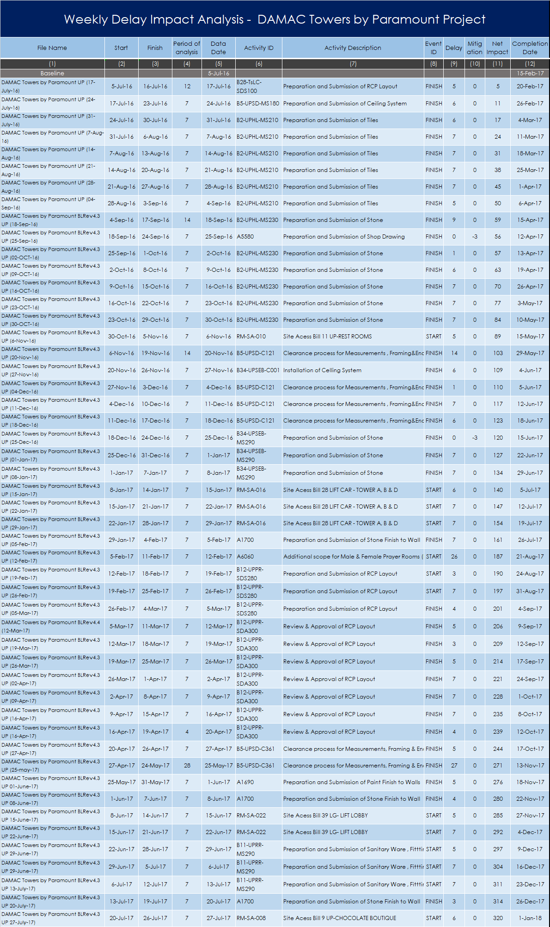
Table 1.1: List of programmes utilized
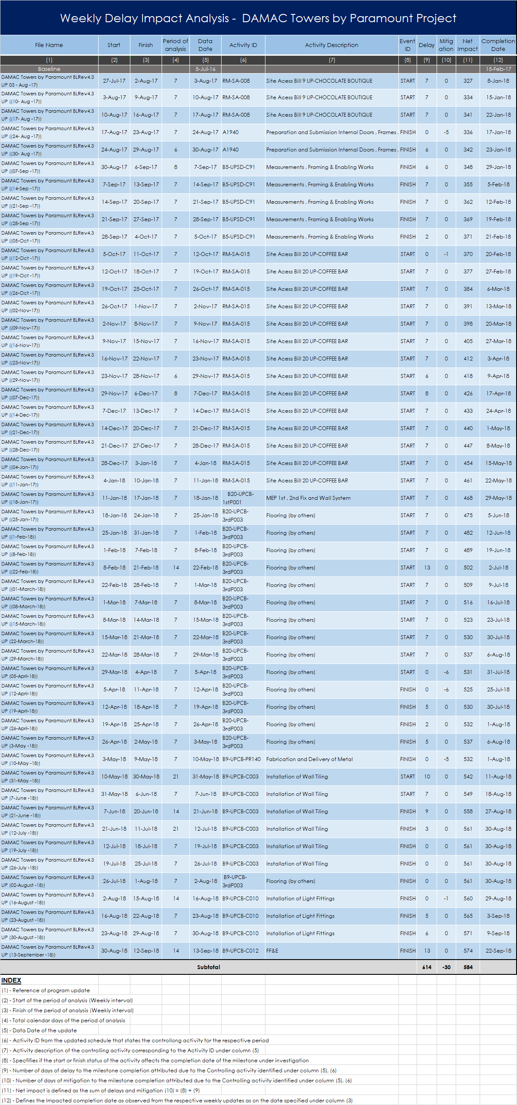

Programme Validation
1.2.6.1 For development of the analysis, the schedule files (presented in Table 1.1) are utilized As-is.
1.2.6.2 The following parameters are reviewed and rectified where applicable as per AACE -29R protocols:
- Open ends
- Construction Logic
- High Lag Values and Negative Lags
- Compliance to Contractual Completion Dates
- High Float Values
- Negative Floats
- Constraints
- Scope of Work
- Scheduling Options
- Actual Start / Finish Dates
1.2.6.3 The contemporaneous schedule updates have been validated assuming the actual dates contained in the As-Built programme (13 September 2018) are correct.
1.2.6.4 The changes in the schedule logic are considered while performing the analysis as the method implemented MIP3.3 is dynamic i.e. it considers the logic changes between the schedule updates.
1.2.6.5 Thus, the following section presents the specific observations and rectifications performed on the schedule to ensure consistent As-Built data:
Original Duration
Observation
The duration in the weekly updates fluctuated (increased/decreased) in the Claimant’s updates, as shown in Figure 1.
Rectification
The duration in the updates utilized has been maintained in line with the Baseline schedule Rev 04.3.
From Figure 1 to 2, the inconsistency in duration is noticed in each excerpt of the updated schedule prior to correction. The inconstancies and relevant rectifications are included in Appendix-OD.
The process of rectification is in line with the process instructed by AACE 29RP-03, and the rectification process was completed prior to the start of the analysis of the updated schedules files,

Figure 01: Excerpt from the Schedule prior to correction
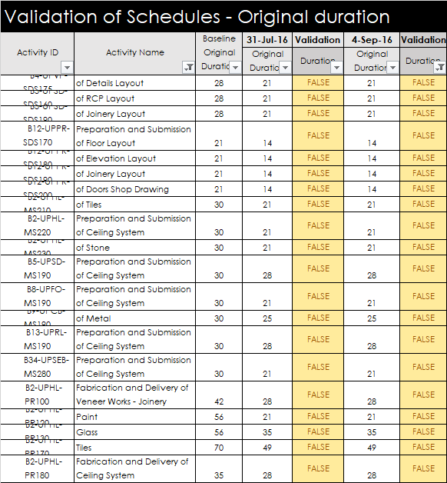
Figure 02: Excerpt from the Schedule prior to correction
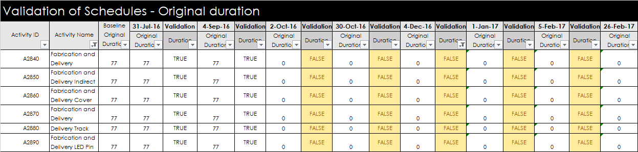
Actual Start/Finish dates
Observation:
Upon review of the weekly schedule files, I observed some inconsistencies in the Actual Start/ Finish Dates and Percent Completes of several activities, as shown in Figure 03. The inconstancies and associated rectifications have been included in Section 5 – Appendix
Figure 03: Excerpt from the Schedule prior to correction
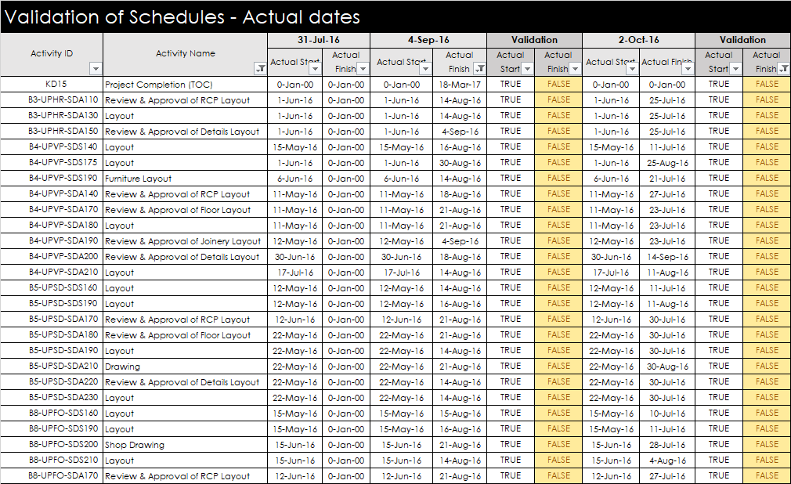
Rectification
Corrections to Actual Start / Finish dates have been made and maintained, in the subsequent updated schedules, based on review of the available contemporaneous records. In this case as well the process of rectification followed the AACE – 29RP-03 prior to the start of the analysis of the schedule files.

Milestone Analysis
1.2.7.1 The Contract Agreement between the Claimant and the Respondent stipulates one Main (1) Completion Milestone for the Project.
1.2.7.2 The Contract entitles the Respondent to levy Liquidated Damages (LD’s) should the Claimant fail to achieve the expected completion date, subject of course to any approved EOT entitlements.
Table 1.2.7.2: Milestone Analysis
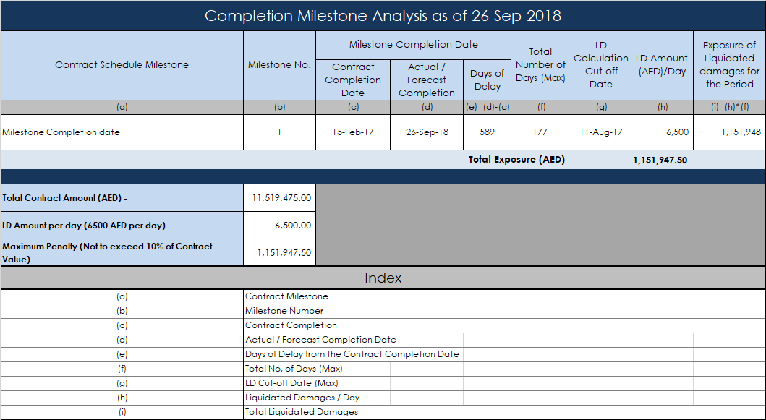
1.2.7.3 Table 1 1.2.7.2, shows that as of 28 September 2018, in absence of an Extension of Time for Completion, after 09 April 2017, the Claimant is exposed to full liquidated damage. As the Maximum cap of LDs on the Claimant’s Contract is reached on one hundred and seventy-seven (177) days as shown on column (f), which far exceeds the total delays of five hundred and eighty-nine (589) days encountered in the project as of the completion date (26 September 2018) considering Completion Date 15-Feb-17, or five hundred and thirty-five (535) days considering Completion Date 09-Apr-17 after the Award received by the Respondent after the Main Contract Arbitration Case.
1.2.7.4 As of the last day of the Project (26 September 2018) no Extension of Time has been awarded to the Claimant, irrespective of the September 2017 submission for EoT by the Claimant which was responded (October 2018) after the project Completion Date (26. September 2018). The Respondent awarded an Extension of time to the Claimant after the Main Contract Arbitration Partial Award was issued, moving the Contract Completion Date for the Subcontract from 15 February 2017 to 9 April 2017. However, this extension of time is not sufficient to change the fact of full exposure to Liquidated Damages for the Claimants Contract.

Variations
In this section, I reviewed the list of variations provided by the Claimant and presented the Table with the summary of the variations. For a better view the Table is attached Section 5 - Appendices
Table 1.2.8A Variations Log
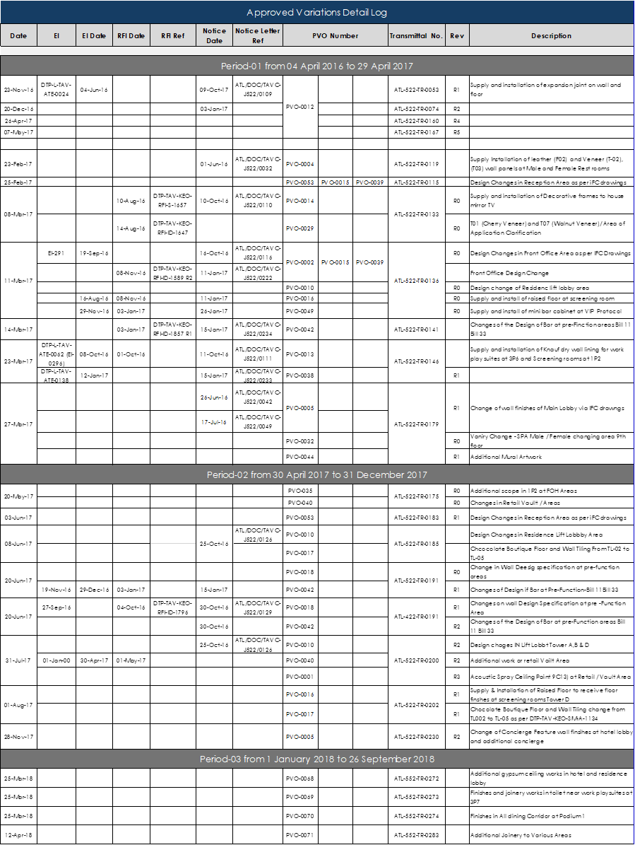
Table 1.2.8B Variations Log
Further details on the variations are provided in the Quantum Expert Report, as my approach is limited to correlate to the extent possible the variations to the identified by the analysis delay events.
Table 1.2.8C Variations Log
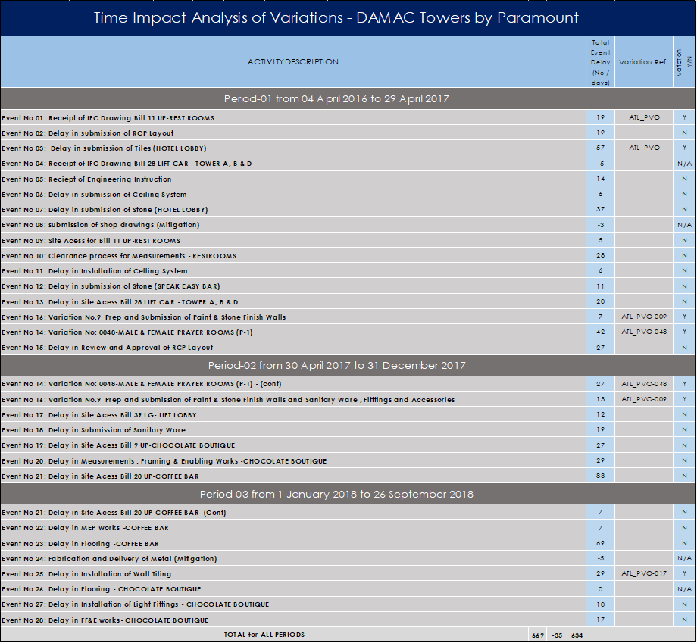
Based on the delay analysis and the identified controlling activities (on the critical path and driving the delay, I have correlated the variations to the controlling activities. As per review of Table 1.2.8C I listed the correlated variations with the identified delay events, and I observe the following:

Breakdown of Variations Time impact by Period of analysis

Period 1: From 4 April 2016 to 29 April 2017
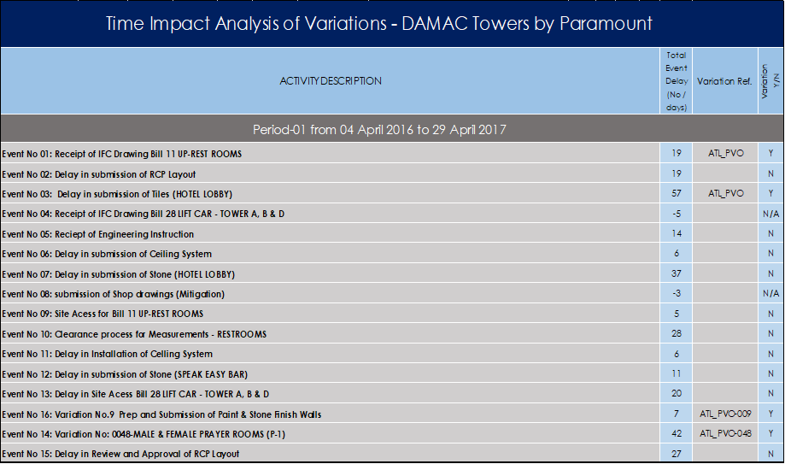
Duration: 390-day Time Impact: 125-day Pct: 32%
This period is marked by a number of scope changes instructed by the Respondent to the Claimant and had a substantial impact on my analysis.

Period 2: From 30 April 2017 to 31 December 2017
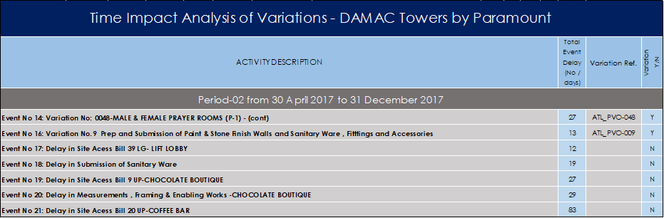
Duration: 245 days Time impact: 40 days Pct: 16%
This period is marked as the most critical regarding the delays by both Experts, and the delays incurred during this period (245 days) have been utilized by the Respondent in their entity against the Claimant. I stretch that only the delays of this period have been utilized by the Respondent against the Claimant.
Only sixteen (16%) percent of the total incurred delays during this period are attributed to variations.

Period 3: From 1 January 2018 to 26 September 2018
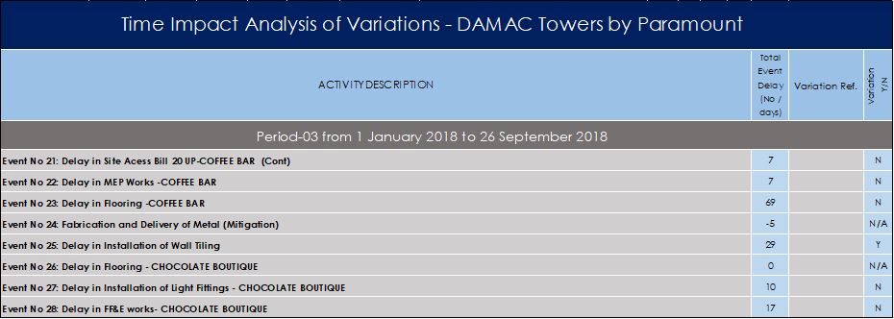
Duration: 268-day Time impact: 29-day Pct: 11%
Only eleven (11%) percent of the total delays incurred during this period are attributed to variations.

Approved Time impact for Variations
Based on the review of the received documents and from interviews conducted with the Claimants staff, I state that no time impact was awarded to Claimant for all approved or pending approval variations as of today.
Based on industry standards every variation shall be assessed by both parties for time and cost impact. The assessment shall be made from the time of identification of a variation until the time of completion of the works the variation consists of, to realize the full-time impact of the variation (if any).
From my review of documents, I have not encountered document addressing request for extension of time due to a variation. Thus, one of my tasks would be to correlate the identified by the analysis delay events with the variations, to assess if any event is related to an approved variation.

Findings of Delay Analysis

1.2.9.1 I conducted the analysis utilizing the available sources (schedule updates - electronic files) provided to me by the Claimant. The method of analysis implemented is based on a retrospective approach as described in detail in Section 1.3.5 (analysing the actual data).

1.2.9.2 The method produces concrete results regarding concurrency, as it is based on analysis of the most critical path events, impacting the Project Completion Milestone. The results of the analysis are presented below in timely order (from Start of the Project to the cut-off date (26 Sep 2018)).

Basic Results

1.2.10.1 Table 2 & 3 indicate in chronological sequence the activities that controlled and impacted the milestone completion date. A controlling activity is one that lies on the most critical path and whose failure to either start or complete in the planned time is controlling the completion of the Milestone under investigation (i.e. lies on the longest Path).
File Name: The unique identification ref of the contemporaneous schedule update
Start: The start date of the period of analysis (window start)
Finish: The finish date of the period of analysis (window finish)
Period of Analysis The number of days per period of analysis
Activity ID: The unique identifier of the controlling activity from the programme file
Description: Detailed Description of the controlling activity as described in the programme

Event ID: Indicates if the activity initiation (Start) or completion (Finish) is controlling
Completion Date: The Forecast Completion date observed per period in the updated schedules
Delay: The delay impact in days to the zone completion milestone for the period
Mitigation: The mitigation impact in days to the zone completion milestone for the period

Net Impact: Represents the net effect of impact (delay/mitigation) to the completion milestone. A negative figure represents a commensurate retraction of the completion date (mitigation) whereas a positive figure represents a commensurate delay of the completion date (delay).

Table 2: Weekly Analysis Findings from 04 April 2016 to 26 September 2018

Table 3 (cont.).: Weekly Analysis Findings from 04 April 2016 to 26 September 2018
Table 4: Analysis of Findings by Period/Date based on the controlling (critical Path) activities (1 to 13)

Table 4 (cont.): Analysis of Findings by Period/Date based on the controlling (critical Path) activities (1 to 13)
Table 5: Analysis of Findings by Event based on the controlling (critical Path) activities (1 to 13)
Table 5 (cont.): Analysis of Findings by Event based on the controlling (critical Path) activities (1 to 13)

1.2.10.2 Table 5 presents the findings of analysis for the period from 04 April 2016 to 28 September 2018. I noted that the forecast completion date as of 26 September 2018 is 11 November 2018. However, the Request for Entitlement to Extension of Time cannot be analyzed cannot exceed the Substantial Completion date of 26 September 2018 when TOC was issued to the Claimant.
1.2.10.3 The negative figures (-3, -3, -5,-1, -6,-6 and -1) in total (-35) days shown on column (11) in Tables 5 represent the mitigation achieved in the project and is attributed to either an increase in productivity, or change in schedule logics or out of sequence Works during these periods.
1.2.10.4 A review of the available records shall be undertaken to establish the potential correlation between the identified events and ones submitted by the Claimant to establish the extent of entitlement to Extension of Time for Completion.
1.2.10.5 The precise number of days between 15 February 2017 (Project Completion Date based on approved Schedule 4.3) and the 26 September 2018 (TOC) date, is five hundred and eighty-eight (588) days. The analysis however has taken into consideration the first part of the project (04 April to 5 July 2016) when the completion date was on 29 December 2016, and that is the reason the net number of delay days increased by forty-six (46) days, (634-588), to six hundred and thirty-four days.

Detailed Analysis for the entire project: Start 04 April 2016 to 26 September 2018

Step 1: Analysis from 04 April 2016 to 30 April 2017
This period covers the start of the project and includes the following major milestones
- Initial completion of the project prior to added scope – 16 September 2016
- 1st Revised completion of the project based on some scope – 29 December 2016
- Contract Completion based on the finalized scope as of 27 August 2017 – 15 February 2017
- Extended Completion as per the Partial Final Award of the Main Contract – 9 April 2017
The Findings of the analysis have been divided into three steps to identify the extent of delays during the specified time periods, while at the same time validate the findings of the two Experts in the analyses produced for the Main contract arbitration case.
Table 1.2.11.1 A Findings of analysis by Period/Date – Controlling activities (critical path)
Table 1.2.11.1B Findings of analysis by Period/Event/Impact – Controlling activities (critical path)
Summary:
Table 1.2.11.1 A, above presents the analysis findings for the weekly updates from 04 April 2016 to 30 April 2017 of the Claimant’s schedule files. The Table presents the controlling (critical path) activities that appear with the associated time impact for each period presented on each separate line.

Table 1.2.11.1 B presents the delay events per period consolidated by the activity description and by the total impact of days to the Milestone Completion Date.
This First period of the project is marked by several scope changes of the Claimant’s original scope of work, which by 27 August 2016 reached 13.8M from the initial 11M. In line with the finalized at the end of August 2016 scope the Claimant prepared and submitted the Baseline schedule with Completion Date 15 February 2017 which was approved by the Respondent by 19 September 2017.

During this period the cumulative net delays amounted to two hundred and ninety (290) days net, over three hundred and ninety (390) days of work. As per analysis the following events have been identified:

- Receipt of IFC Drawing Bill UP Rest rooms………………………………………………………………. 19 days
- Submission of RCP Layout…………………………………………………………………………………… 19 days
- Submission of Tiles – Hotel Lobby…………………………………………………………………………… 57 days
- Receipt of Engineering instructions………………………………………………………………………… 14 days
- Submission of ceiling system …………………………………………………………………………………. 6 days
- Submission of Stone -Hotel Lobby…………………………………………………………………………… 37 days
- Site Access for Bill 11 -Restrooms……………………………………………………………………………… 5 days
- Clearance process for measurements…………………………………………………………………… 28 days
- Installation of ceiling system ……………………………………………………………………………………6 days
- Submission of stone (Speak Easy Bar)……………………………………………………………………… 11 days
- Site Access for Bill 28 Lift Car = Tower A, B & D……………………………………………………………20 days
- Variation No.09 - Submission of Stone Finish to wall………………………………………………………7 days
- Variation No. 048 – Male & Female Prayer Room (P-1)…………………………………………………42 days
- Review and Approval pf RCP Layout – Male & Female Prayer Rooms-P1…………………………27 days
Based on the findings, in this first period, the productivity from 04 April 2016 to 30 April 2017 or in three hundred and ninety (390) days did not exceed thirty-eight (38) percent.
Duration: 390 Days
04 April 2017 - Forecast Completion: 15-Feb 2017
30 April 2017 Forecast Completion: 17 October 2017
Loss of 290 days over a period of 390 days Productivity 26%
Loss of 244 days over a period of 390 days Productivity 38%

The fact that the Claimant and the Respondent negotiated an increase of the scope by almost 50% from June until the end of August 2016 changed the facts of productivity during this period.
Initially the scope was approximately 11M and after several additions and deletions, the scope increased by almost 5M or 50%,, and after further negotiations the parties finally agreed to almost 4M, with a completion date of 15 February 2017., for which are baseline schedule was approved.

Step 2: Analysis from 01 May 2017 to 31 December 2017
This period covers the start of the low productivity period for the project activities as agreed by the two Experts in the Main Contract Arbitration Case, and as considered by the Respondent in its calculations involved on the Supplemental Defense and Counterclaim (March 24), based on the Partial Final Award on the Main Contract Arbitration case with the Employer. The Findings of analysis have been divided in three steps to identify the extend of delays during the specified periods, and same time validate the findings of the two Experts, in the analyses produced for the Main contract arbitration case.
Table 1.2.11.2A Findings of analysis by Period/Date – Controlling activities (critical path)

Table 1.2.11.2B Findings of analysis listed /Event/Date/Impact – Controlling activities (critical path)

Summary:
Based on the findings of the analysis presented above the productivity reached twelve (12) percent, during the period from 01 May 2017 to 31 December 207 or in a period of two hundred and forty-five (245) days the project lost two hundred and fifteen (215) days or seven (7) months.
The analysis of the Claimants schedule reveals a delay of two hundred and sixteen (216) days and a recovery of six (-6) days. Thus a net time impact during this period of two hundred and ten (210) days, close to the 215 identified by the experts.

As per the findings of analysis the following events have been identified:

- Variation No.48 Male and Female prater rooms 27 27 days
- Variation No.9: Prep / submit Paint, Stone finish walls, Int Drs, Frames, Ironmgry &Hardware 13 days
- Site Access Bill 39 LG – Lift Lobby 12 days
- Submission of sanitary ware, fittings and Accessories 19 days
- Site Access Bill 9 UP-Chocolate Boutique 27 days
- Measurements, Framing & Enabling works 29 days
- Site Access Bill 20 UP-Coffee Bar 83 days

Duration: 245 Days
01 May 2017 - Forecast Completion: 17 October 2017
31 December 2017 – Forecast Completion – 20 May 2018
Loss of 210 days over a period of 245 days Productivity 12%

Step 3: Analysis from 01 January 2018 to 26 September 2018
This period covers the resumption of regular productivity in the project after the MEP Final Fix was almost complete by the end of December 2017, until the Substantial Completion of the works both for the Main Contract and Subcontract has been reached and the TOC was issued in accordance with the Contract requirements on 26 September 2018.
The Findings of analysis have been subdivided into three steps to identify the extend of the delays during the specified time periods, and at the same time validate the findings of the two Experts in the analyses produced in the Main contract arbitration case.

Table 1.2.11.3A Findings of analysis by Period/Date – Controlling activities (critical path)
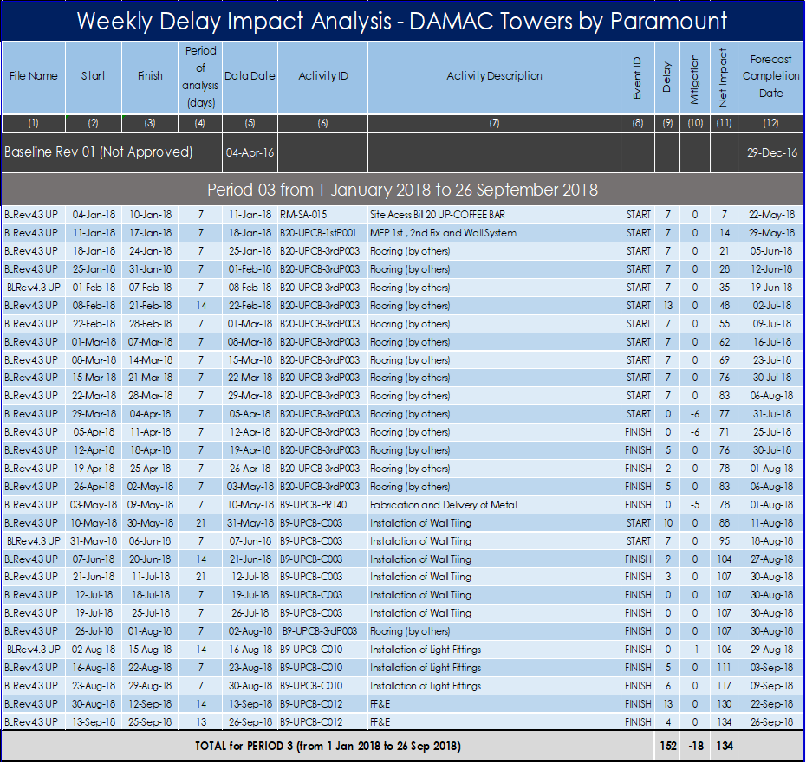

Table 1.2.11.3B Findings of analysis by Event/ Date /Impact – Controlling activities (critical path)
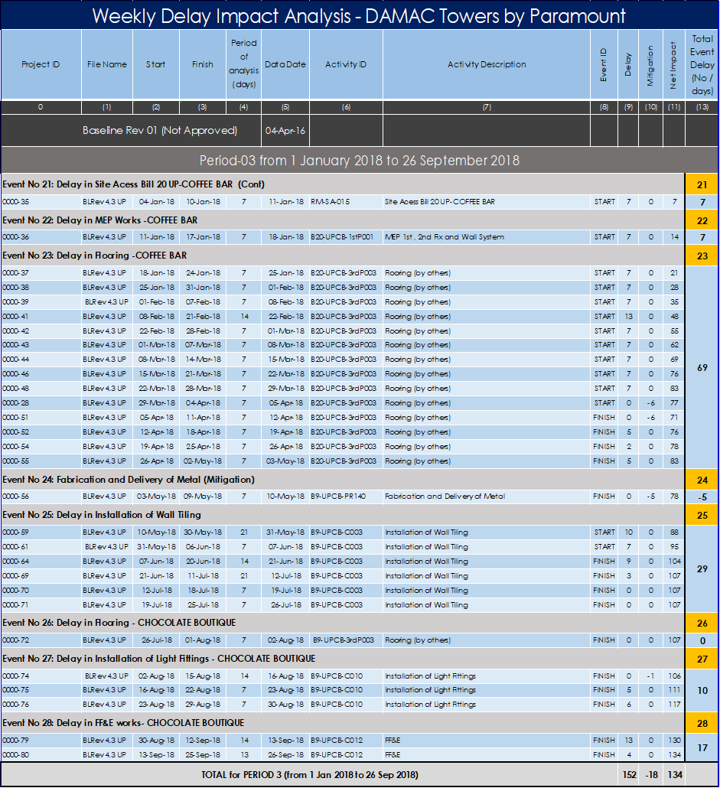

Summaries:
The analysis during this period reveals that the delays during this period have been minimized to one hundred and thirty-four (134) days net until the Main Contract TOC date (26 September 2018).
Based on the findings of the analysis presented above the productivity reached fifty-four (54%) percent, during the period from 1 January to 26 September 2018
As per the findings of analysis the following events have been identified:

- Site Access Bill 20 UP-Coffee Bar 7 days
- MEP works – Coffee Bar 7 days
- Flooring - Coffee Bar 69 days
- Installation of wall tiling 29 days
- Installation of lighting fittings – Chocolate Boutique 10 days
- FF & E works – Chocolate Boutique 17 days

Duration: 268 Days
01 January 2018 Forecast Completion: 22 May 2018
26 September 2018 Main Contract TOC Date - Completed
Loss of 134 days over a period of 268 days Productivity 54%

Correlation of the analysis findings
The Correlation process aims to link the delay events identified by the analysis with the ones the Claimant has notified as critical and / or has claimed in his extension of time submission as controlling the delays in the project.
The Correlation of documents with the events shall assist in the analysis, to relate the delayed events previously notified by the Claimant as critical and review the contemporaneous documents regarding these events, to follow the sequence of events and justify or not the delays incurred and appropriate entitlement to extension of time.
I compiled the contemporaneous documents related to the events as part of my discovery process and developed tables of these for all correlated events further down in my report.
Thus, under this step, I consolidated the following:
- The controlling (critical path) activities and associated delay events from the schedule files
- Correlate the delay events with the ones submitted by the Claimant through his particulars
- Correlate the Variations to the Delay events
- Quantify the time impact of the correlated delay events and assess the justified entitlement to extension of time, based on the above discovery process/
- Concurrency review analysis, to identify the excusable and compensable delays

Correlation of identified from the analysis Events with documents
1.2.13.1 Event No 01: Receipt of IFC Drawings Bill 11UP – Restrooms (04-Apr – 04-May-16) -19 days
Correlation:
The Claimant addressed the changes to the Respondent with letter Ref. ATL/DOC/TAVC-J522/0007 dated 13 April 2016, which superimposed new layout atop of the ones extracted from the original design. The letter refers to the IFC drawings for the blockwork which were subjected to modifications on Podium Levels received via transmittal DTP-T-TAV-ATE-0003 dated 7 April 20016, as well as the kick off meeting received via DTP-T-ATE-0004 dated 9 April 2016. The blockwork layouts received were different than that of the design Drawings, affecting the scope of work. The Claimant submitted its study for the changes, superimposing new work layouts atop the ones extracted from original design drawings. The Respondent was requested to submit a full package of issued for construction drawings inclusive drawings revision log, elevations, layouts. Reflected ceiling plans, etc., and advice the Claimant to the recommended course of action on the subject.
Another Notification on this delay event can be found in letter ATL/DOC/TAVC-J522/00077 dated 08 September 2016, where the Claimant noted that the delay in receipt of IFC drawings (Appendix I) caused as they called “massive delays” to the project.
Assessment:
As I correlated the event with documents of variations and changes in the original scope for the Claimant and considered the time impact of this event attributed to the Respondent, as he has been notified on several occasions due to changes on the layout instructed by the Engineer / Respondent. Thus, the Claimant shall be entitled to an Extension of Time for the entire period (19 days) of impact.

1.2.13.2 Event No 02: Submission of RCP layout (05-May-16- 04-Mar-17) -19 days
Correlation:
On 13 April 2016 the Claimant submitted letter Ref. ATL/DOC/TAVC-J522/0007, the same letter that was addressed on Event No 01. The letter referred to the Claimants request to the Respondent to submit the changes on the Reflected Ceiling Panel (RCP). The activity on the critical path during this period was the RCP layout submission.
In further research of documents for this extended period from March 2016 to May 2017, I identified letter Ref, ATL./DOC/TAVC-J22/0169 dated 28 November 2016, the Claimant makes notice of the delay in RCP Layout, event at this late date, attributed to the incomplete MEP works, which did not allow finalization of the RCP layout.
Thus, the extensive delays appearing for over a year. The letter contains details of all the MEP incomplete works which infringe in the finalization of the RCP layout submission and approvals as the clearances were not finalized due to the MEP works. Several other related notices of delays have been identified and listed below. The Engineer commented that the Claimants work was of slow rate, however as I can see from the schedule of works the relationships in the schedule activities of the Claimant were related to the ones of the MEP 1st and 2nd Fix which were slow as well. The Interior fit-out works always follows the completion of the MEP 1st and 2nd Fix to my knowledge. It is also apparent from my review of the MOM dated 06 November 2016, that the Engineer was instructing changes while the MEP 1st and 2nd fix was ongoing and RFIs regarding the ceiling height were finalized at the last minute. An Email from Mr. Rajinder addressed to Mr. Cem Aricioglu dated 13 November 2016, was sent to request MEP drawings to update the RCP layouts. The email was marked URGENT, and was listing eight areas on the project where the MEP has not been finalized. Similar emails were sent on 3 November 2016 requesting additional information to finalize the RCP layout.
On 19 November 2016, letter Ref ATL-DOC_TAVC-J522-0152 was sent by the Claimant, requesting urgent reply to RCP layouts.
Assessment:
Based on the review a correlation of the documents and the schedule activities with the identified event, I attributed the time impact during this period to the Respondent. Thus, the Claimant shall be entitled to an Extension of Time for the entire period (19 days) of impact.

Additional information covering this Event I found based on my review of the following documents:
ATL-DOC-TAV-J522-0308 dated 05 April 2017 - Notice of delay
DTP-L-TAV-ATE-0100 dated 26 November 2016 – Notice of Delay – FOH Interiors Fit-out works
6197-CM-KEO-TAV-LT-MZ-2928 dated 24 November 2016 – Slow Rate of progress-FOH interior Fit-out
ATL/DOC/TAVC-J522/0139 dated 3 November 2016 – Upper ground Commented RCP Layout
DTP-TAV-KEO-SD-A-2681 dated 31 October 2016
ATL/DOC/TAVC-J522/0117 dated 16 October 2016 – Workspace Handover-Tower A, B, C Level UG Hotel, Hotel Lift Lobby & Residence Lobby
DTP-T-TAV-ATE-0189 dated 13 October 2016 – Document / Drawing Transmittal
WHF-TAV-ATE-013 dated 12 October 2016 – Workspace handover

1.2.13.3 Event No 03: Submission of Tiles Hotel Lobby (12-May-03-Sep-16) -57 days
Correlation:
On 11 May 2016 the Respondent sent transmittal No. DTP-T-TAV-ATE-0024 instructing the Claimant of the Design change in the Hotel Lobby area, which resulted later on change of materials for the walls.
On 15 May 2016 the Claimant sent t letter ref. ATL/DOC/TAVC-J522/0022 – Notice of Delay Exceeding 14 days Contractual Period for shop drawings review. Within this letter the Claimant on Appendix 5 -Delay Events included Delay Event No. 01 – Design Freeze & Receipt of IFC Drawings Bill 2 -Up Hotel Lobby as Closed. The Delay recorded in the case of the Design in the Hotel Lobby was one hundred and seventeen (-117) days and the relevant attachment was again transmittal No. DTP-T-TAV-ATE-0024.
On 22 May 2016 the Claimant sent letter ref. ATL/DOC/TAVC-J522/0026, regarding the continuous delays incurred in Design Freeze & Receipt of IFC Drawings for all areas that exceeded by one hundred and twenty-eight (-128 days). In addition, the letter state that there was delays in site access of all areas by one hundred and nineteen days. This letter was served as a Notice according to Clause 11.1.
On 2 June 2016 the Claimant send a delay notice via letter Ref. ATL/DOC/TAVC-J522/0034 to the Respondent regarding the delays in reviewing the submitted materials for the Hotel Lobby.
On 26 June 2016 the Claimant send a Notice of Variation for the Min Lobby with letter Ref. ATL/DOC/TAVC-J522/0042 to the Respondent. In the letter the Claimant made notice of the Design Changes of Mosaic Tiles (TL01) (ME01) to Embossed leather tile (F67&F68) with metal skirting (ME02) and material changes on the Concierge walls. The Claimant noticed that this letter was served as notification for variation in accordance to Clause 11.1 and for the purposes of Clause 10.2 of the Contract conditions of the subcontract. The letter had several drawings attached to it.
On 2 July 2016 the Respondent replied with letter of 26 June 2016, with letter Ref. DTP-L-TAV-ATE-0032 requesting the Claimant to provide a transmittal reference for any Notice of the Transmittal.
On 17 July 2016 the Claimant made Notice of the Respondent’s request, dated 2 July 2016, with letter Ref. ATL/DOC/TAVC-J522-0049 and in compliance with the Respondent’s request and made notice that the relevant Transmittal in this case was DTP-L-TAV-ATE-0024 dated 11 May 2016.
On 03 October 2016 the Engineer through Material transmittal Ref No. DTP-ATE-TAV-MD-0319 the response to the received material sample, sent on 29-Sep-16 by the Claimant,
Assessment:
The entire delay for this Event is attributed to the change in Design of the Hotel Lobby and change in materials to be installed on the walls of the area. I consider that that these changes govern the entire period of delay and attributed the fifty-seven (57) days of time impact to the Respondent. Thus, the Claimant shall be entitled to an Extension of Time for the entire period (57 days) of impact.
1.2.13.4 Event No 04: Receipt of IFC Drw Bill 28 UP – Lift Car Twr A, B & D (9-15Jun-16) 5 days
Correlation: MITIGATION – NO FURTHER IVESTIGATION
1.2.13.5 Event No 05: Receipt of Engineering instructions (16-Jun- 29-Jun-16) -14 days
Correlation:
On 30 June 2016 the Respondent send a letter Ref. DTP-L-TAV-ATE-0030, regarding scope changes. I recall that this period (May – August 2016) numerous changes of scope were instructed by the Respondent and the Engineer to the Claimant. In addition, letter 6197-CM-KEO-TAV-LT-GR-2083 dated 23 June 2016 describes in detail these changes. The receipt of the Engineer instructions on 23 June 20126 coincides with the start of the delay activity on the critical path generating a slow progress on the activities as the quantities and areas of work as well as the quality of materials required based on the new requirements was evaluated by the Claimant. The increase by fifty (50%) percent of the scope of work required a revaluation of the plan for the entire project.
Assessment:
Since this Event is a change in condition to the scope, and its time impact was never investigated I consider this as a justified delay, and its entire time impact (14 days) was attributed to the Respondent. Thus, the Claimant is entitled to Extension of Time for the entire period (14 days) of impact.

1.2.13.6 Event No 06: Delay in submission of ceiling system (17-Jul – 23-Jul-16) -6 days
Correlation:
On 13 April 2016 the Claimant submitted letter Ref. ATL/DOC/TAVC-J522/0007, the same letter that was addressed on Event No 01. The letter referred to the Claimants request to the Respondent to submit the changes on the Reflected Ceiling Panel (RCP) and Ceiling system.
On 8 September 2016 the Claimant submitted letter Ref. ATL/DOC/TAVC-J522/0077ATL/DOC/TAVC-J522.0077, and under Procurement Status the Claimant made notice regarding the delay in the Ceiling System. The delay in finalization of the Ceiling system final requirements, delayed the Claimants submission of the Ceiling System Purchase Order.
Assessment:
As the continuous changes in design caused passed delays to the placement of POs by the Claimant, I have correlated this event through the documents pointing to the Respondents fault. Thus, the Claimant shall be entitled to an Extension of Time for the entire period (6 days) of impact.
Additional information covering this Event are included in the following documents:
DTP-T-TAV-ATE-0003 dated 7 April 2016 and DTP-T-TAV-ATE-0004 – Minutes of Meeting dated 9 April 2016
1.2.13.7 Event No 07: Delay in submission Stone – Hotel Lobby– (04-Sep –29-Oct-16)-37 days
Correlation:
On 4 October 2016 the Claimant with letter Ref. ATL/DOC/TAVC-J522/0106, Requested clarification on the general specifications, as these were not provided during the Tender Stage, which included the Stone for the Hotel Lobby.
On 8 December 2016 the Claimant requested, with letter Ref. ATL-DOC-TAVC-J522-0179, from the Respondent the Control Samples, for the Hotel Lobby and other areas.
On 18 December 2016 the Claimant with letter Ref. ATL-DOC-TAVC-J522-0189 submitted the material & sample which were over-due. As the Claimant stated that due to the delay by the Engineer to provide approval including the stone for the Hotel Lobby, the activity was delayed.
The activity stopped being critical upon approval of the material.
Assessment:
As I correlated the documents with the delay event and noticed the delay in response by the Engineer, I thus have considered the entire delay (37) as an entitlement for delay by the Claimant. Thus, the Claimant shall be entitled to an Extension of Time for the entire period (37 days) of impact.

1.2.13.8 Event No 08: Submission of shop drawings (18-Sep- 24-Sep-16) 3 days
Description: MITIGATION – NO FURTHER INVESTIGATION

1.2.13.9 Event No 09: Delay in Site Access Bill 11 UP Restrooms (30-Oct – 05-Nov-17) -5 days
Description:
Based on the review of letter Ref. ATL/DOC/TAVC-1523/0113 dated 13 October 2016, I noted that the Claimant could not access the restrooms areas during this time due to the MEP and Civil works, as described in the notice of delay. The Claimant notified The Respondent that the action and progress on the activities would impact the project completion as these activities laid on the longest path at that time. I have correlated the delay event with documents pointing to the Respondent’s culpability.
Assessment:
As I correlated the documents with the delay event and noticed the site access was not allowed, I have attributed the entire relay to the Respondent who was responsible for coordination of the trades. Thus, the Claimant shall be entitled to an Extension of Time for the entire period (27) of impact.

1.2.13.10 Event No 10: Clearance for Measurement/Enable work(06-Nov–17 Dec-17)-28 day
Correlation:
On 28 November 2016 the Claimant sent to the Respondent letter Ref. ATL/DOC/TAVC-J522/0169 – Notice of delay FOH Interiors Fit-out works, stating within that the delay and current absence of approvals for the area Bill 5UP -Safe Deposit, did not allow the Claimant to progress his works,
The Claimant was unable to perform the tasks as per the letter due to the slow approval process and due to the delay in site access, while the MEP works were ongoing.
Assessment:
As I correlated the event with documents justifying the delay, pointing to the Respondent’s risk. I thus have attributed the entire time impact as an entitlement for extension of time for the Claimant. Thus, the Claimant shall be entitled to an Extension of Time for the entire period (28 days) of impact.
Additional information covering this Event are included in the following document:
6197/CM-KEO-TAV-LT-MZ-2928 dated 24 November 2016 – Slow progress -FOH Interior Fit-out works

1.2.13.11 Event No 11: Delay in installation of Ceiling System (20-Nov-26-Nov-16) -6 days
Correlation:
On 28 November 2017 the Claimant submitted letter Ref ATL/DOC/TAVC-J522/0169- Notice of delay. However, this area was not one of the contested by the Claimant areas due to some reason. I also reviewed the Engineer’s letter 6197/CM-KEO-TAV-LT-MZ-2928 dated 24 November 2016 where the area was listed as one amongst others with slow progress.
Assessment
As I correlated the event with documents justifying the delay, pointing to the Respondent’s culpability. Thus, the Claimant shall be entitled to an Extension of Time for the entire period (6 days) of impact.
1.2.13.12 Event No 12: Submit of Stone – Speak Easy Bar (18-Dec-16-07-Jan-17) -11 days
Correlation:
On 4 October 2016 the Claimant with letter Ref. ATL/DOC/TAVC-J522/0106, Requested clarification on the general specifications, as these were not provided during the Tender Stage, which included the Stone for the Speak Easy Bar.
On 8 December 2016 the Claimant requested, with letter Ref. ATL-DOC-TAVC-J522-0179, from the Respondent the Control Samples, in particular for the Speak Easy Bar was sample TL-04.
On 18 December 2016 the Claimant with letter Ref. ATL-DOC-TAVC-J522-0189 submitted the material & sample which were over-due. As the Claimant stated that due to the delay by the Engineer to provide approval including the stone for the Speak Easy Bar, the activity was delayed.
The activity stopped being critical upon approval of the material.
Assessment
As I correlated the documents with the delay event and noticed the delay in response by the Engineer, and thus I have considered the entitlement for the time impact to the Claimant. Thus, the Claimant shall be entitled to an Extension of Time for the entire period (11 days) of impact.

1.2.13.13 Event No 13: Site Access Bill 28 Lift Car Tower A, B & D (08-Jan-28-Jan-17) -20 days
Correlation:
1st Site Access Notice of delay issued on 13 October 2016 via letter Ref. ATL/DOC/TAVC-J522/0113
2nd Site Access Notice of delay issued on 18 December 2016 letter Ref. ATL-DOC-TAVC-J522-0188
3rd Site Access Notice of delay issued on 3 January 2017 via letter Ref. ATL-DOC-TAVC-J522-0209, where this time the Claimant addressed the issue of Site Clearance and requested Time Extension. The Claimant reported in his letter that until that date they have not received clearances to carry-out works as per the planned baseline programme. For that they have attached the Clearance Log which proves that the dates have been breached, for wall and ceiling installation. On 13 February 2-17 and via letter Ref ATL-DOC-TAVC-J522-0279, the Claimant notices that the lift cabin has been handed over on 25 January 2017.
Assessment
As I correlated this event with notices by the Claimant and thus, as the receipt of the lift cabin was completed on 25 January 2017, I justified seventeen (17) days, out of the total of twenty (20) days of impact identified during this period, as I could not justify entitlement beyond the 25 January 2017 (date of identified correspondence that resolves the issue). Thus, the Claimant shall be entitled to an Extension of Time for part of the impact period (17).

1.2.13.14 Event No 14: Var No. 48 Male & Fem prayer Rooms (P1) – (5-Feb –24-May-17)-69d
Correlation:
In a review of the Respondent’s Transmittal DTP-ATL-TAV-RFI-S-0211 dated 23 January 2017, I realize that a variation (VO-048) was issued for the M/F Prayer rooms and there were several clarification letters issued regarding the scope throughout the period of time impact as per the delay analysis.
Additionally, on 05 April 2017 the Claimant with letter Ref. ATL-DOC-TAVC-J522-0308 notified the Respondent of delay in issuance of shop drawings for the Male Prayer Rooms @ P1 floor, and the Claimant stated that they are not held responsible for the delay of 150 days which was due to the delay in review and approval of the shop drawings by the Respondent.
The review of the schedules revealed that due to logic changes attributed to the variation 48 instructed in February 2017 the impact of this variation was reflected on the week 5 to 11 February as 26 days.
Assessment
I correlated this event with several documents that point to a variation, and I attributed the delay to the Respondent. I consider that the Claimant is entitled to the entire periods time impact (69 days) as the change in condition placed the activities related to this event in the critical path on the schedule.
Additional information covering this Event are included in the following documents:
ATL/DOC/TAVC-J522/-146 dated 14 November 2016 – RCP Layouts
DTP-L-TAV-KEO-2833 dated 17 January 2017 - Clarification on scope gap at FOH Area
6197-CM-KEO-TAV-LT-AB-3198 dated 24 January 2017 – Clarification on scope gap at FOH Area
ATL-DOC-TAVC-J522-0247 dated 25 January 2017 – Notice of Variation No 048 0 PR additional scope
WHP-TAV-ATE-024 dated 29 January 2017 – Workspace handover

1.2.13.15 Event No 15: Review and approval of RCP layout (05-Mar-08-Apr-17) -27 days
Correlation
The issue of delay in approval of RCP layout, as the approval of the drawings was substantially delayed from the start of the works. On 28 November 2016 the Claimant addressed the issue via letter Ref. ATL/DOC/TAVC-J522/0169, where he stated that due to the absence of approvals of RCP drawings which is not related to the Claimant, we experience slow progress, and listed several areas where the work could not proceed according to plan.
Assessment
I correlated this event with notices of delay submitted by the Claimant and consider the entirely of the time impact period against the Respondent. Thus, the Claimant is entitled to an extension of time for the entire time impact (27 days) attributed to this event. Additional information covering this Event are included in the following document:
ATL/DOC/TAVC-J522/0146 dated 14 November 2016 – RCP layouts
1.2.13.16 Event No 16: Var.9 Sub Sone & Int Dr, Frames, Iron Hrdw(25-May-29-Aug-17-20 days
Correlation:
On 30 June 2016 the Respondent send a letter Ref. DTP-L-TAV-ATE-0030, regarding scope changes. I recall that this period (May – August 2016) numerous changes of scope were instructed by the Respondent and the Engineer to the Claimant. In addition, letter 6197-CM-KEO-TAV-LT-GR-2083 dated 23 June 2016 describes in detail these changes. The receipt of the Engineer instructions on 23 June 20126 coincides with the start of the delay activity on the critical path generating a slow progress on the activities as the quantities and areas of work as well as the quality of materials required based on the new requirements was evaluated by the Claimant. The increase by fifty (50%) percent of the scope of work required a revaluation of the plan for the entire project.
Assessment
Since this event constitute a change in condition to the original scope of work of the Claimant, I considered the time impact caused by this event, as a justified delay for entitlement to Extension of time by the Claimant for the entire period of impact (20days).

1.2.13.17 Event No 17: Site Access Bill 39 LG – Lift Lobby (08-Jun – 21-Jun-17)-12 days
Correlation:
On 18 January 2018 the Claimant via letter Ref. ATL-DOC-TAVC-J522-0411, referred to the late site clearance for the Guest Lift Lobby for the Lower Ground. As stated in the letter the clearances for these areas have not yet been received as the date of this letter. The issue persisted as other contractors were working in the area at access could not be granted to the Claimant.
On 11 February 2018 the Claimant via letter Ref. ATL-DOC-TAVC-J522-0419 sent another notice of delay for Site Access for Lower Guest Lobby
On 30 August 2018, the Claimant submitted the Monthly Progress Report, which records the delay in access for the Claimant to the Lift Lobby area 465 days behind the planned date. The Claimant commented that still until that date there was no access to the lift lobby area due to other works.
Assessment:
As I correlated the event with delay notices issued by the Claimant, I have attributed the time impact to the Respondent as no action plan was undertaken to mitigate the delays caused by others. Thus, the Claimant is entitlement to Extension of time of twelve (12) days.

1.2.13.18 Event No 18: Submission of Sanitary ware (22-Jun-12-Jul-17) -19 days
Correlation:
On 8 January 2018 the Claimant send a Delay Notice Ref. ATL-DOC-TAVC-J522-411, to the Respondent regarding the continuous delays of several items including the Sanitaryware. The Claimant on his letter point out that they have completed their works and ready to install but the late deliveries have not allowed them to complete their works.
On 30 January 2018 the Claimant send another Delay Notice Ref. ATL-DOC-TAV-J522-0414, to the Respondent stating the excessive delay in receiving the Sanitary accessories for the male and female toilets to complete their work. Additionally, the MEP accessories for vanities had also not been provided five months after these appeared critical on the schedule.
Assessment
As the delay, throughout the period of impact, was attributed to the timely delivery of materials by others, the Respondent has not coordinated the timely delivery of these materials to the Subcontractor. I attributed the time impact to the Respondent. Thus, the Claimant should be entitled to an Extension of time for the entire time impact (19 days) of this event.
1.2.13.19 Event No 19: Site Access Bill 9 UP -Chocolate Boutique (20-Jul – 16-Aug-17) -27 days
Correlation:
On the weekly progress report No. 75 dated 29-November 2017, the Claimant in the Obstruction Report, attached photos of the ongoing Civil and MEP works did not allow other works to start in the area. As of the date of the report, while the planned date to get access to the Site was 22-May 2017, recording a delay of 178 days.
On 28 November 2016 the Claimant with letter Ref ATL/DOC/TAVC -J522/0160 sited the delays in access due to MEP ongoing works for Bill 9 at the Chocolate Boutique area. On 3 January 2017 the Claimant notified the Respondent of delayed Site Clearance via letter ATL-DOC-TAVC-J511-0209, the letter state that Bill 9UP – Chocolate Boutique was awaiting site access. As the Claimant could not get access to the site, he could not perform his work until 7 months later when the activity was on the critical path.
Assessment:
I correlated this event with notices of delay issued by the Claimant, and thus I attributed the time impact to the Respondent as no action plan was issued to mitigate the delays caused by others. Thus, the Claimant shall be entitled to an Extension of Time for the entire period (27days) of impact.
Additional information covering this Event are included in the following document: Monthly Progress Report 30-Aug-18, Section 14
1.2.13.20 Event No 20: Measurements-Framing & Enabling works (30-Aug - 04-Oct-17) -29 days
Correlation:
As stated on Event No .19, on the weekly progress report No. 75 dated 29-November 2017, the Claimant in the Obstruction Report, attached photos of the ongoing Civil and MEP works did not allow other works to start in the area. As of the date of the report, while the planned date to get access to the Site was 22-May 2017, recording a delay of 178 days.
On 28 November 2016 the Claimant with letter Ref ATL/DOC/TAVC -J522/0160 sited the delays in access due to MEP ongoing works for Bill 9 at the Chocolate Boutique area. On 3 January 2017 the Claimant notified the Respondent of delayed Site Clearance via letter ATL-DOC-TAVC-J511-0209, the letter state that Bill 9UP – Chocolate Boutique was awaiting site access to perform measurements and enabling works. As the Claimant could not access to the site he could not perform his work until later.
Assessment:
I correlated the event with notice of delays submitted by the Claimant and thus I attributed the time impact to the Respondent as no action plan was issued to mitigate the delays caused by others. Thus, the Claimant shall be entitled to an Extension of Time for the entire period (29 days) of impact.
Additional information covering this Event are included in the following document:
Monthly Progress Report 30-Aug-18, Section 14

1.2.13.21 Event No 21: Site Access Bill 20 UP -Coffee Bar (05-Oct-17 – 10-Jan-18) -90 days
Correlation:
On the weekly progress report No. 75 dated 29-November 2017, the Claimant in the Obstruction Report, attached photos of the ongoing Civil and MEP works which did not allow other works to start in the area. As of the date of the report, while the planned date to get access to the Site was 22-May 2017, recording a delay of 191 days.
The Monthly Progress Report, issued on 30-August -18 records the delay in access for the Claimant in the Coffee Bar area 250 days behind the planned date.
As per the Claimant’s letter Ref. ATL/DOC/TAVC-J522/0387 dated 18 October 2017, regarding notice of delay. The Claimant reminded the Respondent that most of the areas were release beyond the planned completion date as per the Baseline schedule 4.3. The letter provides a list of the areas that as of the date of the letter (18 October 2017) were still on hold or had no clearance for the Claimant to proceed with his works. The attached photo Log points as NO. 3 area the Bill 20 with the statement – No Site access for coffee bar.
Assessment:
As I correlated the event with notices of delays submitted by the Claimant. I thus I attributed the time impact to the Respondent as no action plan was issued to mitigate the delays caused by others. Thus, the Claimant shall be entitled to an Extension of Time for the entire period (90 days) of impact.

1.2.13.22 Event No 22: Delay in MEP works – Coffee Bar (11-Jan – 17-Jan-18) -7 days
Correlation:
As stated on Event No. 21, on the weekly progress report No. 75 dated 29-November 2017, the Claimant in the Obstruction Report, attached photos of the ongoing Civil and MEP works did not allow other works to start in the area. Ass of the date of the report, while the planned date to get access to the Site was 22-May 2017, recording a delay of 191 days.
The Monthly Progress Report, issued on 30-August -18 records the delay in access for the Claimant in the Coffee Bar area 250 days behind the planned date.
Similarly, to the above case, as per the Claimant’s letter Ref. ATL/DOC/TAVC-J522/0387 dated 18 October 2017, regarding notice of delay. The Claimant reminded the Respondent that most of the areas were release beyond the planned completion date as per the Baseline schedule 4.3. The letter provides a list of the areas that as of the date of the letter (18 October 2017) were still on hold or had no clearance for the Claimant to proceed with his works. The attached photo Log points as NO. 3 area the Bill 20 with the statement – No Site access for coffee bar. The delay incurred in this case it is a paced delay as the sequence of the schedule was pushing this activity on the critical path as a result of the delay in site access due to unfinished MEP works.
Assessment:
As I correlated the event with notices of delay submitted by the Claimant, I thus I attributed the time impact to the Respondent as no action plan was issued to mitigate the delays caused by others. Thus, the Claimant shall be entitled to an Extension of Time for the entire period (7days) of impact.

1.2.13.23 Event No 23: Delay in Flooring – Coffee Bar (18-Jan – 02-May-18) -69 days
Description:
Similarly, to Event No.22, as per the Claimant’s letter Ref. ATL/DOC/TAVC-J522/0387 dated 18 October 2017, regarding notice of delay. The Claimant reminded the Respondent that most of the areas were release beyond the planned completion date as per the Baseline schedule 4.3. The letter provides a list of the areas that as of the date of the letter (18 October 2017) were still on hold or had no clearance for the Claimant to proceed with his works. The attached photo Log points as NO. 3 area the Bill 20 with the statement – No Site access for coffee bar. The delay incurred in this case it is a paced delay as the sequence of the schedule was pushing the flooring activity on the critical path as a result of the delay of access and completion of the ceiling and MEP works.
The Monthly Progress Report, issued on 30-August -18 records the delay in access for the Claimant in the Coffee Bar area 250 days behind the planned date.
Assessment:
As these are pacing delays, I correlated the event with the notices of delay submitted by the Claimant reserving the right to request extension of time in case this event, falls on the critical path later on. As it does in this case, thus I attributed the time impact to the Respondent as no action plan was issued to mitigate the delays caused by others. Thus, the Claimant shall be entitled to an Extension of Time for the entire period (69 days) of impact.

1.2.13.24 Event No 24: Fabrication and Delivery of Metal (03-May – 09-May-18) 5 days
Correlation: MITIGATION – NO INVESTIGATION

1.2.13.25 Event No 25: Installation wall tiling –Chocolate Boutique(10-May-25-Jul-18)-29 days
Correlation:
On 01 August 2017 the Claimant raised Transmittal Ref ATL522-TR-0202 to the Respondent regarding changes on Chocolate Boutique Floor and Wall tiling TL-02 to TL-05 as per Transmittal Reference 6197-CM-KEO-DTP-T-GE-5702. Thus, this event constitutes part of the Variation PVO-017.
On 27 February 2018 the Respondent (Mr. Nabil Yousef) send an email to the Designer of the Chocolate Bar (Lancet Rijas, requesting them to finalize the design and proceed with the submission of the space. The Design was not finalized until later in March 2018.
On 31 May 2018 the Claimant submitted a Notice of Delay with letter Ref. ATL-DOC-TAVC-J522-0445, The Notice referred to the delay of Gypsum board clearance in chocolate boutique @UGF. The Claimant as stated in the letter completed the griding work for the ceiling gypsum board, However, the clearance of the ceiling was delayed apparently due to other works including installation of wall tiling. Consequently, the installation of wall tiling was delayed as the entire sequence of works was delayed. This again is a pacing delay event due to the nature of sequence of works.
Assessment:
As I correlated the event with several notices of delay submitted by the Claimant reserving his right to an extension of time in case this event becomes critical as in this case it proves to be, I thus I attributed the time impact to the Respondent as no action plan was issued to mitigate the delays caused by others. Thus, the Claimant shall be entitled to Extension of Time for the entire period (29 days) of impact.

Additional information covering this Event are included in the following documents:
ATL522-TR-0231 Transmittal of weekly Progress Report No. 75 dated 29 November 2017
ATL/DOC/TAVC-J522/0128 dated 20 October 2016 – Notice of Variation 17-Chocolate Boutique Floor Tiling From TL-02 to TL-07

1.2.13.26 Event No 26: Delay in Flooring – Chocolate Boutique (26-Jul – 01-Aug-18) 0-days
Correlation: NO IMPACT – NO INVESTIGATION

1.2.13.27 Event No 27: Install light fittings – Chocolate boutique (02-Aug-29-Aug-18)-10 days
Correlation:
On 31 May 2018 the Claimant submitted a Notice of Delay with letter Ref. ATL-DOC-TAVC-J522-0445, The Notice referred to the delay of Gypsum board clearance in chocolate boutique @UGF. The Claimant as state din the letter completed the griding work for the ceiling gypsum board, However, the clearance of the ceiling was delayed apparently due to other works including MEP Final Fix. Consequently, the installation of light fittings in the Chocolate Boutique, was delayed for a substantial time and turn critical during this period (02-Aug – 29-Aug-18), as the predecessor activities had not yet been completed.
Additionally, I reviewed email exchange from the Respondent to the Claimant, dated 14 June 2018, requesting the Claimant to proceed with sprinkler marking as the subcontractor for sprinkler Team was waiting at the site.
Another email exchange from the Claimant to the Engineer, dated 30 August 2018, stated that based on the site walk between the Employer and the Respondent a sketch was issued that required approval for the light arrangements. It is apparent that the light fixtures installation was delayed as all works should have been completed in the areas prior to the installation of the light fixtures. In this case the closure could not complete in the ceiling as they work were on going with the sprinkler works.
Assessment:
As I correlated the event with Notices of delay issued by the Claimant and attributed the entire period of impact to the Respondent as action has not been taken to mitigate the delays. Thus, the Claimant shall be entitled to an Extension of Time for the entire period (10) of impact.

1.2.13.28 Event No 28: Delay in FF&E works–Chocolate boutique (30-Aug-26 Sep-18)-17 days
Correlation:
As stated on Event No. 27, on 31 May 2018 the Claimant submitted a Notice of Delay with letter Ref. ATL-DOC-TAVC-J522-0445, the Notice referred to the delay of Gypsum board clearance in chocolate boutique @UGF. The Claimant as state din the letter completed the griding work for the ceiling gypsum board, However, the clearance of the ceiling was delayed apparently due to other works including MEP Final Fix. Consequently, the FFE&E works could not proceed without having the clearance and subsequent activities complete, to receive the FF&E.
Additionally, I reviewed the email submitted on 10 November 2018, after TOC date, from the Respondent to the Claimant, requesting to insure the balance of the FF&E at site, as for the
POS Counter the site was occupied from scaffolding by others, however the material was at site For the Island Counter the Respondent was waiting the Employer to complete the Mosaic works
Assessment
As I correlated the event with notice of delays submitted by the Claimant and thus I attributed the time impact to the Respondent as no action plan was issued to mitigate the delays caused by others. Thus, the Claimant shall be entitled to an Extension of Time for the entire period (17) of impact.

Summary of Correlation (Delay Events and Documents Discovery)

Table 1.2.14 below presents a summary of the correlation between the events identified by the analysis and the existing documents (Notices of delay, Variation orders, letters, transmittals etc.) related to the subject. I tried to identify documents that shall justify or not the delays encountered and relate them as close as possible to the appropriate events.

Delay events, proven through document discovery, to be attributed to Variations after the start / sign off of the contract agreement between the Claimant and Respondent, I considered their time impact due to change in scope, that has never previously been assessed and quantified, thus the Claimant is entitled to extension of time due to these changes of the original scope.

Notices of Delays submitted, expressed the right of the Claimant to request entitlement to Extension of time in case these events lay in the critical path and become the cause of a delay. Thus, for the identified delay events laying on the critical path, I have reviewed the schedule sequence and have also considered them as a justification for entitlement for Extension of Time by the Claimant.

Table 1.2.14 I inserted below presents the summary of time impacts of the all delay events identified by the analysis, on the Claimant’s Schedules. The Table presents the existence (justification) of correlation between events, and the associated justified time impact Entitlement by the Claimant.

TABLE 1.2.14: Correlation of all delay events and Entitlement to Extension of time by the Claimant

Evidence of Concurrency
1.2.15.1 I reviewed and analyzed the findings of the analysis for the merit of concurrency, to assess whether the identified time impacts shall be excusable only, or compensable as well. In this case no concurrency has been identified throughout the project duration. The method utilized for evaluation of concurrency is the literal concurrency compared to the functional one.
1.2.15.2 AACE International Recommended Practice No. 29R-03, presents two approaches in identifying the Concurrent Delays; Literal and Functional Concurrency.
1.2.15.3 Under the Literal theory instructions, the delays must be literally concurrent in time, as in “happening at the same time.” If the first delay started on day one, and the second delay started on day two, they would not be concurrent. In this analysis, the identified events did not prove any concurrency during any period.
1.2.15.4 The impact events identified using contemporaneous records did not reveal any evidence of literal concurrency between impacts events associated with the Claimant’s risk for any period.
1.2.15.5 The longest path in completion of the scope of works was analyzed, and the controlling activity for each period identified, to assess the impact (delay/mitigation) on the milestone under investigation. The method utilized (MIP 3.3) identifies the most critical activity, and the number (one or more) of concurrent paths with similar negative float.
1.2.15.6 The impact events identified utilizing as contemporaneous sources the schedule records did not reveal any evidence of literal concurrency between events throughout the project period (04 April 2016 to 26 September 2018).
1.2.15.7 I want to point out that the fact that the files provided by the Claimant were weekly updates, ensures an accurate and frequent change of the critical path and that is the cause of the number of delay events identified in this analysis.
1.2.15.8 In this analysis concurrency has not been identified on any window analyzed utilizing the literal concurrency approach.
1.2.15.9 I utilized the literal concurrency approach as the project was monitored in weekly intervals, which allow frequent changes (small time intervals) on the critical path, thus minimizing the margin of error, to the extent of concurrent delays.

Summary of Findings

The Summary of findings of the delays analysis in this Section 1 of my report, is related to the investigation of the Claimants schedule files only.
1.2.16.1 Period 1: The first period of analysis marks the commencement of the works by the claimant, while the two parties were in continuous negotiations for three months (June though end of August 2016), regarding the finalized scope of work.
During this period the Claimants productivity ranged between 30 – 40%
Total Impacts: 290 over 390 days
1.2.16.2 Period 2: This period experienced major delays of the project duration. During this period both the MEP 1st and 2nd Fic and interior fit our works in the FOH where ongoing in parallel.
During this period the Claimants productivity fell to 12%
Total Impacts: 210 over 245 days
1.2.16.3 Period 3: This period saw a return to levels of delays similar to prior to Period 2. During this period both the MEP 1st and 2nd Fic and interior fit our works in the FOH where ongoing in parallel.
During this period the Claimants the productivity level was raised to 54%
Total Impacts: 134 over 268 days
1.2.16.4 Entitlement: Upon the correlation process of all Events was completed I am of the opinion that the Claimant is entitled to Six hundred and forty-four (644) days from the date of Contract Completion – 15 February 2017. However, as the TOC was received earlier, the Entitlement of time cannot exceed the TOC Date (26 September 2016). Thus, the Claimant’s entitlement shall be confined to Five hundred and eighty-eight (588) days, or to the date of issuance of TOC (26 September 2018),
1.2.16.6 As no literal concurrency has been identified during the review of the analysis and the identified events. Thus, the entire period of Entitlement to Extension of Time shall be compensable to the Claimant.

SECTION 2

Technical Analysis of

Analysis of the Critical Period

(30 April through 31 December 2017)

Preface
In this Section of the report, I investigate all the Main Contractor’s Schedule files, and particularly the Critical Period of 30 April to 31 December 2017.
In my opinion this task is strongly recommended as the Respondent’s Counterclaim, included in the Supplemental Defense and Counterclaim dated 20 March 2024, considers exclusively and in their entirety the delays incurred during this period (215 days) attributable to the Claimant.
The Respondent, on his Supplemental Defense and Counterclaim (March 2024), submitted the Reports of the two Experts (Respondent’s and Employers) involved in the Main Contract Arbitration Case. The Experts Reports content has been masked throughout, leaving only the analysis for the period 30 April to 31 December 2017 unmasked. and enabling me to review their assessments during this period.
On Section 3 of this Report, I will elaborate on the findings of the Experts, while in this Section 2, I perform a delay analysis for this period (30 April to 31 December 2017) only, to assess the findings of the Main Contract Schedule files and present them, to assist the Arbitral Tribunal with their understanding.
Additionally, I will compare my findings with the Experts of the Main Contract Arbitration case and the analysis I performed on the Claimant’s schedules to draw my conclusions both to the extent of the delays as well as to the responsibility of the parties regarding the delays incurred.
The objective of development of a second analysis based on the Main Contractor’s schedules is to develop an understanding of the nature of delays incurred during the critical period from 30 April to 31 December 2017. The findings of my analysis on the Main Contract Schedules will enable me to:
- Compare the events identified with the ones of the Experts in the Main Contract Arbitration
- Compare the events identified from the Main Contract with Subcontract (Section 1) schedules
- Express opinion, thus providing guidance to the Arbitral Tribunal on the delays during this period.

References
The References utilized for this task have been listed in the beginning of my report, however I list them here for easy reference

The Main Contract document (Respondent vs Employer)

Amendment Letter No4 dated 05 December 2015

First Expert Report of Mr. Aidan Coyne

First Expert Report of Mr. Andrew Yendall

Reply Expert Report of Mr. Andrew Yendall

Reply Expert Report of Mr. Aidan Coyle

Second joint Statement of Mr. Coyne and Mr. Yendall

General Data of the Main Contract Agreement

Preamble

The objective for review of the Main Contract Agreement, is that the Respondent, in his Supplemental Defence and Counterclaim refers in parts to his Main contract regarding planning issues and quantum calculations to determine the final value of the counterclaim, coupled by the submission of the two Expert Reports of the Main Contract Arbitration. These have been submitted for reference regarding the opinion of the Experts on the incurred in the project delays, thus I considered my duty to review and understand the sections of the Main contract that were tangible to my tasks, and required my thorough investigation, prior to expressing my opinion regarding the incurred in the project delays.

Additionally, the amendments, that have been issued during the project revised the Contract Original Completion date. Thus. I reviewed these amendments to understand the revised requirements of the Respondent, as these have material use in forming my opinion, as far as the planning issues are concerned. I understand the severity of this task as the allocation of responsibility of delays in the project is the main issue in this case. In this Section, I will present only the parts of the Main Contract that I have considered valuable and material to my review.
Introduction
The Main Contract was signed between the Employer and the Respondent on 26 August 2013, through the Acknowledgement and Acceptance letter.
Tender offer by the Respondent………………………………………………. 13 August 2013
Letter of Acceptance……………………………………………………………… 26 August 2013
Main Contract Start ………………………………………………………………… 26 September 2013
Budget of the Project……………………………………………………………….. AED 105,900,000,000
The Liquidated Damages…………………………………………………………… AED 600,000 / day
Limit of Liquidated Damages………………………………………………………. 10% of the Contract Price
Interim Milestone 1- Complete of the whole structure………………………… 600 days
Interim Milestone 2 – Complete Aluminum & glazing all Towers…………….. 810 days
Interim Milestone 1 LDs ………………………………………………………………. AED 10,000/ day
Interim Milestone 2 LDs………………………………………………………………… AED 10,000/ day
Engineer’s Damages ………………………………………………………………….. AED 20,000/ day
Amendment letter No 4 - Revised Completion Date ………………………….30 November 2016 (31 days grace)
Amendment letter No 4 - Default Penalty…………………………………………. AED 32,000,000
Amendment letter No 4 – CM Team…………………………………………………AED 115,000/day (Max AED 3,500,000)
Amendment letter No 4 – Acknowledgement and Acceptance letter signed on 05 December 2015

Method of delay analysis utilized

MIP 3.3 – Observational / Dynamic/ As is Windows Analysis
The method implemented, for assessment of Extension of Time, is an Observational / Dynamic / Contemporaneous, As-is, Windows analysis (WA) applied in monthly increments.
The method is referred to as Time Slice Method or Windows Analysis. The Windows in this case are monthly schedule updates, as the progress of the Baseline was updated on monthly bases.
It is dynamic due to the fact it utilizes all schedule update files. It requires both a networked Baseline or host schedule, and contemporaneous As Built data to allow progressive updating.
The method conforms to AACE’s Recommended Practice 29RP-03 / Forensic Analysis / TCM Framework: 6.4 Forensic Assessment (MIP-3.3–Observational/Dynamic/ Contemporaneous). The meaning of dynamic is explained in the following excerpt:
“…. because the method uses Schedule updates whose logic may have changed from
previous updates as well as from the Baseline, it is considered a dynamic logic method”
The Baseline was updated at monthly intervals and comprises as part of the contemporaneous records produced during the Project and utilized for analysis. AACE Practice 29R-03 provides clarification as to the contemporaneous nature of the analysis as following:
“…...It is labelled contemporaneous because updates it relays on were prepared contemporaneously with the Project execution as opposed to reconstructed after – the – fact as in MIP 3.5.”
Finally, the AACE. 29R-03 provides a clarification as to the As – Is Label of the analysis as following:
“……the As-is label distinguishes this method from MIP3.4 by the fact that
the updates are evaluated almost completely untouched or “as-is”
Each update provides a “snapshot” of the status at that point in time, and from which one can discern two important pieces of information. Firstly, the sequence of activities which represents the Critical Path to completion, and secondly, the extent of actual delay incurred to that period.
The method is effective and reliable, as the snapshot Schedules accurately reflect the status of the works on the respective dates. There are three (3) criteria that influence the analysis’ reliability:
1. The Baseline Schedule is detailed and “networked”. The activities logic relationships within the electronic file facilitate reasonable conclusions.
2. Secondly, the historic element of each snapshot is developed from accurate As Built data; and
3. Finally, the future element of each snapshot Schedule should accurately and reasonably represent the status of the works on the date of analysis.
The analysis identifies the activities that always control the Project Completion, by incrementally updating Schedule progress, and identifying the Critical Path after each update, each impact is recorded between two periods together with the associated controlling activity. The retrospective approach identifies the extent to which the controlling activity remains controlling during the two consecutive periods.

Sources of analysis - Schedules utilized

The sources utilized for analysis is the electronic Primavera schedule files as presented in Table 2.4.1
The column labelled “Start” describes the Start of the project, while the “Finish” column describes the corresponding forecast completion date for the current update of the schedule respectively.
The column labelled “Data Date” records the update date of the schedule investigated.
Table 2.4.1: List of Schedules utilized
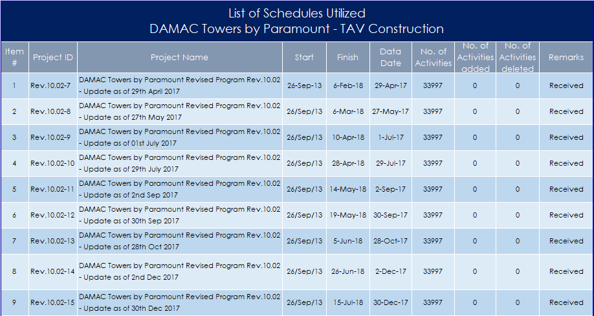

Validation and Rectification of schedules
    - For development of the analysis, the schedule files (presented in Table 1) are utilized As-is.
    - The following parameters of the schedules, have been reviewed, validated, and rectified where applicable as per AACE -29R protocols:
- Open ends
- Construction Logic
- High Lag Values and Negative Lags
- Compliance to Contractual Completion Dates
- High Float Values
- Negative Floats
- Constraints
- Scope of Work
- Scheduling Options
- Actual Start / Finish Dates
    - The contemporaneous schedule updates have been validated, for the above parameters, to the extent possible, based on the available information assuming the actual dates contained in the As-Built programme (30 December 2017) were correct.
    - During the schedule validation process, no anomalies were identified in the As-Built dates recorded. In the absence of having the Baseline available to perform additional validation and rectifications, the extent of validation was limited to the available schedule updates only.
    - The changes in the schedule logic have been considered while performing the analysis as the method implemented MIP3.3 is dynamic i.e. it considers the logic changes between the schedule updates.
    - Thus, no rectification was necessitated on the schedules.
    - The following checks were performed on the schedule to ensure consistent As-Built data:
Table 2.5.7.1: Validation (Original Duration)
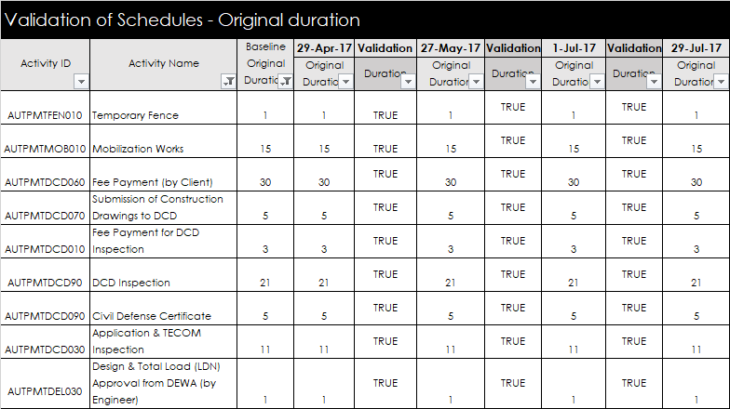
Table 2.5.7.2: Validation (Actual Dates)
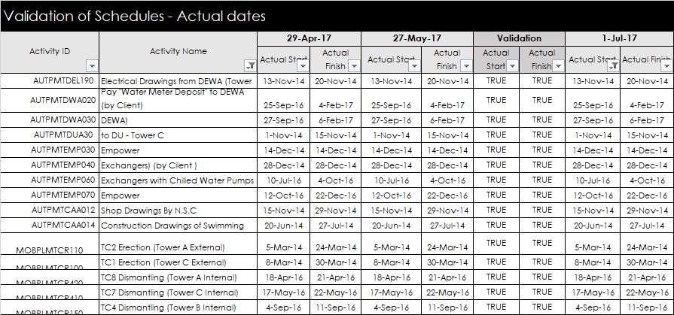

Findings
    - I conducted the analysis utilizing the available sources (schedule updates - electronic Primavera files) provided to me by the Respondent. The method of analysis implemented is based on a retrospective approach as described in detail in Section 2.3.1.
    - The method produces concrete results regarding concurrency, as it is based on analysis of the most critical path events, impacting the Project Completion Milestone.
    - Basic Results

Table 2.6.3.1 indicates in chronological sequence the activities that controlled and impacted the milestone completion date. A controlling activity is one that lies on the Critical Path and whose failure to either start or complete in the planned time is controlling the completion of the Milestone under investigation (i.e. lies on the longest Path).
File Name: The unique identification ref of the contemporaneous schedule update
Start: The start date of the period of analysis (window start)
Finish: The finish date of the period of analysis (window finish)
Period of Analysis The number of days per analysis
Activity ID: The unique identifier of the controlling activity from the programme file
Description: Detailed Description of the controlling activity as described in the programme

Event ID: Indicates if the activity initiation (Start) or completion (Finish) is controlling
Completion Date: The Forecast Completion date observed per period in the updated schedules
Delay: The delay impact in days to the zone completion milestone for the period
Mitigation: The mitigation impact in days to the zone completion milestone for the period

Net Impact: Represents the net effect of impact (delay/mitigation) to the completion milestone. A negative figure represents a commensurate retraction of the completion date (mitigation) whereas a positive figure represents a commensurate delay of the completion date (delay).
Table 2.6.3.1: Monthly Analysis Findings from 29 April 2017 to 30 December 2017
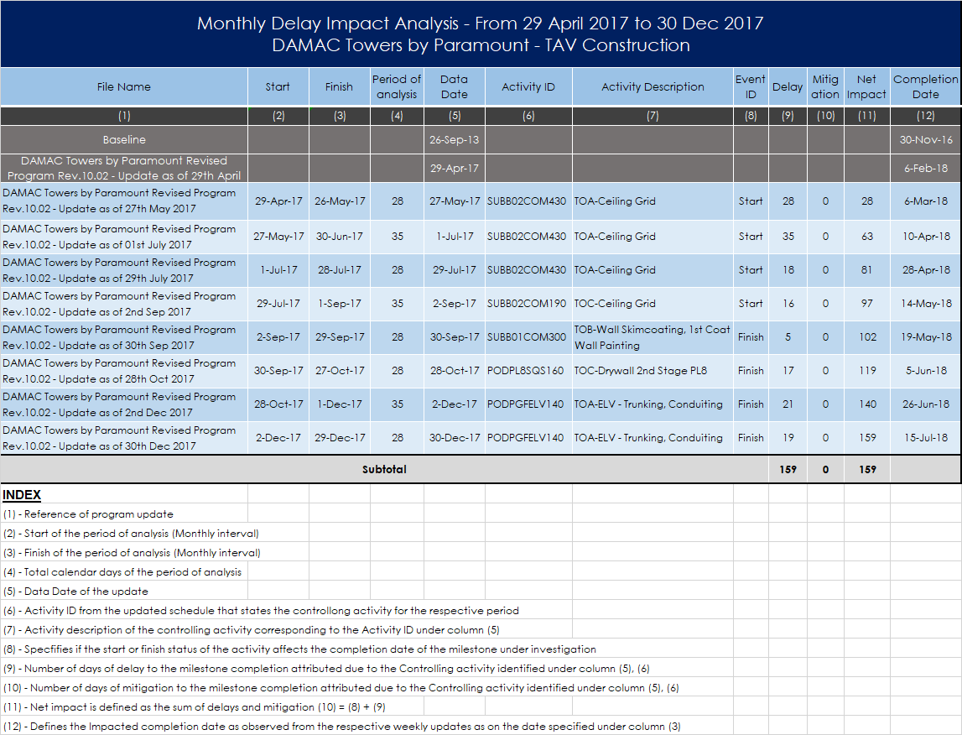
Table 2.6.3.2: Analysis of Findings by Event based on the controlling (critical Path) activities
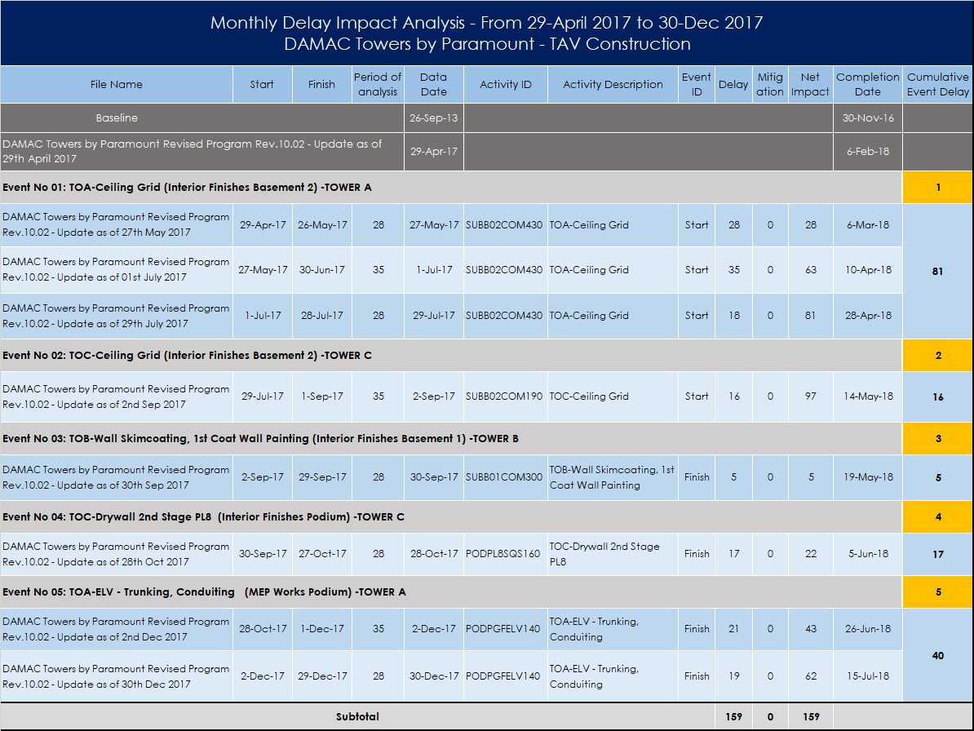

Analysis of findings

The following events have been identified based on the respective controlling (most critical) activities as driving the delays and delaying the project.
- Event No 01: TOA-Ceiling Grid (Interior Finishes Basement 2) -TOWER A (Substructure Podium)
- Event No 02: TOC-Ceiling Grid (Interior Finishes Basement 2) -TOWER C (Substructure Podium)
- Event No 03: TOB- 1stCoat Wall Paint(Interior Finishes Basement 1) -TOWER B (Substructure Podium)
- Event No 04: TOC-Drywall 2nd Stage PL8 (Interior Finishes Podium) -TOWER C (Podium)
- Event No 05: TOA-ELV - Trunking, Conduiting (MEP Works Podium) -TOWER A (Podium)
Each event has been separately analyzed and the document’s discovery provides substantiation as to what was the cause of the delay.
For the purpose of analysis of the Main Schedules received by the Respondent, the criteria of “Actual Dates” was considered over the “Retained logic”, to address the issue of out of sequence activities” encountered during my review of these.

Event No. 01 -TOA-Ceiling Grid Basemt 2 -Tower A-Podium -29-Apr-28 Jul-17 - 81 days
Correlation:
This event relates to the delays in installation of the ceiling grid of interior finishes for the common area in basement 2 Tower A. As on 29 July 2017, the status of the activity was noted to be not started.
Assessment
It was identified as work by others, thus no further investigation into the event was undertaken.

Event No. 02 0 - TOA-Ceiling Grid Bsmt. 2-Tower C Podium:29-Jul-01-Sep-17 -16 days
Correlation:
This event relates to the delays in ceiling grid of interior finishes for common area in basement 2 Tower C. As on 02 September 2017, the status of the activity was noted to be not completed.
Assessment
It was identified as work by others, thus no further investigation into the event was undertaken.

Event No.03 TOB-Wall Skim coat, Wall Paint Bsm 1-Tower B Pod–02-29 -Sep-17 – 5 days
Description:
This event relates to the delays in wall painting works of interior finishes for basement 1 Tower B. As on 30 September 2017, the status of the activity was noted to be not completed.
Assessment
It was identified as work by others, thus no further investigation into the event was undertaken.

Event No.04 - TOC-Drywall 2nd StPL8--TOWER C (Podium) 20-Sep –27 Oct-17 - 17 days
Correlation:
This event relates to the delays in drywall of interior finishes for Level 8 Tower C of Podium. As on 28 October 2017, the status of the activity was noted to be not completed.
Assessment
It was identified as work by others, thus no further investigation into the event was undertaken.

Event No.05 TOA-ELV-Trunk, Conduit (MEP-Pod)-Tower A–28-Oct– 29-Dec-17–40 days
Correlation:
This event relates to the delays in MEP works for GF Tower C of Podium. As on 30 December 2017, the status of the activity was noted to be not completed.
From review of the documents, it is apparent that the Contractor completed his works late and he was ready to apply for LV inspection on 7 December 2017 as per the latest letter (DTP-L-TAV-KEO-2456) dated 12 December 2017. This caused an excessive delay on the critical path from 28 October to 29 December 2017 as proven by the analysis.
I performed the correlation between the event and the documents that I had in my possession as these have been submitted by the Claimant regarding this Event.
Assessment:
The delays during this period have been attributed to others, and precisely by the MEP subcontractor
Documents:
DTP-L-TAV-KEO-2456 dated 12 December 2017
6197-CM-KEO-DTP-T-GR-10175 dated 04 December 2017
6197-CM-KEO-TAV-L-KEO-3367 dated 18 October 2017
DTP-L-TAV-KEO-3367 dated 28 September 2017
6197-CM-KEO-TAV-LT-AL-3907 dated 19 September 2017
DTP-L-TAV-KEO-3351 dated 14 September 2017
DTP-L-TAV-KEO-3294 dated 23 August 2017
6197-CM-KEO-TAV-LT-AG-3706 dated 17 July 2017
DTP-L-TAV-KEO-3230 dated 06 July 2017

Findings of the Analyses’
From the analysis performed on the Respondent’s Schedules for the Critical Period (30 April to 31 December 2017), I have identified the following:
  - The Critical Path passes through the Podium of Tower A and C
  - The Critical Path’s Controlling activities for four out of five periods are Interior Finishes
  - The Critical Path activities areas are the Basement areas
  - The Critical Path for the last period is related to MEP works
Having reviewed the Experts Reports for the Main Arbitration Case, I concluded the points of agreement as follows:
- The location of the Critical Path – Podium Area
- The Tower A and C
- The Basement Area
- The Interior Finishes and MEP works
However, I must point out that the Interior Finishes belong to other ID subcontractors and not to the Claimant as proven by the analysis. To clarify the matter on how far from the critical path were the Claimant’s activities I analyzed the schedule data (activities) to identify the lag of these from the most critical path. I have not identified any Claimant’s activities, in the proximity of the most critical path from April to November 2017, however I have identified one activity close to the most critical path in December 2017 as shown below.
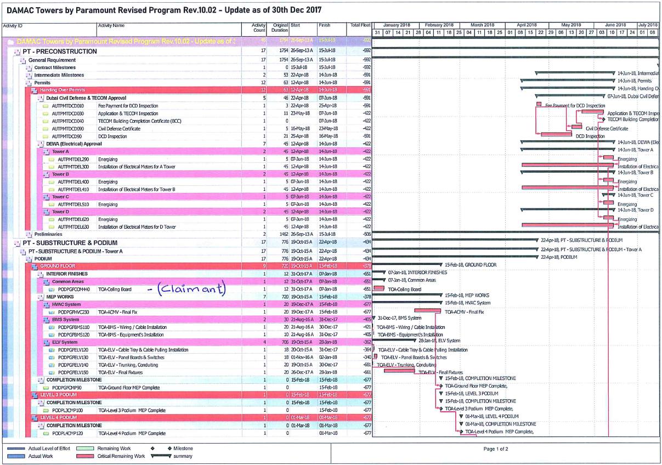
In the excerpt posted above from the Respondent’s Main schedule for the month of December 2017, I observed the Claimant’s critical activities are shown to have negative float of 651 vs -677, or twenty-six days (26) from the most critical activity of the project, which belongs to MEP works Completion.

Float analyses from Start to Completion

Introduction
The purpose of developing the float maps, both for the Main Schedule (Respondent’s) and Subcontract schedule (Claimant’s), for the entire period of the Subcontract works are two folded:
  - Compare the float map of the Main Contract (Respondent’s) vs Subcontract (Claimants)
  - Compare the Experts assessment regarding delays incurred from April to December 2017.
TABLE 2.8.1: Float Analysis of the Main Contract for the period of Claimants Subcontract
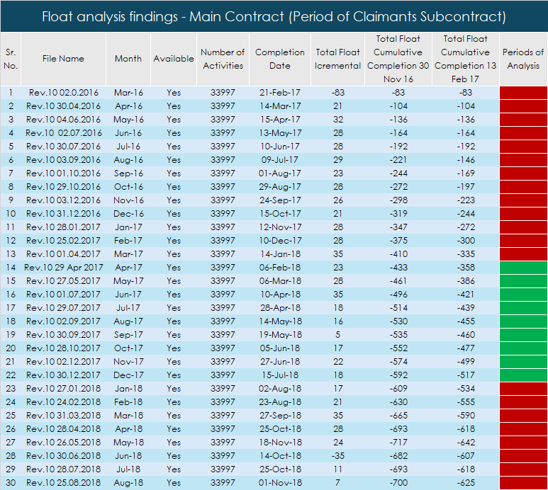
Table 2.8.1 presents the identified floats by period from the Main Schedule (Respondent’s) files for the entire duration of the Subcontract. In green color on the last column identifies the critical periods identified by the Experts on the Main Contract Arbitration as critical. This period starts with -433 days negative float in April 2017 and ends with -592 days in December 2017 a difference of approximately 160 days., in comparison to the -215 days identified by the Experts.

Process
Float, is defined as the time the performance of an activity may be delayed without delaying overall project completion. Float is a resource that provides flexibility in the contractor’s schedule and each activity has its float values based on a CPM calculation. Furthermore, when a project is delayed or proceeds ahead of the planned schedule, recalculating its schedule to obtain updated float values for remaining activities is necessary.
Through the Primavera@ schedule files, total float values for each month were recalculated and noted as is from the schedule updates of main Contract schedule as well as subcontract schedule. Float values were noted for the following periods:
- For the Main Contract schedule: from March 2016 to August 2018, with reference to the project completion as 30 November 2016.
- For Subcontract schedule: from April 2016 to September 2018, with reference to the project completion as 15 February 2017.
The float analysis was performed to compare and authenticate the results of the analysis performed by the Respondent related to the counterclaim.
Table 2.8.2A & 2.8.2B shows a graphical representation for the float values against monthly interval of schedules updates for main as well as subcontract schedule:
Table 2.8.2A: Graphical representation of Float values for Main contract (Respondent) schedules files
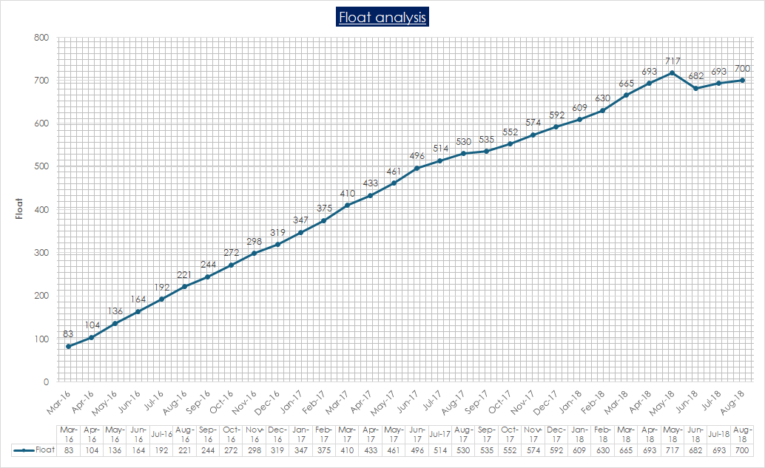
Table 2.8.2B: Graphical representation of Float values for subcontract (Claimant’s) schedule files
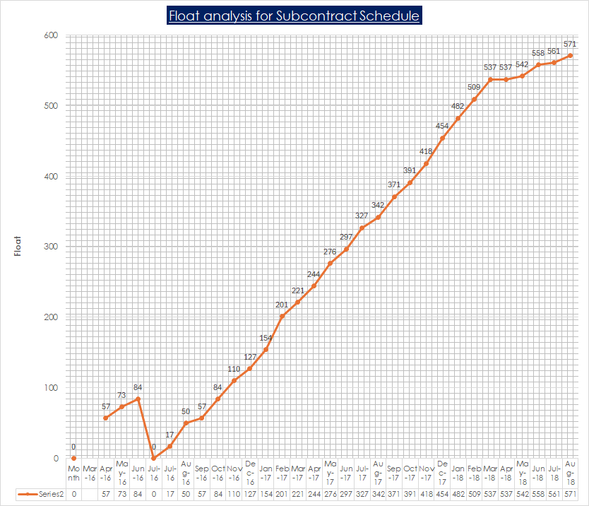

It is apparent from the graph that the early period is marked by the scope finalization of the Claimant’s work on the project, thus we encounter a steep drop in the float in the schedule.

Comparative analysis
The purpose of comparing the float maps for both Main Contract and Subcontract schedules files, for the entire period of the Subcontract works:
- Compare the quantum of delays on the float map of Main Contract (Respondent’s) vs Subcontract (Claimants)
- Identify similarities, differences, and patterns of delays within the subcontract period (from April 2016 to August 2018) and provide assessment on the findings.
- "The Main schedule updated received by the Respondent, had the schedule settings for “Retained logic”, so the total float values for each month were calculated and noted as is from the schedule updates. Furthermore, it contained out-of-sequence activities due to which it may not reflect the correct critical path.

Table 2.8.3: Comparative analysis of Float maps for main vs subcontract schedules
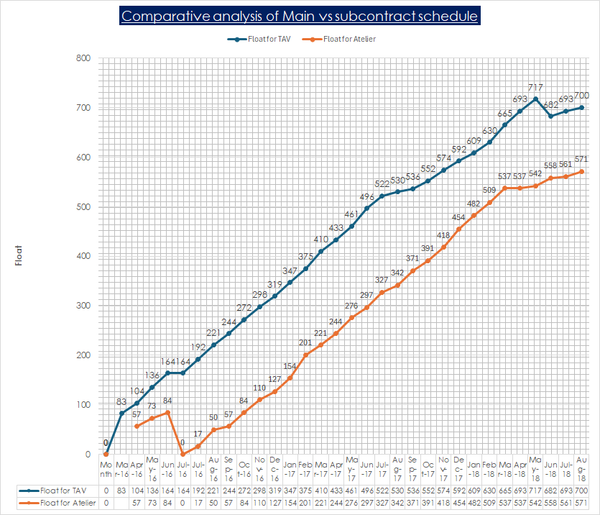

Findings
- It is worthwhile to state that the comparative analysis of the two sets of schedule files is based on two different Completion Dates, as the Respondent has kept the Revised Completion to 30-Nov-17, while the Claimant considered the 15-Feb-17 as per the approved by the Respondent schedule. Thus in order to clarify the variance in delays between the two curves we have to reduce the delays of the Main Contractors curve by seventy-five (75) days, the difference between the 1st Revised Completion based on Amendment No 4 (30 November 2016), and the 2nd Revised Completion (13 February 2017).
- The Float analysis of the Respondent’s schedules is performed utilizing the electronic schedule files for the entire duration of the Claimant’s contract (March 2016 to 26 September 2018 - TOC date).
- The Float analysis of the Claimant’s schedules is performed utilizing the electronic schedule files (P6) for the entire period of the Claimant’s subcontract from 04 April 2016 to 13 September 2018.
- From the comparative analysis, I observe that the delays, utilizing the 15-February 2017 as the revised completion date, were consistently higher in the Main Contract in comparison to the Claimants’ delays which appear consistently lower by over one hundred days, throughout the Claimants Contract period. The Tabular comparison of the two (Main vs Sub) schedule files appears on the following Table.

My observations on the Table above can be summarized as following:
- The delay variance of the two schedules varies from 47 to 175 days as per the last column.

- The Critical period, 30 April to 31 December 2017, appears to have a consistently high variance between 124 to 63 days. It appears that the first part (31 March to 30 September 2017) of this period is more intense in delays.

- The Red identification in the individual columns of data defines extremely low periods of productivity as in thirty (30) days they lost thirty-five (35) days on one occasion in the period of March 2018. Perhaps due to changes in logic it created anomalies in the recording of progress, however I consider these as low periods.

- The Green shade identifies the periods of extremely good productivity based on the plan as the one for the Claimant in April 2018, where in 30 days the productivity reached 100%.

- The fact that the variance between the two schedules was mostly one hundred days until November 2017, points to the fact that there were apparently other delays in the project besides the Claimants scope.

- Another observation made from this comparison is that form the period of November 2017 until the end of the Project the Variance between the two contracts was minimal and that points to the Completion of other tasks from the main Contract and the concentration to the Claimants works.

- The Man Contract Delays are consistently higher than the Subcontract Delays pointing to other causes of delay in the project. Additionally, the Green Colors point to small discrepancies between the variances of delays pointing out that the Critical activities were converging to several ID works.

Comparison of delay analyses of Experts / Main Contract / Subcontract

Introduction
In this Section I compare the findings, identified in my analysis in Section 2 (Main Contract schedules) with the ones identified by the Experts in the Main Contract Arbitration. for the critical period from 30 April to 31 December 2017 only. The purpose is to identify the validity of results regarding the delays incurred during this period, and provide clarity on the causes behind the discrepancies in the findings.
It is worth noting that the method of analysis I utilized is the MIP 3.3 (Dynamic windows, observational, as is) which utilizes all monthly schedule upon validation of the records to the extent possible.
However, the method utilized by the Experts is MIP 3.2 (Observational, Static, and Periodic) also called as planned vs As Build, where the windows are chosen subjectively based on the analysts’ standards.
The fact that there are two different methods of analysis utilized might potentially produce slightly different calculations regarding the impacts of time. Below I present the Tables with the floats (delays) for the Main Contract / Expert analyses and provide the comparison between the two and my professional opinion on the discrepancies identified.
Table 2.9.1A: Float Analysis utilizing the Main Contract Schedule files –30 April to 31 August 2017
Table 2.9.1B: Float Analysis utilizing the Main Contract Schedule files – 31 August - 31 December 17

Table 2.9.1C: Experts Findings
Expert 1: AY Start Finish Delays Risk Critical
Date Date Cum Incr Path
Window 5a 29 Apr 17 31 Aug 17 450 100 Claimant Podium
Window 5b 31 Aug 17 30 Dec 17 565 115 Claimant/MEP Podium
Expert 1: AC
Window 4.2 30 Apr 17 31 Aug 17 450 100 MEP Podium
Window 4.3 31 Aug 17 30 Dec 17 565 115 MEP Podium
As seen in Table 2.9.1.C, the Experts agree on everything, besides the responsible party for the delays.
Expert 1: claims that the Claimant was responsible for delays in Window 5a, while there is a share accountability of delays in Window 5b, between the Claimant and the MEP Final Fix.
Expert 2: claims that as far as Window 4.2 is concerned the risk for the delays lay with the MEP 1st and 2nd Fix, while for Window 4.3 the risk lays with the MEP Fina Fix.
The risk of parties on the encountered delays is the only disagreement between the two Experts throughout all their reporting.

Comparison of the analysis findings of the Main Contract by me and the Experts
- Step 1: Period 1: 30 April – 31 August 2017 - Window 5a or Window 4.2
Comparing the findings of the first Table 2.9.1A and Table 2.9.1.C -Experts Window (5a or 4.2), in the first case the summary of the Main Contract Schedules has given a delay of ninety-seven (97) days, where on the other hand the Experts agree on one hundred (100) days delay during this period. The results are satisfactory as the variance is very small (100-97=-3).
Opinion:
I agree that during this period the delay was approximately one hundred (100) days.
I also agree that the Critical Path passed through the Podium area of Tower A and C
I agree that the most critical activities were the Interior Finishes on the Basement Area (Tower A & C), however these interior finishes were the responsibility of other Subcontractors and not by the Claimant.

- Step 2: Period 1: 1 September – 31 December 2017 - Window 5a or Window 4.2
Comparing the findings of the first Table 2.9.1B and Table 2.9.1.C Experts window (5b or 4.3), in the first case the summary of the Main Contract Schedules gave a delay of sixty-two (62) days, where on the other hand the Experts agreed on one hundred and fifteen (115) days’ delay during this period.
The discrepancy is due to several facts:
- No validation of the inherent data (prior to the Claimants contract period) and thus no rectification has been performed on the utilized schedule files.
- The extent of validation and rectification was limited to the files received for the Claimant’s Contract period (April 2016 to September 2018). Thus, the rectifications performed by the Experts on previous logic ties or activity durations, prior to April 2016 might be one of the causes of discrepancy. I utilized the schedules received after minor adjustments, that cannot justify the difference (115-62=53) of the encountered fifty-three (53) day.
- The difference in method utilized can also be an additional factor of the differences encountered in the impact of the delays during this period. The Experts have utilized the as Planned vs as built methodology which allows larger periods of time to be investigated under one (1) window, without investigation of each schedule file as (1) window as I have utilized in the monthly window analysis. The result is that the comparison of critical activities is taken from the start to the end as one window and compared to the same activities in the Baseline. In this case the activities are considered subjectively as driving throughout the period (several Monthly periods) produces different time impact results than dissecting the event in individual periods as I have done under the method of windows analysis I have implemented.

I am not going to comment on the advantages or disadvantages of each method here, as my instructions are to provide the Tribunal with my professional opinion. Thus, I only express my opinion of what I consider appropriate regarding the delays incurred during this period and I do that below.

Opinion:
Regarding the discrepancy in days of delay identified in the Respondent’s Main Schedule analysis (62) and the Experts (115) my observations are as follows:
Since the inconsistencies encountered in the schedule files were minor and the overall schedules were well maintained, I attributed the difference in the delay impact days, encountered between the Main Schedule analysis and the Experts, predominantly in the method of analysis utilized by the Experts and less on the rectifications performed in previous periods.
As I stated earlier, the method of As Planned vs As built, utilized by the Experts, tends to exaggerate the impact of one event, as this sole event is considered critical under the particular window under investigation. The time of this event is analyzed solely against the Planned in the Baseline duration and tends to become the controlling factor of this delay.
In the absence of details of the analysis carried out by the Respondent’s Experts, I assume that delay was identified by simply comparing what happened (as-built dates) to what was supposed to happen (as planned dates), without considering the as built critical paths. The Experts method does not investigate near-critical paths that may experience delay, as this method cannot consider shifts in the critical path over the time being static in nature. In my analysis I have utilized every monthly update, which presents the dynamic approach as it captures the changes in critical path on monthly bases, without assuming the driving event as unique from start to completion. It is apparent that for this method I relied on the fact that the schedule files received were good with minor inconstancies.
I agree with the Experts that the Critical Path passed through the Podium area of Tower A and C
I agree that the most critical activities were both the MEP works, and the Interior Finishes performed by several subcontractors. In this case, these interior finishes were the responsibility of other Subcontractors
Clarification: A point I must make clear here deals with the Revised Completion Date.
As per the review of the Experts Reports I realize that they agree that the delay in the project on 30 April 2017 was three hundred and fifty (350) days. As per the Tables 2.9.1a and 2.9.1b, I conclude that the Experts have considered the 13th February 2017 as Revised Completion Date of the Project, while the Main Contract Schedule files I received and analyzed kept the 30 November 2016 as Revised Completion Date. As of the date of this report, and after several attempts, I have not been able to receive the copy of the document confirming the Revised Completion Date as 13 February 2017.

Comparison analysis on the Claimants schedules for 30 April – 31 Dec 2017
The purpose of comparison between the findings of the Claimant’s (Subcontract) Schedules during this period is to identify the extent of delays within the Claimant’s Subcontract works, and compare these delays to the delays identified, both in the Main Contract and the Experts reports This comparative analysis will enable me to develop and express an opinion on the incurred delays.
Table 2.9.2A: Float Analysis utilizing the Subcontract Schedule files –30 April to 29 August 2017
Table 2.9.2B: Float Analysis utilizing the Subcontracts Schedule files –31 August – 3 January 2017
Period 1: 30 April – 30 August 2017
- Step 1A: - Window 5a or Window 4.2- Experts findings
Comparing the findings of Table 2.9.2A Claimant’s / Subcontract Schedule, and Table 2.9.1.C -Experts Window (5a or 4.2), in this case the summary of the Subcontract Schedules shows a delay of ninety-eight (98) days, where on the other hand the Experts agree on one hundred (100) days’.
The difference between the three Experts for this period is negligible
Delays: Experts analysis 100 days > Subcontract Schedule 98 days
Opinion: I agree that during the period 01 May – 31 August 2017 the delay on the project was approximately one hundred (100) days, as per my statement made earlier, as the subcontract findings of a lesser number of days 97<98<100 is a proof that other causes of delays were taking place during this period. All sources agree that the delays experienced were similar during this period.
- Step 1B: Main Contract Schedules’ findings
Comparing the findings of Table 2.9.2A Claimant’s / Subcontract Schedule and Table 2.9.1.A – Main Contract in this case the summary of the Subcontract Schedules shows a delay of ninety-eight (98) days, where on the other hand the Main Contract analysis revealed ninety-seven (97) days delay during the same period.
Delays: Claimant’s Schedule 98 days > Respondent’s Schedule
Opinion: Based on the findings I observe that during the period 30 April – 31 August 2017 the delays per the Respondent’s (Main Contract) schedule delays and Claimants Schedule for this period. This leads me to believe the delays in activities in the Main Contract were aligned to the Claimant’s activities which means that the Claimant’s delays were not the main source of delays of the Main Contract during this period.
A proof that the Claimant’s activities were not laying on the most critical path is because the analysis during this period of the Main Schedule administered by the Respondent had activities by others (MEP and other ID subcontractors) as most critical as shown in this Section of the report.
Period 1: 31 August – 31 December 2017
- Step 2A: Window 5a or Window 4.2 – Experts findings
Comparing the findings of Table 2.9.2B Claimant’s / Subcontract Schedule and Table 2.9.1.C Experts’ findings, in the first case the summary of the Schedules has given a delay of one hundred and fifteen (115) days, where on the other hand the Subcontract analysis revealed a delay of one hundred and twelve (112) days. The difference between the three experts is minor during this period.
Delays: Experts analysis 115 days > Subcontract Schedule 112 days
Opinion: Based on the findings I observe that during this period, the delays, as with the Main Contract schedules utilized by the Experts, were one hundred and fifteen (115) days. This number is in line with the Subcontractor’s / Claimants Schedule for this period. I agree with the Experts to the Extent of the delay encountered by the project during this period.

- Step 2B: Period 1: 31 August – 31 December 2017 - Main Contract findings
Comparing the findings of Table 2.9.2B Claimant’s / Subcontract Schedule and Table 2.9.1.B Main Contract delay analysis, in the first case the summary of the Claimant’s Schedules has given a delay of one hundred and twelve (112) days, where on the other hand the Main Contract analysis revealed sixty-two (62) days’ delay during the same period.
Delays: Experts 115 days > Claimant’s schedule112 days > Respondent (Main Contract) 62 days
Opinion: Based on review of the findings, I observed that during this period the delays, as per the analysis of the Main Contract schedule files, were sixty-two (62) days. However, the number of delays of the Subcontract is higher (112) than the sixty-two (62) days identified in the Main Contract Schedules. This leads me to believe that the Main Contract Schedules did not consider the Claimants’ (Subcontract) work as the most critical during this period, as if this was the case it should have been impacted proportionally by one hundred and twelve (112) days,
Clear Proof that the Claimant’s activities were not on the most critical path is also based on the fact that the analysis during this period of the Main Schedule administered by the Respondent had activities by others (MEP and other ID fit out subcontractors) identified as most critical.

Consolidated opinion on delays incurred from the 01 May – 31 December 2017
Upon completing the comparative study between the three analyses,
- Experts on the Main Contract schedules
- My analysis on the Main Contract schedules
- My analyses on the Subcontract schedules
to determine the correctness, completeness and accuracy, to the extent possible, of the delays incurred in this case I express here my professional opinion, as following:
It is of particular interest to me the cumulative delays during this period which are as following for each case:
Overall Period 245 days
Experts analysis 215 days Productivity rate12%
Main Contract Schedule analysis 159 days Productivity rate 29%
Subcontractors Schedules 210 days Productivity rate 13%

As I pointed out in Section 2.9.3, the delays identified by the Experts tend to be exaggerated due to the method of analysis (As Planned vs As Built) utilized. This method (AP/AB) tends to concentrate on one critical activity from start to end (Window), and in this case there is no doubt that the governing activities during this period were the MEP 1st & 2nd Fix, the Fit out works FOH, and the MEP Final Fix. The analysis of these activities has been undertaken in detail by the two Experts with different results as to the risk of the parties, and I will not elaborate further.

However, a critical factor is the fact that the analysis of the Claimants (Subcontractor’s) schedules, revealed for the first period the number of days (98) match the Main Contract (97), and the Experts analysis findings (100) for the same period.

In the second period the Subcontract schedules revealed one hundred and twelve (112) days of delay and the Main Contract only sixty-two (62) days of delay. This is a clear indication that the Main Contract schedule was not considering the Claimant’s works (Subcontract schedules) as the most critical, as they were not proportionally impacted.

SECTION 3

Assessment of Counterclaims submission made by the Respondent

Assessment of Counterclaims submission made by the Respondent

Preamble

This Section consists of three parts:
  - The Review of the two Experts positions, based on my review of their Reports and Joint Statements to introduce the Arbitral Tribunal with their individual assessment of the delays incurred during the period 30 April to 31 December 2017.
  - Review of the Contract Clauses regarding Liquidated Damages
  - Calculations and Correlation of Experts Findings with Contract Requirements

Part 1 – Review of Experts Reports for Main Contract Arbitration

3.2.1 Review of Experts Reports (DL 19212) vs Contract Clauses on LDs and Max cap

      - Introduction
This Section summarizes the findings of the two Experts (Respondent’s and Employer’s) on the project delays, as substantiated in their submitted reports for the Main Contract Arbitration Case,
The findings, as well as their joint statements regarding the causes of delays, have been considered by, the Main Contract Arbitral Tribunal, to reach their verdict, as detailed in the documents:
- Partial Final Award dated 10 August 2023
- Final Award dated 02 January 2024
The findings of the Two Experts have been also adapted by the Respondent’s Legal Counselor in developing the following documents:
- Supplemental Defense and counterclaim dated 20 March 2024
- Amended reply to Defense and Counterclaim dated 28 July 2024
      - References
For development of this Section of the Report, my review was based on the following documents:
- Report of Mr. Aidan Coyne – Independent Expert witness – Delay – 12 May 2021
- Supplemental Reply Report – Independent Expert witness – Delay – 05 July 2021
- Expert Report of Mr. Andrew E. Yendall on Delay issues – 01 May 2021
- Reply of Mr. Andrew E. Yendall on Delay issues 02-July 2021 02 July 2021
- Second Joinder Statement of Mr. Coyne and Mr. Yendall – 1- March 2021
- Letter of TAV to KEO on 12-Dec-17
- Letter of KEO to TAV on 19-Dec-17

Review of Mr. Aidan Coyne’s (Respondent) position

      - The Expert Report by Mr. Coyne (Respondent’s Expert)
Mr. Coyne developed Window 4, for the period from 31 December 2016 to 31 December 2017, and he considers that the critical path passes through the installation of the MEP and internal finishes in the Podium Levels. He dissected the period in two-time segments as following:
- 30 April 2017 to 31 August 2017
- 31 August 2017 to 30 December 2017
Under paragraph 317 of his Report Mr. Coyne agrees with Mr. Yendall (the Employer’s Expert) that the Critical Path passes through the Podium from December 2016 to December 2017 and states:
“In paragraph 5.6 of the Experts first Joint Statement, Mr Venda II and I agree that, in the period from 31 December 2016 to 31 December 2017, the critical path proceeded through the progress of the works to the Podium levels.”
Under paragraph 318 of his Report Mr. Coyne states that he agrees with Mr. Yendall on the overall project delays during the period of the year 2017 as follows:
“318.1 By 31 December 2016, the works were around 250 days in critical delay
318.2. By 30 April 2017, the extent of critical delay had increased to around 350 days
318.3. By 31 August 2017, the extent of critical delay had increased to around 450 days
318.4. By 31 December 2017, the works were 565 days in critical delay
319 Accordingly, in the period from 31 December 2016 to 31 December 2017, around 315 days of critical delays were incurred.”
In several other occasions in the Report, the Expert points out to the same findings.
AGREEMENTS BETWEEN THE EXPERTS:
For clarity, I listed again the two Experts positions regarding the inherent Project Delays as follows:
The two Experts agreed that
- The Critical Path during the year 2017 passed through the Podium Levels
- The Inherent Delays on the critical path were as following:
  - 250 days – 31 - December 2016
  - 350 days – 30 – April – 2017
  - 450 days – 31 – August 2017
  - 565 days – 31 – December 2017
  - Overall Delay for the year 2017 – 315 days

I considered that both Experts in their calculation of delays considered the 13 February 2017 (Revised Completion as benchmark to count the delays in the project. This is the date considered as revised Completion Date in the Certificate of Completion. However, the electronic Schedule files provided to me by the Respondent reflect only the 1st Revised Completion date of 30 November 2016 based on Amendment letter No. 04 date 05-December 2016. Thus, there is a lag of seventy-five (75) days in calculation of delays between Experts and the Respondent’s schedule. Mr. Coyne’s opinion, regarding the risk of parties in the delays incurred between January to 31 August 2017, is expressed in paragraph 325 where he states:
“In my opinion, from January 2017 to 31 August 2017, the installation of the above ceiling MEP was critically driving the progress of the Podium works….”
Mr. Coyne’s opinion, regarding the risk of parties in the delays incurred in the period 31-August to 31 December 2017, is expressed in paragraph 408 (page 40 of 40) as follows:
30-April to 31 August 2017
Slower than planned progress of 1st and 2nd fix MEP installation due to:
• Delayed sign-off of M EP above ceiling services
• Design and coordination of the above ceiling services
Incremental Delays 100 days, Cumulative delays 450 days
31-August 2017 to 31 December 2017
• Delayed sign-off of M EP above
• Modifications to the LV design
Incremental Delay of 115 days for the period, Cumulative Delay 565 days for 2017

Clarification: The above calculations consider that the inherent project delays
30 April 2017 were Three hundred and fifty (350) days
31 August 2017 increase by one hundred (100) to Four hundred and fifty (450) days
31 Dec 2017 increase by one hundred & fifteen (115) to Five hundred and sixty-five (565) days
SUPPLEMENTAL REPORT BY Mr. Coyne (Respondent’s Expert)
Mr. Coyne issued the Supplemental Report on 05- July 2017, where he included the Scott Schedule produced by the two Experts, highlighting the areas of agreement / disagreement, as shown below:
Period: 30 April 2017 to 30 December 2017 – Window 4 For Mr. Coyne / Window 5 For Mr. Yendall
Mr. Coyne’s position regarding the Critical Path
Period: 30 April 2017 to 30 December 2017 – Window 4
Critical Path: Through the slower than planned 1st and 2nd fix Podium MEP installation.
Mr. Yendall position regarding the Critical Path
Period: 29 April 2017 to 1 October 2017
Critical Path: Interior finishes activities in the Podium/Substructure.
Status: Disagreement on critical Path Impact: 100 days (agreement on impact)
Period: 1 October 2017 to 30 December 2017
Installation of the MEP final fix works to the Podium.
Status: Partially – Agree Impact 115 days (agreement on impact

Review of Mr. Yendall’s (Respondent’s) position
      - The Expert Report by Mr. Yendall (Employer) dated 01 May 2021
The Report summarized its findings as following:
On page 6 of 33 and paragraph 2.8 the Expert provides the agreement with Mt. Coyne as follows:
“The Experts agree that from Jan 2017 to the End of 2017 the critical path run through the progress of the works to the Podium Levels, The Experts will further examine in their restive reports the underlying causes of delays to those works and what particular trades /activities were critical within the MEP and/or finishes work in the Podium during this period.”
20-Apr-17 to 31 Aug 17 Cumulative Delay 450 days Incremental 100 days
31-Aug-17 to 30-Dec-17 Cumulative Delay 565 days Incremental 115 days
The Expert in page 20 and par 2.45, under Window 5 - 29th April 2017 to 30th December 2017 summarizes their agreements regarding the delays prior and after the critical year 2017 as following:
“On the basis that Mr Coyne and I agree that at the start of the period I have defined as Window 5, the extent of critical delay to TAV's works was 350 days, but by the end of December 2017 the extent of critical delay had increased to around 565 days, we are in agreement that over this Window a critical delay of around 565-350 = 215 days was incurred.
Thus, the Main points of agreement of the two Experts are
- As of 30 April 2017, the Critical delays amounted to 350 days
- As of 31-December 2017 the Critical delays amounted to 565 days
Additionally, the Expert in page 20 and paragraph 2.46 stated the location of the Critical path
“We are in agreement, that it was the works to the Podium levels that remained on the critical path to the completion of TAV's works throughout this Window (albeit we would further refine the activities that we considered were critical within the Podium over that period in our reports)”
Both Experts agreed that during 2017 the Critical Path passed from the Podium Levels
Regarding the causes of delay Mr. Yendall in paragraphs 2.48 and 2.50 considers
From 30 April to 30 September 2017 the interior Finishes were leading the critical path.
From 1 October to 30 December 2017, he considers the MEP Final fix as critical leading the Critical Path and agrees with Mr. Coyne over this period (01 October to 30 December 2017).
The following are excerpts of his statement regarding the causes of delays:
“2.48 In the period up to around the end of September 2017, it seems to me that the interior finishes work remained driving the progress of the Podium works, with the MEP final fix works making limited progress ahead of that time it appears on account of the significant, ongoing, incomplete interior finishes works. Around half of the delay in this Window occurred in the first half of this period (Mr Coyne and I agree that the extent of critical delay by the end of August 2017 was 450 days, and thus a further 100 days of critical delay had accrued from the start of my Window 5 and the end of August 2017).”

“2.50 From October 2017, in my opinion, the MEP final fix works likely became critical to the completion of the works to the Podium (and as the Podium works were determinative of the completion of the works as agreed with Mr Coyne, the MEP final fix works were critical to the completion the works overall). Those works continued to make slower than planned progress over the final months of 2017, with more significant progress made in the fire fighting and HVAC final fixes only from around October and November 2017, respectively. In my opinion, it was only in around the last quarter of 2017 that the interior finishes work in the Podium were sufficiently progressed to enable the MEP final fix works to make more significant progress. It seems likely, however, that the progress achieved by the MEP final fix works would have remained limited by the ongoing progress of the interior finishes works (with the MEP final fix works later catching up with the progress of the interior finishes works in the Podium by early 2018)”
In his conclusions sated in paragraphs 9.38 through 9.45 in pages 197 and 198 states:
9.38 My Window 5 spans a period of 8-months from the end of April 2017 to the end of December 2017. Mr Coyne and I agree that the works to the Podium were on the critical path during the period I have defined as my Window 5 and that over that period a further critical delay of 215 days accrued.
9.39 In my opinion, it was the interior finishes works to the Podium that were driving the completion of TAV's works in the Podium at the start of this Window (and as that area was critical to the completion of TAV's works overall, those works were critical to the completion of the project).
9.40 In the period around the end of September 2017, it seems to me that the interior finishes work remained driving the overall progress of the Podium works, with the MEP final fix works making limited progress ahead of that time it appears on account of the significant, ongoing, incomplete interior finishes works. Around half of the delay in this Window had occurred in the first half of this period (Mr Coyne and I agree that the extent of critical delay by the end of August 2017 was 450 days, and thus a further 100 days of critical delay had accrued from start of my Window 5 and the end of August 2017).
9.41 The precise causes of the ongoing slow progress in the interior finishes works in the Podium are not clear from the evidence available; it is apparent that over the period to September 2017, TAV continued to make steady (but slower than planned) progress in the various finishes’ activities being performed in the Podium area with slow progress common to most floors of the Podium. The evidence indicates that TAV remained dissatisfied with the performance of Atelier, its subcontractor for those works (to the extent that ahead of the end of this Window it had descoped aspects of Atelier's works and awarded those to another subcontractor on account of Atelier's ongoing delays).
9.42 From around October 2017, in my opinion, the MEP final fix works likely Became critical to the completion of the works to the Podium (and as the Podium works were determinative of the overall completion of the works as agreed with Mr Coyne, the MEP final fix works were likely critical to the completion of TAV' s works overall). Those works continued to make slower than planned progress over the final months of 2017, with more significant progress made in the fire fighting and HVAC final fixes only from around October and November 2017, respectively. In my opinion, it was only in around the last quarter of 2017 that the interior finishes work in the Podium were sufficiently progressed to enable the MEP final fix works to make more significant progress. It seems likely, however, that the progress achieved by the MEP final fix works would have remained limited by the ongoing progress of the interior finishes works (with the MEP final fix works later catching up with the progress of the interior finishes work in the Podium by early 2018).
9.43 The evidence indicates that similar issues with the progress of Atelier continued through the last quarter of 2017.
9.44 By the end of 2017, the work to each of the locations (i.e. each of the Towers and the Podium) contained around the same number of manhours outstanding to close-out the remaining works. Therefore, both Mr Coyne and I agree that from January 2018 onward, the critical path ran more generally, through the completion of the remaining finishes and MEP final l fix works across the project.
9.45 In my opinion, the issues that were set out in the SOC (as well as in later pleadings by the Contractor) do not explain or support the conclusion that the Employer was responsible for the low level of production that was achieved over this period. Rather, I consider the delays incurred throughout Window 5 to have been caused by the poor performance of the subcontractors and the resulting low levels of production achieved.

Points of Agreement Between the Two Experts
I included the entire Conclusion statement of Mr. Yendall to emphasize the fact that the two Experts on the Main Contract Arbitration Case, agree regarding the following two points
- The Critical Path passes through the Podium Levels throughout 2017
- The MEP Final Fix causes Critical delays for the period of 01 October to 30 December 2017
- The Window 5 (30 April to 30 December 2017) total delay impact as to 215 days,
- Total cumulative days at the end of December 2017 adding to 565 days (350 + 215)

Part 2 - Review of the Contract Clauses regarding Liquidated Damages

Review of Clauses regarding Liquidated Damages on the Main Contract.

      - Objective
My review of the relevant Main Contract Clauses, for all intents and purposes aim to identify the financial impact due to the delays incurred during the project and the exposure, by the Respondent, to the associated Liquidated Damages during the Critical Period (30 April to 31 December 2017).
My objective is to calculate the maximum period of delays allowed by the Main Contract to the Main Contractor to reach the Maximum cap of Liquidated Damages, and correlate/compare that with the delays encountered in the project during the Critical Period.
This calculation will enable me to assess the validity of the Respondent Counterclaim, which is based on imposing all delays incurred during the Critical Period (30 April to 31 December 2017), to the Respondent.

Review of the Instructions to Tenderers & Contract Conditions
Under Volume 1 Tender and Contract Conditions Main Work Package and in Section 1 – Contract Agreement (page 4) the Document has been signed by both parties (page 2 or 6 of the file).
The letter of acceptance dated 26 August 2013, Ref DTP/FW/LOA-020/2013 has been signed by both parties on 26 August 2013.
Appendix to Tender / Sub Clause 47.1 specifies the Liquidated Damages are AED 600,00 per day
Appendix to Tender / Sub Clause 47.1 specifies the Limit of Liquidated Damages 10% Contract price
Appendix to Tender / Sub Clause 47.1 specifies that the Engineers Damages are AED 20,00 per day
In the Supplemental Defense and Counterclaim, dated 20 Match 2024, issued by the Respondent on paragraph 35, a Table has been developed and presented listing all damage incurred on the project.
In summary the Respondent lists the following Categories of damage.
Liquidated Damages Clause 47.1 10% of Contract Price AED 105,900,000
Engineer’s Damages @ AED 20,000/day for 535 days AED 10,700,000
Default Payment 32,000,000 AED 32,000,000
Construction Management Team AED 115,000/day AED 3,500,000

SUBTOTAL AED 152,100,000

Part 3 - Calculations & Correlation of Experts Findings with Contract Requirements

Calculation of number of days to reach Maximum cap (10%) of LDs
The Main Contract, and under industry standards contains a maximum cap on Liquidated Damages (LDs) imposed for delays. This represents the amount the party causing delays is required to pay in case of extended delays. Under the Main Contract Agreement this Maximum cap was set at ten (10%) percent of the Contract Price, as stipulated in the Contract which the Respondent presented in paragraph 35, page 7 of his Supplemental Statement of Defense and Counterclaim.
The maximum cap of LD’s, is ten percent (10%) of the Contract amount shown is AED 105,900,000 and thus the stipulated amount of liquidated damages (LDs) per day is AED 600,000.
The number of days to reach the cap of 10% if AED 105,900,000 / AED 600,000 = 176.50 days.
The above represents the number of days of delay in the project, that in case it is reached the party (in this case the Respondent) is required to pay the Maximum amounts of LDs to the Employer,
Additional burdens in case of missing the Revised Completion Date agreed by the parties are:
    - A penalty agreed by the parties based on Addendum No 4, dated 05 Dec=2017 of AED 32M
    - Engineer’s Fees at AED 20,000/day
    - CM fees at AED 115/day capped at AED 3.5M

Correlation of the Inherent project delays vis a vis to the days to impose Max LDs

      - Objective
Review and correlation of delays incurred in the project as presented and agreed by both Experts, on the Main Contract Arbitration Case, with the Contract requirements regarding calculation of Liquidated Damages and the associated number of days to reach the Maximum cap of LDs.
      - Correlation
The two Experts developed three (3) points of Agreement as presented in paragraph 3.2.2
One of the three points of agreement between the Experts deals with the number of days of inherent delays in the project on 30-April 2017.
Both Experts agreed that the inherent delays on the project, on 30 April 2017, were three hundred and fifty (350) days. Comparing this number to the number of days to reach maximum cap for LDs as per Contract, we see that this number of days, on 30 April 2017, exceeds the one the Respondent shall reach to be imposed the Maximum cap number of Liquidated Damages.
The comparison of the two is as follows:
Inherent delays on the project as of 30-Apr-24 - 350 days per Expert Agreements
No. of delay days to reach Max cap of LDs (per Contract)- 176.50 days – Per Contract Clause 47.1
Clarification of Variance in days (Delay vs Max Cap) on 30 April 2017
The Respondent in his Supplemental Statement of Defense and Counterclaim dated 20-March 2024 and in paragraph 33, page 7 states that:
“TAV was only able to obtain an Extension of Time to the completion date of 130 days (of 665 days of delay it sought such that the completion date for the whole of the works was revised from 30 November 1016 to 9 April 2017”
The Partial Final Award, issued by the Arbitral Tribunal of the Main Contract Arbitration, allowed for one hundred and thirty (130) days’ relief to the Respondent for the delays incurred in the project.
These one hundred and thirty (130) days of EoT, as per the Respondent’s statement have been shared with the Claimant extending the Claimants Completion date from 15 February to 9 April 2017 (including seventy-five days awarded to the Respondent by the Engineer), as per par 48 (page 10) of the Supplementary Defense and Counterclaim submitted by the Respondent on March 2024,
“Accordingly, Atelier’s Subcontract Completion Date is likewise revised to 9 April 2017,
by reference to the final decision confirmed in the Partial Final Award.”
I consider the one hundred and thirty (130) days (Extension of time Award to the Respondent by the Main Contract Arbitration Case), have been partially awarded previously to the work of the Respondent. As the Respondent received by the Engineer seventy-five (75) days revising his Completion from 30 November 2016 to 13 February 2017. Thus, the net extension to 9 April 2017 was only fifty-five (55) days, as per the Partial Award of the Main Contract Arbitration Case.
As conveyed in the last paragraph of Section 3.2.2 of this Report, the Experts calculated the project delays from the revised completion date of 13 February 2017 (as per TOC). Thus, part of the 130-day extension of time awarded to the Respondent (from the Partial Final Award) is included in the delay calculation of the Experts. The balance of this award is fifty-five (55) days (130-75).
Thus, the revised calculation of delays as of 30 April 2017 will be as follows:
Inherent delays on the project as of 30-Apr-24 - 350 days – per Expert Agreements / schedules
Extension of Time Award DL19212 + 55 days – As per the Final Award
Subtotal Delay on 30-April 2017 - 295.00 days
Number of Day for Max cap of LDs) - 176.50 days
Variance (Excess delays beyond Max cap of LDs) – 120.00 days
      - Conclusions
From the calculation above I conclude that on 30 April 2017 when the Respondent Considers that this date constitutes the start of the delays for the Claimant, the project was already one hundred and twenty (120) days in delay, or four months. Hence, and based on the Partial Final Award, in my opinion, there was no possible way for the Claimant to reverse the delays and mitigate them to complete the activities and the project on time, the way the Partial Final Award was presented.
My opinion is that the Counterclaim as presented by the Respondent in his Supplemental Defence and Counterclaim is invalid, as the Main Contractor, based on the Experts opinion had exceed the maximum number of days reflected by the full amount of LDs on 30 April 2017.
TABLE: Display Evolution of Delays throughout the project
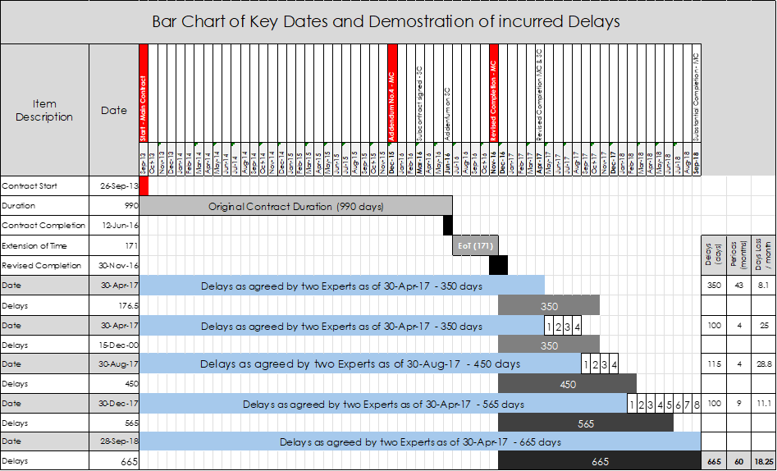
The Table above demonstrates that the inherent delays, of the project, reached prior to the works of the Claimant (for the critical period 30 April to 31 December 2017) had significantly impacted the project, to the extent that any mitigation of the works would not avert the fact that the Respondent was exposed to the Maximum cap of LDs, prior to the works by the Claimant.
As presented earlier, the delays on 30 April 2017 exceeded two hundred and ninety-five (295) days, far higher than the Maximum cap (10% of Contract price) as per contract for LDs which is reached in one hundred and seventy-six (176) days. In other words, after discounting the Partial Final Award which brings the Completion Date to 9 April 2017, on 30 April 2017 the Main Contract exceeds the Maximum LDs by one hundred and twenty (120) days, or approximately four (4) months.
Irrespective of the fact that the Claimant could not avert with his actions the fact that the project was on the RED (in triple digits – 350 days delays) prior to start of the period the Claimants work was considered by the Respondent responsible for part of the delays, and attributed two hundred and fifteen (215) days of delay to the Claimant during this period (30 April -31 December,2017).
I have undertaken (Section 1 and 2) the technical analyses of both the Claimant and Respondent schedule files of the critical year 2017, to identify the causes of delays during this year, and assess the risks of the parties on the delays incurred to project during this period.

SECTION 4

Conclusions and Opinions

Preamble
In this Section I present my Conclusions by Section, together with my professional Opinion on the issues regarding planning. My professional opinion is based on reviews of documents received by the Claimant and the Legal Counselor regarding the case.
I utilized these documents, to undertake an independent delay analysis in the Claimant’s schedules (Section 1, and an analysis for the Critical Period (30 April – 31 December 2017). utilizing the Main Contract schedules (Section 2), as well as a number of other analyses (Float, comparative, superimpositions etc.) that could assist me in forming an objective opinion as to how the delays unfold in the project during the presence of the Claimant.
For ease follow-up, I divided the Conclusions and Opinions by the Sections presented in my report.
- Section 1: Claimant’s entitlement to Extension of Time under his Subcontract
- Section 2: Technical Analysis of Critical Period (30 April through 31 December 2017)
- Section 3: Assessment on Counterclaims submission made by the Respondent

Section 1: Claimant’s Entitlement of Extension of Time

4.1.1 General
In this Section I analyzed the Subcontractors Schedule administered by the Claimant from the start of the project (04 April 2016) until the TOC date (26 September 2018) to identify the causes of delay and the events that cause delay to the completion of the Claimant’s works.
I performed a delay analysis, reviewed the Subcontract agreement, the request for Extension of Time, and the associated contemporaneous documentation.
Upon completion of the delay analysis and identification of the delay Events, I performed a correlation between the Events identified and the associated documentation to assess the culpability of the parties on the delays incurred.
The correlation between the identified events, the identified documentation (Notices of delay, Notices of obstruction. Letters, variations), and research of the schedule logic of the critical activities formed my opinion on the culpability of the parties regarding the time impact for the identified delay events.
Further, the implementation of the concurrency analysis, through the literal method, made me decide regarding the Parties’ exposure to compensability of the delay’s events.
The analysis I performed concluded that the Claimant for the period of his performance of works from 04 April 2016 to 26 September 2018, is entitled to six hundred and forty-four (644) days out of six hundred and sixty-nine (669) days of the total delay encountered in his Contract Agreement.
Since the number of days of Entitlement exceeds the Project Completion Date (26 September 2016), which is not more that five hundred and eighty-eight (588) days, thus, I considered that the Claimant is entitled to the entire number of five hundred and eighty-eight (588) days of delay incurred in the project, both excusable and compensable since no concurrency has been identified, utilizing the literal concurrency method.
As stated earlier the total number of delay days (588) is counted considering the completion date of the project being the 15 February 2017 as per Baseline schedule 4.3.
However, taking in consideration the Partial Final Award of the Main Contract which extended the Project Completion for the Respondent and consequently for the Claimant by one hundred and thirty (130) day, to 9 April 2017, then the Claimant shall be entitled to five hundred and thirty-three (533) days from a total number of six hundred and nine (609) days of justifiable delay.
For purposes of compensability, the calculation of the quantum shall commence from the original Contract Completion Date of 15 February 2017, and that is how it is calculated and presented in my Report.
I summarized the impact of the delay events identified in my analysis and presented in a summary format by Event here below.

Section 2: Technical Analysis of Critical Period (30 Apr through 31 Dec 2017)

4.2.1 General about Section 2
In this Section I analyzed the Main Contract Schedule for several reasons, which I believe allowed me to have a clearer and more substantiated picture of the ongoing events during the critical period (30 April to 31 December 2017), exclusively utilized by the Respondent in his Counterclaim.
The Findings of my analysis have been presented with Tables and Graphs, in Section 2, as I tried to better illustrate to the Arbitral Tribunal Panel the points of agreement and disagreement with the data I have received regarding this case.
Conclusion 1
The Main Schedule Analysis for the Critical Period revealed that the Critical Path was passing from the Podium and from the Basement Areas and the critical activities for this period were the Interior finishes and the MEP works. As the analysis has shown none of the most critical activities belonged to the Claimant.
This period was marked by poor coordination of the trades and several changes in design. The Claimant as well as other Fit out subcontractors were waiting for clearances from the MEP subcontractor after the completion of the 1st and 2nd Fix works. They did not want to execute work and perform reworks later as the ceiling clearances were not finalized. Towards the end of the period, we see the MEP inspections being delayed and the MEP Final Fix taking over the critical path.
Additionally, from several correspondences I have reviewed there were obstacles in moving around the site as the MEP Subcontractors with their scaffolding were obstructing the movement of others in the areas of work. This is the reason that I stated that poor coordination of Subcontractors by the Main Contractor is the predominant cause of these delays.
Conclusion 2
The comparison of the delays between the three sources of information I analyzed have brought their own results, which I believe are valuable for reviewing.
The Period of analysis was dissected by the Experts in two periods, I followed their lead in order to provide equitable results, as I compared the same periods for the results obtained from the Claimants Schedules and the Respondent’s schedules as far as the quantification of delays during this period is concerned.
- During the first period, from 30 April to 31 August 2017 the following delays have been recorded by the three sources utilized in my analysis.
  - The Experts considered 100 days
  - Respondent’s schedule 97 days
  - Claimants schedule 75 days

It is apparent that the method of analysis utilized (As Planned vs As Build), by the Experts tends to provide delay numbers (100) closer to the Main Contract Schedule (97).
The fact that the Claimant’s schedule fell behind in delays (75) reflects retrospectively to the Main Contract, less delays during this first period in their work than the Main Schedule.
These findings cross check with the findings of the Main Schedule analysis where the critical path on these months (April – August 2017) was passing from activities by others, and not the Claimant’s.
- During the second period, from 01 September to 31 December 2017 the following delays have been recorded by the three sources utilized in my analysis.
  - The Experts considered -115 days
  - Respondent’s schedule- 62 days
  - Claimants schedule -102 days
It is apparent that the Experts, through the method they utilized for analysis (As Planned vs As Build) in the end of the period of analysis identified much higher numbers of delays than what the actual ones.
As explained earlier, the As-build critical path, in this method and in particular the Critical activity is considered throughout the window critical and dominant even if the activity is no longer on the critical path, based on the updates of the schedules. The method tends to have a subjective view of the examiner as to what is considered as built critical path.
Another point here is although the Claimant’s works show substantial delays, they do not appear as the driving (most critical) activities throughout the period as per my analysis of the Main Schedule files.
In my opinion, although delayed, the Claimant’s works were not the dominant drive of delays during this period, but rather part of the overall slow progress, due to poor coordination and management of the works by the Respondent.

Section 3: Assessment on Counterclaim submission by the Respondent

4.3.1 Professional Opinion
I reviewed the Supplemental Defense and Counterclaim submitted by the Respondent on 20 March 2024, briefly after the Partial Final Award was issued regarding the Main Contract Arbitration Case.
The Respondent raised the bar in his counterclaim and included proportionally part of the LDs attributed to the project delays from the Main Contract Arbitration Award to the Claimant as detailed in Section 3 of this Report.
The Main Contract Agreement stated the Liquidated Damages (LDs) were capped at ten (10%) percent of the Main Contract Price. The LDs were contractually agreed at AED 660,000/ day. The maximum number of days to reach the 10% cap of LDs was one hundred and seventy-six and a half (176.5) days.
Both Experts, appointed on the Main Arbitration case, agreed in their reports that the project prior to 30 April 2017 was falling behind by three hundred and fifty (350) days, this delay was measured from 13 February 2017, as the Experts in their analysis considered the revised completion date of the project.
The fact that the maximum cap has been reached much earlier than the 30 April 2017, is clearly apparent from the above statements. Thus, there was no possible way for the Claimant to reverse the fact that the project was already delayed for more than nine months (292 days) on 30 April 2017.
The two hundred and ninety-two days are calculated from the revised Completion date of 9 April 2017 based on the award of the Main Contract Arbitration of one hundred and thirty (130) days.
Thus, the difference from 13 February 2017 to 9 April 2017, is fifty-five (55) days, and this number is subtracted from three hundred and fifty (350) days, as the experts calculated from 13 February 2017.
The inherent number of days of delay on 30 April 2017 – two hundred and ninety-five (295) days, is much higher than the maximum allowable days to reach the cap for LDs which was only one hundred and seventy-six (176.5) and a half day as explained in detail in Section 3.
Additionally, the Supplemental Defense and Counterclaim submitted by the Respondent on 20 March 2024, derived all cost calculations for delays incurred for the period from 30 April to 30 December 2017, according to his statement. The Respondent attributed exclusively all delays for the period between 30 April to 31 December 2017, to the Claimant.
The critical period (30 April to 30 Dec2017) the project was already and by far in the red, as the 350 days, or revised after Partial Final Award to 295 delay days was by far more than the 176.5 of the maximum cap for the LDs. Thus, it was impossible for the Claimant on 30 April 2017, to reverse this delay and complete the works on time.
In my opinion, from a planning perspective and utilizing common sense, there is no merit to the Respondents Counterclaim, the way it is structured throughout the Supplemental Defense and Counterclaim dated 20, March, as per my calculations and reasoning presented in Section 3.

SECTION 5

Appendices

Appendices
  - Curriculum Vitae – Mr. Christo Papachristou
  - Referenced Documents
  - Section 1 - Graphs & Charts
  - Section 2 - Graphs & Charts
  - Section 3 - Graphs & Charts

5.1 - Curriculum Vitae – Mr. Christo Papachristou

5.2 - Referenced Documents

5.3 – Section 1: Graphs & Charts

5.4 – Section 2: Graphs & Charts

5.5 – Section 3: Graphs & Charts

Addendum (ATL-DOC-DPC-J522-0043) dated 28 June 2016
First Expert Report of Mr. Aidan Coyne dated 12 May 21
Reply Expert Report of Mr. Aidan Coyne dated 05-July-21
Second Joint Statement of Mr. Coyne and Mr. Yendall dated 01-Mar-21
First Expert Report of Mr. Yendall dated 01-May-21
Reply Expert Report of Mr. Yendall dated 02-Jul-21
Supplemental Defence & Counter Claim dated 20-Mar-24
DTP-ER-PM-IC-LON-067-2016 dated 03-Mar-2016
6197-CM-KEO-TAV-LT-GE-1626 dated 06-March 2016
ATL-DOC-DPC-J522-0043 dated 28 June 2016, Fit out Package 2
DTP/MT/RS/AL-030/2015 Amendment Letter 4 , Settlement of claims, Extension of Time, Dated 05 December 2015
ATL/DOC/TAVC-1522/0076 dated 7 September 2016 – Resubmission of Baseline Programme Rev.04.3
DTP-L-TAV-ATE-0053 dated 20 September 2016 – Resubmission of Baseline Programme Rev 04.3
Signed Subcontract Agreement dated 30 March 2016
Engineer letter ref: 6197-CM-KEO-TAV-LT-GE-1626 dated 06 March 2016
Claimant letter ref: ATL-085Q/15/LG dated 03 March 2016
Subcontractor letter ref: ATL/DOC/TAVC-J522/0030 dated 29 May 2016
Claimant Letter ref: A TL/DOC/TA VC- 1085/0003 dated 24 March 2016
Claimant Letter ref: ATL/DOV/TAVC-J522/0024 dated 18 May 2016
Respondent Letter ref: DTP-L-TAV-ATE-0021 dated 22/05/2016
Claimant Letter ref: ATL/DOV/TAVC-J522/0030 dated 29/05/2016
Respondent letter ref: DTP-L-TAV-ATE-0053 dated 20/09/2016
Claimant Letter ref: ATL/DOV/TAVC-J522/0076 dated 07/09/2016
Statement of Claim (SOC) dated 02 December 2021
Addendum Letter No. 04 issued on 05 December 2015
ATL/DOC/TAVC-J522/0030 dated 29 May 2016
DTP-L-TAV-ATE-0283 dated 09 October 2018
ATL-DOC-TAVC-1522-0486 dated 04 December 2018
ATL-DOC-TAVC-J522-0487 dated 14 July 2019
Contractor letter ref : DTP-L-TAV-ATE-0283 dated 09 October 2018
Claimant Letter ref: A TL/DOC/TAVC- 1085/0003 dated 24 March 2016
Claimant Letter ref: ATL/DOV/TAVC-J522/0024 dated 18 May 2016
Respondent Letter ref: DTP-L-TAV-ATE-0021 dated 22 May 2016
Claimant Letter ref: ATL/DOV/TAVC-J522/0030 dated 29 May 2016
Respondent Letter ref: DTP-L-TAV-ATE-0023 dated 02 June 2016
Respondent Letter ref: DTP-L-TAV-ATE-0030 dated 30 June 2016
Claimant Letter ref: ATL/DOV/TAVC-J522/0076 dated 07 September 2016
Respondent letter ref: DTP-L-TAV-ATE-0053 dated 20 September 2016
ATL/DOC/TAVC-J522/0007 dated 13 April 2016 – Changes in Layouts and Claimants scope of works
Transmittal DTP-T-TAV-ATE-0003 dated 7 April 2016
Transmittal DTP-T-TAV-ATE-0004 dated 9 April 2016
ATL/DOC/TAVC-J522/00077 dated 08 September 2016
ATL/DOC/TAVC-J522/0007 dated 13 April 2016
ATL/DOC/TAVC-J22/0169 dated 28 November 2016-Notice of delay -FOH Interiors Fit out works
MOM dates 06 November 2016
Email from Mr. Rajinder addressed to Mr. Cem Aricioglu dated 13 November 2016
ATL-DOC_TAVC-J522-0152 dated 19 November 2016 – M/s TAV Urgent reply on RCP layouts
ATL-DOC-TAV-J522-0308 dated 05 April 2017 - Notice of delay DTP-L-TAV-ATE-0100 dated 26 November 2016 – Notice of Delay – FOH Interiors Fit-out works 6197-CM-KEO-TAV-LT-MZ-2928 dated 24 November 2016 – Slow Rate of progress-FOH interior Fit-out ATL/DOC/TAVC-J522/0139 dated 3 November 2016 – Upper ground Commented RCP Layout DTP-TAV-KEO-SD-A-2681 dated 31 October 2016 ATL/DOC/TAVC-J522/0117 dated 16 October 2016 – Workspace handover -Tower A, B, C Level UG Hotel, Hotel Lift Lobby & Res. Lobby DTP-T-TAV-ATE-0189 dated 13 October 2016 – Document / Drawing Transmittal WHF-TAV-ATE-013 dated 12 October 2016 – Workspace handover
DTP-T-TAV-ATE-0024 dated 11 May 2016
ATL/DOC/TAVC-J522/0022 dated 15 May 2016
ATL/DOC/TAVC-J522/0026 dated 22 May 2016
ATL/DOC/TAVC-J522/0034 dated 02 June 2016
ATL/DOC/TAVC-J522/0042 dated 26 June 2016
DTP-L-TAV-ATE-0032 dated 2 July 2016
ATL/DOC/TAVC-J522-0049 dated 17 July 2016
DTP-L-TAV-ATE-0030 dated 30 June 2016 – FOH Scope Changes, M/s Atelier and M/s Romeo Interiors
6197-CM-KEO-TAV-LT-GR-2083 dated 23 June 2016 - FOH Scope Changes, M/s Atelier and M/s Romeo
ATL/DOC/TAVC-J522/0007 dated 13 April 2016 – Changes in Layouts and Claimants scope of works
ATL/DOC/TAVC-J522/0077 dated 08 September 2016
DTP-T-TAV-ATE-0003 dated 7 April 2016 and DTP-T-TAV-ATE-0004 – Minutes of Meeting dated 9 April 2016
ATL/DOC/TAVC-J522/0106 dated 4 October 2016 – Request for General Specifications
ATL-DOC-TAVC-J522-0179 dated 8 December 2016 – Control Samples required
ATL-DOC-TAVC-J522-0189 dated 18 December 2016 – Material & Sample Under review – Over due
ATL/DOC/TAVC-1523/0113 dated 13 October 2016 – Notice of delay to Site Access
ATL/DOC/TAVC-J522/0169 dated 28 November 2016 – Notice of delay FOH Interiors Fit-out works
6197/CM-KEO-TAV-LT-MZ-2928 dated 24 November 2016 – Slow progress -FOH Interior Fit-out works
ATL/DOC/TAVC-J522/0169 dated 28 November 2016 – Notice of delay FOH Interiors Fit-out works
6197/CM-KEO-TAV-LT-MZ-2928 dated 24 November 2016 – Slow progress -FOH Interior Fit-out works
ATL/DOC/TAVC-J522/0106 dated 4 October 2016 – Request for General Specifications
ATL-DOC-TAVC-J522-0179 dated 8 December 2016 – Control Samples required
ATL-DOC-TAVC-J522-0189 dated 18 December 2016 – Material & Sample Under review – Over due
ATL/DOC/TAVC-J522/0113 dated 13 October 2016 – No Clearance Access Notice
ATL-DOC-TAVC-J522-0188 dated 18 December 2016 – No Clearance Access Notice
ATL-DOC-TAVC-J522-0209 dated 3 January 2017 – Site Clearance, Time Extension
ATL-DOC-TAVC-J522-0279 dated 13 February 2017 – Further update on the status of the FOH Area Handed over to the subcontractor,
DTP-ATL-TAV-RFI-S-0211 dated 23 January 2017 – RFI request for prayer room scope confirmation
ATL-DOC-TAVC-J522-0308 dated 05 April 2017 – Notice of Delay in shop drawings
Peimavera Excerpt included in Section 5 - Appendix dated February 2017
ATL/DOC/TAVC-J522/-146 dated 14 November 2016 – RCP Layouts DTP-L-TAV-KEO-2833 dated 17 January 2017 - Clarification on scope gap at FOH Area 6197-CM-KEO-TAV-LT-AB-3198 dated 24 January 2017 – Clarification on scope gap at FOH Area ATL-DOC-TAVC-J522-0247 dated 25 January 2017 – Notice of Variation No 048 0 PR additional scope WHP-TAV-ATE-024 dated 29 January 2017 – Workspace handover
ATL/DOC/TAVC-J522/0169 dated 28 November 2016 – Notice of delay FOH Interiors Fit-out works
ATL/DOC/TAVC-J522/0146 dated 14 November 2016 – RCP layouts
DTP-L-TAV-ATE-0030 dated 30 June 2016 – FOH Scope Changes, M/s Atelier and M/s Romeo Interiors
6197-CM-KEO-TAV-LT-GR-2083 dated 23 June 2016 - FOH Scope Changes, M/s Atelier and M/s Romeo
ATL-DOC-TAVC-J522-0411 dated 18 January 2018 – Delay in clearance
ATL-DOC-TAVC-J522-0419 dated 11 February 2018 – Delay in site access for lower guest lobby
Monthly Progress Report dated 30 August 2018, Section 14
ATL-DOC-TAVC-J522-0411 dated 8 January 2018 – Various Critical Delays on Site
ATL-DOC-TAVC-J522-0414 dated 30 January 2018 – Notice of delay in Paramount project
ATTL522-TR-0231 Transmittal of weekly Progress Report No. 75 dated 29 November 2017
ATL/DOC/TAVC -J522/0160 dated 28 November 2016 – Notice of Delay FOH Interior Fit-out works
ATL-DOC-TAVC-J511-0209 dated 3 January 2017 – Site Clearance, Time Extension
Monthly Progress Report 30-Aug-18, Section 14
ATL522-TR-0231 Transmittal of weekly Progress Report No. 75 dated 29 November 2017
ATL/DOC/TAVC -J522/0160 dated 28 November 2016 – Notice of delay -FOH Interiors Fit-out works
ATL-DOC-TAVC-J511-0209 dated 3 January 2017 – Site Clearance – Time Extension
Monthly Progress Report 30-Aug-18, Section 14
ATTL522-TR-0231 Transmittal of weekly Progress Report No. 75 dated 29 November 2017
Monthly Progress Report 30-Aug-18, Section 14
ATL/DOC/TAVC-J522/0387 dated 18 October 2017 – Notice of delay variations and work progress
ATL522-TR-0231 Transmittal of weekly Progress Report No. 75 dated 29 November 2017
Monthly Progress Report 30-Aug-18, Section 14
ATL/DOC/TAVC-J522/0387 dated 18 October 2017 – Notice of delay variations and work progress
ATL/DOC/TAVC-J522/0387 dated 18 October 2017 – Notice of delay variations and work progress
Monthly Progress Report 30-Aug-18, Section 14
Transmittal Ref. ATL522-TR-0202 dated 01 August 2017
Email from Respondent to Lancet Rijas dated 27 February 2018
ATL-DOC-TAVC-J522-0445 dated 31 May 2018 – Notice of delay for Gypsum Board clearance in chocolate boutique @UGF
ATTL522-TR-0231 Transmittal of weekly Progress Report No. 75 dated 29 November 2017, and ATL/DOC/TAVC-J522/0128 dated 20 Oct 2016
ATL-DOC-TAVC-J522-0445 dated 31 May 2018 – Notice of delay for Gypsum Board clearance in chocolate boutique @UGF
Email dated 14 June 2018, from Moustafa Mohammed Kamel Elashkar (Res) to Rami (Claimant)
Email dated 30 August from the Lerin (Claimant) to the Abd Barakat (Engineer),
ATL-DOC-TAVC-J522-0445 dated 31 May 2018 – Notice of delay for Gypsum Board clearance in chocolate boutique @UGF
Email dated 10 November 2018 from Moustafa Mohammed Kamel Elashkar (Res) to Rami (Claimant)
Ref TAV/L/KA/LT/UA-0209 dated 13 August 2013
Ref. DTP/MT/RS/AL-030/2015 dated 05 December 2015
Main Contract, Dated 26 August 2013
Supplemental Statement of Defense and Counterclaim, date 20 March 2024

