Ron Martinelli, Ph.D., CMI-V, BCFT, CFA
America’s Forensic Expert

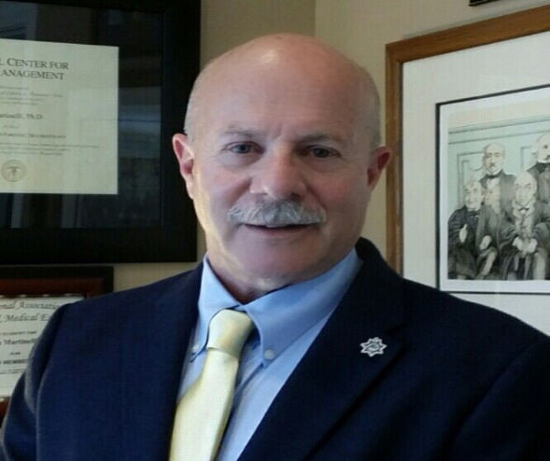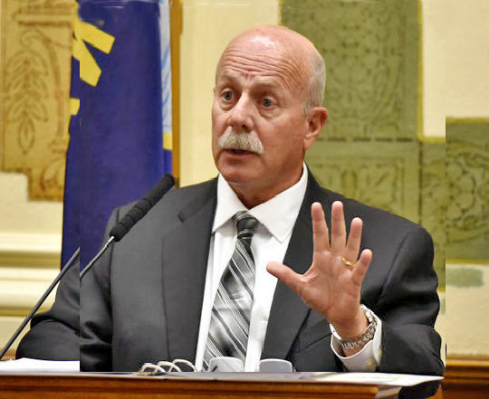

Dr. Ron Martinelli is a nationally renowned forensic criminologist who is the only police expert in the country who is also a Certified Medical Investigator at the physician’s level. He is also a Certified Suicide Investigator accredited by the University of Utah Medical School and the American Association of Suicidology.

Dr. Martinelli directs the nation’s only multidisciplinary Forensic Death Investigations & Independent Review Team and specializes in forensic investigations including officer-involved and civilian self-defense shooting death cases. He handles all 4th, 8th and 14th Amendment litigation; as well as officer and civilian-involved criminal self-defense cases.

Dr. Martinelli, is a retired San Jose (CA) Police Department detective with a background in investigations, medicine and applied sciences including forensics, psychology & psychological profiling; physiology and human factors; violent crimes and death scene investigations. He has been referred to in the forensics and legal community as the “expert’s expert.”

Dr. Martinelli’s police assignments include patrol officer, Field Training Officer, field training coordinator, detective, police academy instructor and police academy director. He was the first street gang investigator at the San Jose PD and was assigned to a number of high-risk assignments including tactical patrol, burglary suppression and was an undercover robbery and prostitution decoy officer in the Street Crimes Unit. He was a highly-decorated police officer and detective, having received 140 police department and community commendations for his work, including the Outstanding Duty Award and a nomination for the Medal of Valor.

Dr. Martinelli provides forensic expert services to the U.S. Department of Justice, several State Attorney Generals’ Offices, major metropolitan cities, the U.S. Navy and USMC Judge Advocate General’s Offices, District Attorney and Public Defender’s Offices and numerous nationally prominent private law firms.
Dr. Martinelli is a subject matter expert in premises liability, private security practices, workplace violence, school violence, responses to active shooters, civilian self-defense and deadly force. He has conducted criminal psychological profiles on the nation’s most high-profile active shooter suspects.

Dr. Martinelli is a forensic investigations expert for FOX News, OANN, CNN-HLN, NPR, Discovery, History and Investigations Discovery channels; and is a contributing writer to America Out Loud, USA TODAY, The Hill, POLICE Magazine, Law & Order Magazine, The Forensic Examiner, The Law Enforcement Executive Forum, PoliceOne.com and Officer.com. Dr. Martinelli is the author of the new book, “The Truth Behind the Black Lives Matter Movement and the War on Police.” His nationally syndicated radio show, “A Thread of Evidence” appears weeknights on AmericaOutLoud.com.

Dr. Martinelli has investigated over 350 officer-involved and civilian self-defense shooting death cases. He was the prevailing police expert in the landmark U.S. Supreme Court decision for law enforcement on deadly force entitled, White v. Pauly out of New Mexico’s 10th Circuit, where he is a retained expert for the NM State Attorney’s Office. He has offices in San Antonio, Texas and Southern California.

Dr. Martinelli is considered as one of our nation’s premiere law enforcement trainers and has trained tens of thousands of professionals nationally and internationally representing the law enforcement, criminal justice, military, intelligence, legal, medical, social service, security, corporate and education communities.

