Thomas J. Zaydon, Jr., M.D., F.A.C.S.  Diplomate, American Board of Plastic Surgeons  Phone (305) 856-3030  Fax (305) 285-9423  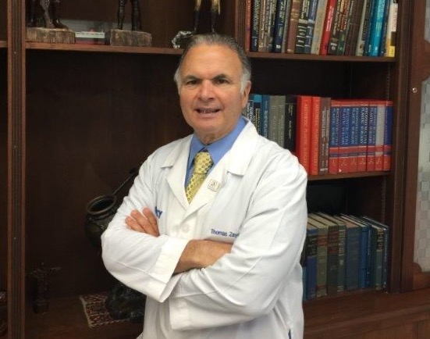 |  | Office Addresses:  Mercy Professional Building (Main Office)  3661 South Miami Avenue  Suite 509  Miami, FL 33133  Metropolis  9060 SW 73 Court  Miami, FL 33156  Apple Medical Center  20800 Biscayne Boulevard  Aventura, FL 33180  Davina Medical Center  151 NW 11 Street #E304  Homestead, Fl 33030  North Florida Dermatology Associates  1541 Riverside Avenue  Jacksonville, FL 32204
 | www.drzaydon.com e-mail: drzaydon@drzaydon.com

EDUCATION  TRAINING  PAGE -2-  MEDICAL LICENSURES  BOARD CERTIFICATIONS | B.S.  Florida State University  Tallahassee, FL (June 1974)  M.D.  Drexel University College of Medicine  Philadelphia, PA (June 1978)  Intern, general surgery  Eastern Virginia Medical School  Norfolk, VA (June 1978 - June 1979)  Resident, general surgery  Eastern Virginia Medical School  Norfolk, VA (June 1979 - June 1980)  Resident, general surgery  Monmouth Medical Center  Long Branch, NJ (July 1980 - June 1981)  Senior resident, general surgery  Monmouth Medical Center  Long Branch, NJ (July 1981 - June 1982)  Resident, plastic surgery  Louisiana State University  New Orleans, LA (July 1982 to June 1983)  Chief resident, plastic surgery  Louisiana State University  New Orleans, LA (July 1983 – June 1984  New Jersey - August 1981 (current)  Louisiana - December 1981 (current)  Florida - April 1984 (current)  Diplomate, American Board of Plastic Surgery  Diplomate, National Board of Medical Examiners  Fello, American College of Surgeons

PROFESSIONAL APPOINTMENTS | Advisory Board – Pro Assurance Company - 2011-present  President, Florida Society of Plastic Surgeons – 2014-2015  Chief of Plastic Surgery – HCA Plantation/Mercy, Miami, FL – 2011-present  Legislative Liason- Florida Society of Plastic Surgery  Southeastern Society Plastic Surgery, Strategic Planning  American Society of Plastic Surgeons  American Society for Aesthetic Plastic Surgeons  American College of Surgeons  Southeastern Society of Plastic & Reconstructive Surgeons  Florida Society of Plastic & Reconstructive Surgeons  Greater Miami Society of Plastic Surgeons  Florida Medical Association  North Florida Dermatology: Jacksonville, Florida  Locum Tenens: HCA/Lawnwood Trauma Center level2- Fort Pierce, Florida  Emergency room call: Mercy Hospital, Baptist Hospital, South Miami Hospital, Doctors Hospital
SOCIETY MEMBERSHIPS

ADDITIONAL ASSIGNMENTS

SPEAKING ENGAGEMENTS/PUBLICATIONS  INTERESTS & ACTIVITIES | Corvel Corporation  FCCI Insurance Group  Hartford  Mercy Hospital Physicians  Lamorte Burns  North Dade Bar  North Miami Beach Police/Fire Department  Pro Assurance  Sedgewick Claims Management Services  SFCMN (South Florida Case Manager’s Network)  Worker’s Compensation 69th Annual Convention  Board – St. Jude Catholic Church

