CURRICULUM VITAE

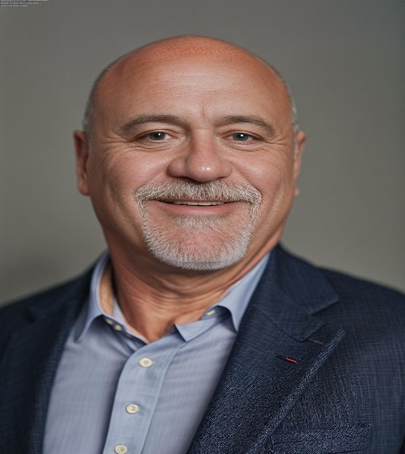
Kevin Mathews
d/b/a Mathews Consulting

CONTACT INFORMATION
Phone: (502) 419-0361
Email: kevin@mathewsconsulting.org
Web: www.mathewsconsulting.org

BRIEF SUMMARY OF EXPERTISE
Trained and instructed commercial drivers and commercial driver applicants in the requirements of the Federal Motor Carrier Safety Administration (FMCSA) and Department of Transportation (DOT) regulations to obtain or maintain a Class A Commercial Drivers License. Former litigator with over 50 cases tried to a jury.

SKILLS
- Class A Commercial Drivers License (CDL)
- Hazardous Materials Endorsement
- Doubles/Triples Endorsement
- Tankers Endorsement
- Forklift and Pallet Jack Certified
- Smith System of Driving (5 Keys)

EXPERIENCE
DRIVER INSTRUCTOR/TRAINER| XPO LTL, Inc.
Louisville, KY | Aug 2019-Present (part-time as of 1/1/24)
- Administered, managed, and conducted CDL A driving schools adhering to FMCSA and DOT regulations
- Instructed students on various aspects of becoming a commercial driver, including hours of service, pre/post trip inspections, hazardous materials transportation, Smith System of driving, distracted/fatigued driving, operation of tractor-trailer combination vehicles on public roadways, coupling and uncoupling of doubles trailers, linehaul operations, pickup and delivery operations, etc.
- Road tested driver applicants and post-hire drivers in accordance with DOT and company requirements
- Onboarded newly hired dockworkers and drivers
- Managed/conducted company-required annual training for various employee roles
- Oversaw rollouts of new company processes affecting drivers and dockworkers
- Reviewed drive cameras daily for driver coaching and recognition opportunities
- Monitored hours of service of 100+ drivers daily to ensure they were following FMCSA and DOT regulations
- Assisted drivers that needed instruction on how to use the adverse driving conditions and 16-hour short-haul exceptions
- Certified all new dockworkers and drivers on a forklift

DRIVER SALES REPRESENTATIVE (DRIVER) | XPO Logistics, Inc.
Louisville, KY Aug 2017- Aug 2019
- Operated various length tractor-trailer combination vehicles (including sets of double trailers)
- Worked both linehaul and city P&D operations, including the loading and unloading of trailers using a forklift
- Coordinated with dispatch office to provide an optimal experience for customers

EXPERIENCE (Continued)
DRIVER/PACK-OUT TRAINER | First Fleet, Inc.
Murfreesboro, TN | Aug 2012- Aug 2017
- Pulled 53-foot trailers out of Bardstown, KY filled with bread products
- Drove to various service centers in TN, IN, KY and OH to unload and distribute (pack-out) bread products to appropriate local routes
- Trained new drivers/shippers how to “pack-out”
- Received safety bonuses every quarter eligible

OTR DRIVER | Crosby Trucking Services, Inc.
Mount Sidney, VA | Aug 2011- Aug 2012
- Over-the-road driver covering Northeast, Midwest, and East Coast routes

EDUCATION
- CERTIFIED DRIVER INSTRUCTOR, XPO Logistics, Inc.
Ann Arbor, MI | Sept 2019
- CERTIFIED DRIVER TRAINER, XPO Logistics, Inc.
Louisville, KY | Aug 2019
- CDL, Truck Drivers Institute
Sellersburg, IN | Aug 2011
- JD, University of Louisville Brandeis School of Law
Louisville, KY | Aug 1989-May 1992
- BA, POLITICAL SCIENCE, University of Louisville
Louisville, KY | Aug 1981-July 1986

HONORS & AWARDS
- XPO LTL Employee Excellence Award Winner, 2nd Quarter, 2023

